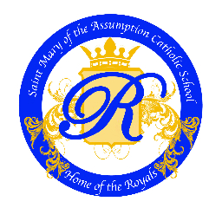

St. Mary of the Assumption Catholic School
Teaching Position Open

St. Mary of the Assumption Catholic School in Van Wert, Ohio is seeking a qualified Teacher for our upcoming 2026/2027 school year. We are seeking a candidate who is proficient in all the content areas and can adhere to the precepts and faith of the Catholic Church, uphold the traditions of St. Mary of the Assumption parish and community, and maintain the academic excellence of our students.

RESPONSIBILITIES
- Uphold High Quality Academics and Expectations
- Able to Relate and Develop Rapport with Students
- Work Closely and Collaborate with the St. Mary’s Staff
- Be Flexible to Schedule Adjustments
- Participate in Outside School Activities and Events
- Maintain Commitment to the Students, School, Community, and the Royal’s Family

QUALIFICATIONS/REQUIREMENTS
- Bachelor of Education
- Ohio Teaching License or Non-Tax License Required
- FBI/BCI Background Check
- Must model the behaviors and precepts of the Catholic Church

SALARY
Per Negotiated Contract based on years of experience.

HOW TO APPLY
To apply for this position, please submit the required materials to the St. Mary of the Assumption Catholic School’s Principal either by mail, email, or fax:

Principal: Fr. Chris Bohnsack
Address: 611 Jennings Road
Van Wert, Ohio 45891
Email: info@stmarysvanwert.com
Phone: (419) 238-5186

Please submit a Cover Letter, Resume, Current Teaching License, and Two Letters of Recommendation.

For more information, please contact the St. Mary of the Assumption Catholic School Office.

