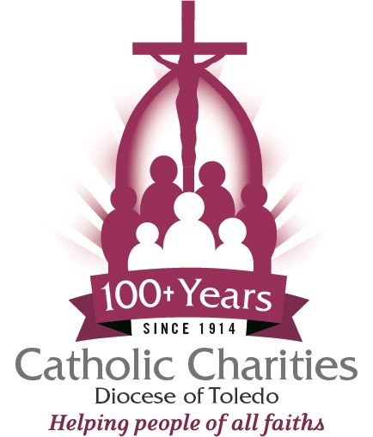
Catholic Charities Diocese of Toledo
Position Description
Position: Residential Specialist FLSA: Non-Exempt
Full or part-time: Full-Time or Part-Time
Reports to: Program Coordinator Pay grade: 5
Number of Direct Reports: 0 Ministry: Miriam House
Last updated: 11-21-25 Location: Norwalk – Miriam House

Position Objective
The Residential Specialist fosters positive communication and steadfast advocacy, assisting women and children throughout their journey during their time at Miriam House. Residential Specialists maintain the facility’s order, cleanliness, and safety and offer friendly service to our residents while ensuring compliance with house policies and procedures.
Essential Responsibilities
- Responds timely to the needs of Miriam House residents with a positive, customer-friendly attitude.
- Ensure house residents follow house policies and procedures, maintain their daily schedules, complete assigned chores, are aware of periodic house meetings, are reminded about house activities and workshops, and make certain they are respectful housemates and neighbors.
- Responsible for administrative duties, including, but not limited to, answering phones and greeting visitors in a courteous and friendly manner, creating the weekly menu, grocery list and the resident’s chores schedule, laundry, dispensing medication, and maintaining daily activity logs and reports.
- Responsible for communicating resident information to the Case Manager on a regular basis.
- Upon arrival, assist residents moving into the house.
- Upon resident departure, cleans and prepares bedroom for future resident occupancy.
- Maintains clear and consistent communication, including operational issues, with the Program Coordinator.
- Performs other related duties, as assigned by Supervisor.

Qualifications
- High school diploma required or general equivalency degree (GED).
- At least 1 year of relevant work experience in a social services environment is desirable.
- Must have and maintain CPR and First Aid certifications.
- Proficiency with Microsoft Excel and Word.
- Maintain a current driver's license, with the ability to travel within the Diocese of Toledo.
- Successful BCI/FBI background check, prior to employment and every 5 years.

Competencies
- A sincere commitment to the Catholic Charities mission and core values and the drive to put them into action.
- Ability to prepare meals from established meal plan and monitor approved food preparation activity of house guests.
- Solid verbal and written communication skills and basic business math skills.
- High level of attention detail and accuracy.
- Ability to work with diverse groups of people and demonstrate exemplary customer service skills.
- Exercise considerable independence and judgment.
- High level of confidentiality, in working with sensitive and privileged information.
- Planning, organizing and prioritizing work; being proactive; taking initiative; following through on commitments; and simultaneously managing multiple priorities.
Working Conditions
- This position works within a household environment and will use standard computers and office equipment when necessary.
- While performing the responsibilities of this job, the employee may regularly be required to stand, walk, sit,
use hands, reach, climb, balance, stoop, kneel, crouch, crawl, talk and listen.
- The employee may need to regularly lift and move up to 25 pounds.
- The noise level in the work environment is usually moderate.
- The physical demands described here are representative of those that must be met by an employee to
successfully perform the essential functions of this position. Reasonable accommodations may be made
to enable individuals with disabilities to perform these functions.

Qualified candidates please submit cover letter, resume, and salary expectations to:
humanresources@toledodiocese.org

