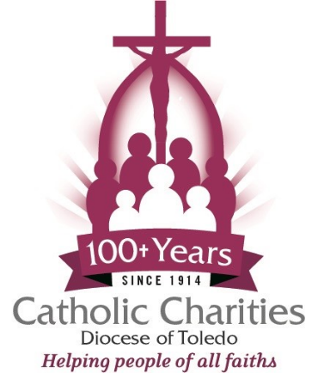
Position Opening
Catholic Charities – Diocese of Toledo

Program Coordinator
Norwalk, Ohio Office
48 Executive Drive, Unit B Norwalk, OH 44857

Catholic Charities – Diocese of Toledo is seeking a full-time Program Coordinator for the Norwalk locations.
Primary responsibilities include:
The Program Coordinator leads the effective and efficient delivery of ministry services to Miriam house guests in support of the Catholic Charities' purpose, mission, and core values. Through consistent training, the coordinator ensures that Residential Specialists and the Community Health Worker understand their specific work responsibilities, priorities, and purpose within the organization.
Essential Responsibilities
- Provides leadership to ministry personnel through daily communication, ongoing performance feedback, information sharing, ongoing training, development, and hands-on leadership.
- The Program Coordinator is a key contributor in ministry planning, budgeting, goal setting, and grant application input.
- Establishes and maintains community connections in support of ministry objectives.
- Participates in community forums, workshops, and meetings impacting ministry services.
- Shares timely communication of ministry events, volunteer activities, and client transformation stories with the Program Director.
- Responsible for overall leadership of the operations and activities of the Community Emergency Services ministry, which delivers crisis navigation services, financial assistance for basic needs, financial literacy, and case management services to include, but are not limited to, information and referrals, client intake and assessment, 1-1 financial counseling/workshops, ongoing case management, and, if desired by clients, offers spiritual engagement.
- Works with local employers and community partners to expand opportunities for individuals.
- Conducts periodic home visits with clients along with the Community Health Worker.
- Responsible for ensuring client case documentation is timely and complete and adheres to federal, state, and local regulations.
- Seeks out collaboration opportunities with relevant community partners.
- Performs other related duties, as assigned by the supervisor.

Candidates for the position must possess:
- Bachelor's degree from an accredited college or university in Business, Social Work, Psychology, Healthcare, or a similar field.
- Three years of relevant work experience; supervisory experience is preferred.
- Maintain a current driver's license and the ability to travel within the Diocese of Toledo.
- Computer-savvy and proficient with Microsoft Excel, Word, and PowerPoint.
- Ability to work flexible hours; some evening and weekend hours may be necessary.
- Successful BCI/FBI background check, prior to employment, and every 5 years.

Qualified candidates, please submit a cover letter, resume, and salary expectations to: humanresources@toledodiocese.org

