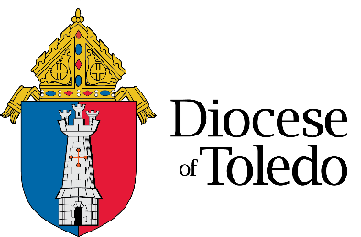
Diocese of Toledo, Department of Catholic Education
Diocesan Regional Director
Position effective July 1, 2023, or sooner

The Diocese of Toledo and the University of Notre Dame’s Alliance for Catholic Education (ACE) Academies eagerly expect a partnership for the 2023-2024 school year. This collaboration will engage 2-3 Toledo Catholic schools in the process of revitalization. The Diocese and University will enter into a multi-year partnership that seeks to strengthen underserved Catholic schools and provide system-level support. To realize identified goals, the Diocese of Toledo is hiring a Diocesan Regional Director to support the revitalization of the Toledo Notre Dame ACE Academies (NDAA).

The NDAA Diocesan Regional Director emphasizes continuous improvement in all aspects of schooling, including Catholic identity, operational vitality, and teaching and learning. This position provides leadership and supports the revitalization of schools and school communities and is a change agent who works collaboratively with principals, the diocese, and with the NDAA national team to increase equity and create the necessary environment that results in strong character formation and accelerated student achievement while working to form scholars and saints. In partnership with the schools’ leaders, the NDAA Diocesan Regional Director serves as a catalyst to close the achievement gap, increase enrollment, improve overall school performance, and transform the life trajectories of the children and families they serve.

Primary duties and responsibilities include:
• Process and build systems for goal development, enactment, and measurement.
• Participate in monthly learning triads (NDAA, Regional Director, Principals) focused on responsive support for teaching and learning goals.
• Deliver school professional development to facilitate grade-level collaboration, content, and pedagogy training.
• Facilitate Principal Professional Learning Communities to problem-solve challenges and ensure enactment of key change levers.
• Analyze student assessment data for action planning.
• Travel to the University of Notre Dame, participate in school visits, and attend professional development opportunities.
• Build and execute Instructional and Coaching Framework, to drive excellence in teaching and learning.
• Coaching: Leadership teams, school leaders, and identified teachers.

Candidates for the position must possess:
• Master’s Degree in education administration, equivalent, or actively pursuing.
• Minimum of five years of experience in teaching or administration.
• Ability to obtain an Ohio Department of Education license.
• Must be a practicing Roman Catholic in good standing with the Church who upholds the teaching and traditions of the Catholic Church.
• Ability to think strategically, anticipate future consequences and trends, and incorporate them into the organizational plan, in collaboration with the school principals, Senior Director of Catholic Education, and related boards.

Qualified candidates please submit cover letter, resume, and salary expectations to: Meghan Reed, Director of Human Resources, humanresources@toledodiocese.org.

