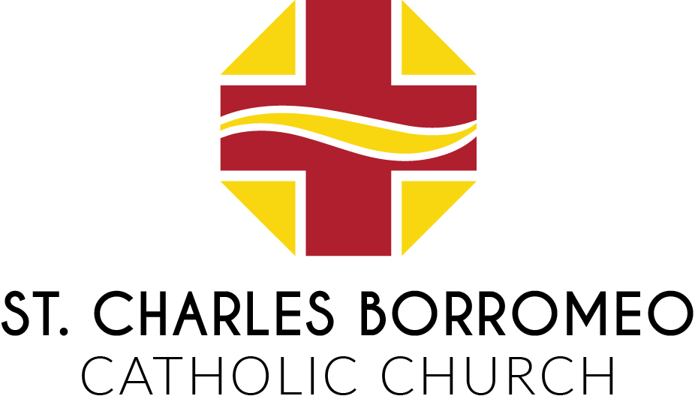

Position: | Director of Christian Corner Community Center
Reports To: | Director of Operations (Pastor for mission-related objectives)
Effective Date: | April 27, 2026
FLSA: | Full-time, Salary-Exempt

General Summary: The Director of the Christian Corner Community Center (CCCC) is a minister of faith who works in accordance with the parish's core values. The Director is responsible for implementing all administrative activities that ensure the smooth operation of the Christian Corner Community Center.

Essential Duties and Responsibilities
- Operations:
  - Understand and manage the day-to-day business side of Christian Corner Community Center.
  - Lead efforts to assure alignment of staff and volunteers with the organization’s mission, vision, and values: "Believing with Faith. Welcome with Love. Serving with Christ."
  - Supervise Church-paid, government-paid, and service-hour personnel and maintain their appropriate paperwork.
  - Ensure volunteers are placed in appropriate roles and that each station is appropriately manned.
  - Coordinate and retrieve all food donations.
  - Oversee the operation of the cooking stations, food distribution, food donations, and organization of the kitchen to ensure that CCCC is operating smoothly and quality is maintained.
  - Maintain information flow via email, mail, etc.
  - Perform other related duties as assigned by supervisor/Pastor.

Environment/Security:
  - Ensure appropriate and safe conduct of volunteers, staff, and clients is always maintained.
  - Ensure that employees and volunteers successfully complete all requirements of the Diocesan Program for the Protection of Children and Vulnerable Adults prior to employment and maintain a satisfactory background check throughout their time at Christian Corner Community Center.
  - Report any incidents of violence, threats, or activities involving law enforcement to the Business Manager.
  - Responsible for coordinating maintenance and security of the building and its contents.

Financial Responsibilities:
  - Coordinate and participate in the solicitation of funding from foundations, corporations, businesses, individuals, and through fundraising events.
  - Oversee major mailings and solicitations.
  - Supervise the research, preparation, and submission of grant proposals.
  - Ensure the successful management of the donor database, acknowledgment
letters, and other donor-related administrative activities.
  - Responsible for monitoring expenses by members of staff. Submit receipts to the Director of Operations.
  - Manage all donor development and fundraising activities in conjunction with St. Charles Parish.

- Public Relations:
- Represent CCCC during food distribution hours and to the public, and during community activities, public events, and conferences.
- Focus efforts to strengthen awareness of the organization throughout the entire region.
- Work closely with other organizations serving the needs of the less fortunate, including other human services organizations (NWOFB, Our Daily Bread, St. Vincent DePaul, etc.). These are to be a linked ministry of the Outreach Commission of St. Charles Parish to ensure open communication with parish leadership.
- Serve as a Staff Resource Member at monthly parish meetings for the Outreach
- Commission of St. Charles Parish.

- Qualifications

- A bachelor's degree from an accredited college or university in Business or Social Work is desired. Will consider a candidate with a high school diploma or GED and sufficient related work experience.
- Three years of relevant work experience and supervisory experience.
- Maintain a current driver's license, with the ability to travel within the Diocese of Toledo.
- Proficiency with Microsoft Excel, Word, and PowerPoint.
- Ability to work flexible hours; some evening and weekend hours may be necessary.
- Successful BCI/FBI background check, prior to employment, and every 5 years.

Knowledge, Skills, and Abilities Required
- Must obtain Safe Serve certification within 90 days of hire.
- Must have a valid driver’s license.
- Understanding and passion for the organization’s mission; empathy and compassion for those living in poverty.
- Must be willing to work on-site, full-time. Regular attendance is essential for this position.
- The ability to respect, promote, accommodate, and not conflict with the mission, moral, and social teachings, doctrines, and laws of the Roman Catholic Faith.
- Must successfully pass the required background checks and all requirements of the Diocesan Program for Children and Vulnerable Adults Protection prior to employment and maintain a satisfactory background check throughout employment.

Language Skills
- Ability to read, analyze, and interpret general business periodicals, professional journals, technical procedures, or governmental regulations.
- Ability to write reports, business correspondence, and procedure manuals.
- Ability to effectively present information and respond to questions from groups of managers, clients, vendors, employees, and the public.

Mathematical Skills
- Ability to add, subtract, multiply, and divide across all units of measure, using whole numbers, common fractions, and decimals. Ability to compute rates, ratios, and percents, and to draw and interpret bar graphs.

Reasoning Ability
- Ability to define problems, collect data, establish facts, and draw valid conclusions. Ability to interpret a wide range of technical instructions in mathematical or diagrammatic form and to handle multiple abstract and concrete variables.

Physical Demands
- The physical demands described here are representative of those required to perform the essential functions of this job. Reasonable accommodation may be made to enable individuals with disabilities to perform the essential functions. While performing the duties of this job, the employee is regularly required to stand, walk, and sit; use hands; reach, climb, or balance; and stoop, kneel, crouch, or crawl. The employee must regularly lift and/or move up to 30 pounds.

Working Conditions
- The work environment characteristics described here are representative of those an employee encounters while performing the essential functions of this job. Reasonable accommodations may be made to enable individuals with disabilities to perform these essential functions.
- The noise level in the work environment is usually moderate.

Receipt and Acknowledgment
I acknowledge that I have received a copy of this position description. I have read and understood it. I am responsible for complying with all duties, requirements, and responsibilities contained herein, including any subsequent revisions.

This job description outlines the general nature and level of work performed by employees in this classification. It is not intended to serve as a comprehensive inventory of all duties, responsibilities, and qualifications required of employees assigned to this position.

I understand and agree that the position description is for informational purposes only and is not to be construed as a contract between the Diocese of Toledo and its employees.

Employee Printed Name
Employee Signature | Date
Supervisor Signature | Date
Pastor Signature | Date

