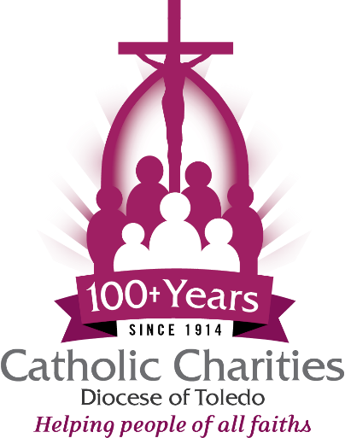

Catholic Charities 3rd Annual Hands of Christ Gala
Bulletin Announcement

Catholic Charities Diocese of Toledo’s Third Annual Hands of Christ Gala will be Thursday, November 5, 2026 at The Premier, 4480 Heatherdowns Blvd., in Toledo. Our sincere thanks to Perrysburg AutoMall for being our $25,000 Presenting Sponsor!
Enjoy remarks by Bishop Daniel E. Thomas and a keynote presentation by American film producer and screenwriter Jim Wahlberg. Rich and Connie Cronin of Maumee, and Daniel and Christine Campbell of Shiloh, are the 2026 Hands of Christ honorees.
Tickets are on sale now at $100 per person ($125 after October 1). Seating is limited, so we encourage you to make your reservations early at catholiccharitiesnwo.org/2026gala by October 10.
Together, we can continue sharing the love of Christ with those who need it most!
-30-
Annually, Catholic Charities serves 45,000 people of all faiths and backgrounds living in the 19 counties of the Diocese of Toledo, providing food, shelter, crisis and case management, utilities and emergency assistance, education, adult advocacy services, disaster relief and various social justice ministries. To learn about volunteer opportunities or make a gift supporting the work of Catholic Charities Diocese of Toledo, visit catholiccharitiesnwo.org.

