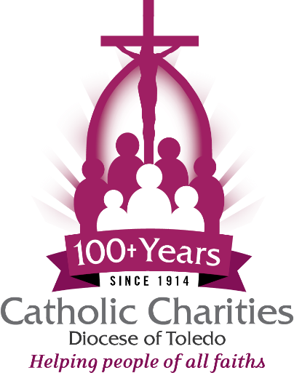

Catholic Charities 3rd Annual Hands of Christ Gala
Bulletin Announcement

Join us for an evening of faith, fellowship and philanthropy at our 3rd Annual Catholic Charities Diocese of Toledo’s Hands of Christ Gala Celebration, Thursday, November 5, 2026. Our sincere thanks to Perrysburg AutoMall for being our $25,000 Presenting Sponsor!
Attendees will enjoy remarks by the Most Reverend Daniel E. Thomas, Bishop of the Diocese of Toledo, and a keynote presentation by American film producer and screenwriter Jim Wahlberg.
“This is our signature fundraising event for the year, celebrating our transformational ministries serving people of all faiths across the Diocese of Toledo,” says Rodney Schuster, Executive Director of Catholic Charities Diocese of Toledo, noting event sponsorships are still available. “This year we are pleased to honor Rich and Connie Cronin, of Maumee, and Daniel and Christine Campbell, of Shiloh, as our ‘Hands of Christ’ award recipients.”
Doors open at 5:45 p.m. at The Premier, 4480 Heatherdowns Blvd., Toledo, OH 43614. The dinner program begins at 6:45 p.m. Dinner seating is $100 per person ($125 after October 1) Reserve a table of 8 for $800. Make your reservations at catholiccharitiesnwo.org/2026gala by October 10.
Margaret and Adam Hoff are serving as Gala Co-Chairs. Other members of the Gala Planning Committee include Jim Peniston, Nicholas P. Carr, Kelly Donaghy, Mary Gerken, Rodney Schuster, Jennifer Lippus and Deb Boyce.
Contact any member of the planning committee or reach out to Jennifer Lippus, Director of Development, for more information at 419.214.4890 or email her at jlippus@toledodiocese.org
-30-
Annually, Catholic Charities serves 45,000 people of all faiths and backgrounds living in the 19 counties of the Diocese of Toledo, providing food, shelter, crisis and case management, utilities and emergency assistance, education, adult advocacy services, disaster relief and various social justice ministries. To learn about volunteer opportunities or make a gift supporting the work of Catholic Charities Diocese of Toledo, visit catholiccharitiesnwo.org.

