Grade Divisions |
PEE WEE | MINOR | CADET | JUNIOR
K – 1st | 2nd – 3rd | 4th – 6th | 7th – 8th
No standings |  | League Standings
No Tournament |  | League Tournament

Competitive Divisions |
BRONZE | SILVER | GOLD
0% Experience & no club/travel players on roster. | 50% Experience with >4 club/travel players on roster. | 80% Experience with 5< club/travel players on roster

General Rules |
- National Federation High School Rules will govern CYO leagues, unless stated otherwise. NFHS rule books may be purchased online at www.nfhs.com
- Official scorecards are kept as permanent records of each game. Coaches and CYO Official are to sign the scorecard at the end of the match to make official.

Coaches Meeting |
- Pre-game conference in the Neutral Area on the sideline, midfield.
- Coin Flip for Home/Away team (league and tournament play)
- Rosters and lineups will be verified, and updates/changes may still be made.
- CYO All Play Rule will be reviewed, and any “dressed” player a coach is not playing due to injury or team must report at this time to the officials and opposing team.

“All Play” Rule | Soccer
- Every healthy uniformed player on the roster and present at the game, must play at least one half of each contest.
  - This does not include players being disciplined for missing practice(s) or other team infractions.
Pre-Match Procedure |
- All teams will line up in front of parents/spectators to recite the “CYO” prayer and Pledge of Allegiance.
  - After the Pledge of Allegiance, teams will go back to their benches and have 1 minute for any final prep.
  - Starters then should take the field.
Match Play & Results | Pee Wee | Minor | Cadet | Junior
Length | Two 20min. Halves | Two 25min. Halves | Two 25min. Halves | Two 30min. Halves
Length | Game clock is a continuous/running clock.  Time is stopped at the discretion of the official. | There will not be “Extra time” added to the end of regulation.
Halftime | 5 Min. | Teams will switch sides/goals for 2nd half
Standings | No Standings |  | Standing Calculation & Display  Standings are driven solely by points, awarded as listed below.  The declining point value of a win for excessive goal differentials is to discourage teams from running up the score.
Standings |  |  | Win if goal differential is +6 or less |  | 3 _{points}
Standings |  |  | Win _{if goal differential is +7} |  | 2 _{points}
Standings |  |  | Win _{if goal differential is +8} |  | 1 _{point}
Standings |  |  | Win _{if goal differential is +9} |  | 0 _{points}
Standings |  |  | Win _{if goal differential is +10} |  | -1 _{points}
Standings |  |  | Tie |  | 3 _{points}
Standings |  |  | Loss |  | 0 _{points}
Standings |  |  | Win _{by forfeit} |  | 3 _{points}
Standings |  |  | Loss _{by forfeit} |  | -3 _{points}
_{Match Play & Results Continued}
 | _{Pee Wee & Minor} |  | _{Cadet & Junior}
Tournament | No tournament |  | End of season tournament
Seeding |  |  | Overall Record, Head-to-Head
Tournament Play |  |  | Coaches will choose their tournament slot during the tournament meeting, the last day of regular season.
Tie Breaker  ^{Tournament Play Only} |  |  | 5 Min. Overtime  Full 5min. will be played. This is NOT sudden death.
Tie Breaker  ^{Tournament Play Only} |  |  | 2nd Tie Breaker | 5 vs 5 Penalty Kicks  Coaches will select 5 players and 1 goalie.  ^{Official will select the goal}  If game is still Tied – Another round of penalty kicks with 5 different players and goalie will take place.

Match Play & Adjustments by Divisions |
Uniform Requirements
Equipment & Field | Pee Wee | Minor | Cadet | Junior
Ball | Size 3 | Size 4 | Size 4 | Size 5
Field Dimensions | Tim Boyle & GESU 1 & 2  ^{50 x 40 yds} | McQuade & Wurzel  ^{70 x 50 yds} | TFO & OCP  ^{90 x 45-55 yds}
Goal Sizes | 6 1/2’ H x 18 ½’ W |  | 8’ H x 24’ W

- Metal cleats are prohibited
  - Tennis/turf shoes or molded cleats are acceptable.
- Properly fitted shin guards are MANDATORY and must be entirely covered by the player’s socks.
- Jerseys with numbers on the back are to be worn with an opposite color shirt for the goalie.
  - Teams with similar color jerseys: Away team will be asked to either switch to a 2nd jersey or wear pull-over mesh jersey which will be available at the CYO Complex.
  - Pants with zippers or belts are prohibited.
- All jewelry is prohibited.

CYO “All Play” | All uniformed players on the bench must play at least one half of match
A player must participate in at least three league games to play in the tournament. Any request for an exception to this rule must be submitted to the CYO office in writing prior to the start of the tournament.

Equipment & Field | Pee Wee | Minor | Cadet | Junior
Players on Field | 6 | 7 | 8 | 9
Players on Field | Team may start with at least Five (5) | Team may start with at least Five (5) | Team may start with at least Five (5) | Team may start with at least Six (6)
Substitutions  ^{Unlimited} | Any number of players from either team MAY be substituted WITH the referee’s permission during ANY stoppage of play. Substitutes must be ready at the Midfield line prior to a request for substitution.  Substitutes MAY NOT enter the field of play until permitted by the referee.
Offsides | No | Yes, a player is offside if they are in the attacking half and closer to the opposing team's goal-line than both the ball and the second-last opponent/last defenseman.
Field Dimensions | Tim Boyle & GESU 1 & 2  ^{50 x 40 yds} | McQuade & Wurzel  ^{70 x 50 yds} | TFO & OCP  ^{100 x 45-55 yds}
Goal Sizes | 6 1/2’ H x 18 ½’ W |  | 8’ H x 24’ W
Offsides |
Offside Position: A player is in an offside position if they are nearer to the opponent’s goal line than both the ball and the second-to-last defender when the ball is played to them. Remember, being in an offside position alone is not an offense.
Involvement in Active Play: To be penalized for offsides, the player in the offside position must be involved in active play. This means interfering with an opponent or gaining an advantage from being in that position.
Timing is Key: The crucial moment for determining offsides is when the ball is played to the player in question. If they were in an offside position at that moment and subsequently become involved in active play, an offside offense is committed.

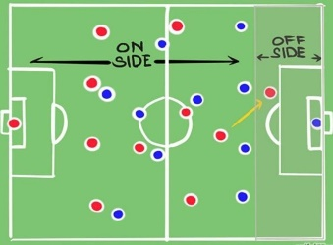
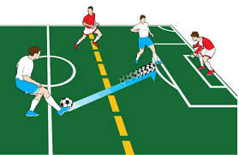

Game Play |
Goals | When the ball is over the goal line entirely between the goal post and under the cross bar.
Handball in the box | When a defender intentionally or unintentionally touches the ball with their hand or arm.  - If the ball goes in the goal, the goal counts and no penalty kick is issued  - If the ball does not go into the go, a penalty kick is awarded to the attacking team.
Corner Kicks | When the ball is kicked out of play by the defense over the endline.
Goal Kicks | When the ball is kicked out of play by the offense over the endline.  - Goal kicks may be kicked by the goalie or teammate.  - The opposing team is to be outside the penalty area when a goal kick is kicked, and the ball is not live until it crosses the penalty box.
Throw ins | When the ball is kicked out of play over the sidelines.  - The throw in is awarded to the opposite team of who kicked the ball out.  - Proper throw in is an overhead throw with both hands and both feet must stay in contact with the ground.
Goalkeeper Restrictions | Goalkeepers can only hold the ball for a maximum of six seconds, starting from the moment they gain control of it.  - If the ball is held for longer than six seconds, an indirect free kick is awarded to the opposing team.  Pass Back Rule: Goalkeepers cannot handle the ball with their hands or arms if a teammate deliberately kicks it to them, or throws it to them directly from a throw-in.  Goalkeepers can play the ball anywhere on the field, but they cannot handle the ball with their hands or outstretched arms outside of their penalty area.
Heading | Heading is not permitted for the following divisions: Pee Wee, Minor, and Cadet.
Slide Tackling | Slide tackling is not permitted for the following divisions: Pee Wee and Minor
Build-out Line | The build-out line runs across the field equidistant between the top of the penalty area and halfway line.  - BOL is for the following divisions: Pee Wee  - Promotes playing the ball out of the back in a less pressured setting.  - The opposing team must move back behind the BOL for a goal kick.  - When the goalkeeper obtains possession of the ball, they may pass, throw, or roll the ball anywhere on the field.  - Opposing team must move back behind the BOL once the goalkeeper obtains possession of the ball.  - Coaches are encouraged to remind their players to retreat behind the BOL.  - Coaches are encouraged to teach goalkeepers to wait for the opposing team to move behind the BOL.
Goalkeeper Punts | For the following divisions: Pee Wee  - Goalkeeper shall not punt the ball.  - Goalkeeper may place the ball on the ground and pass/kick it as desired.

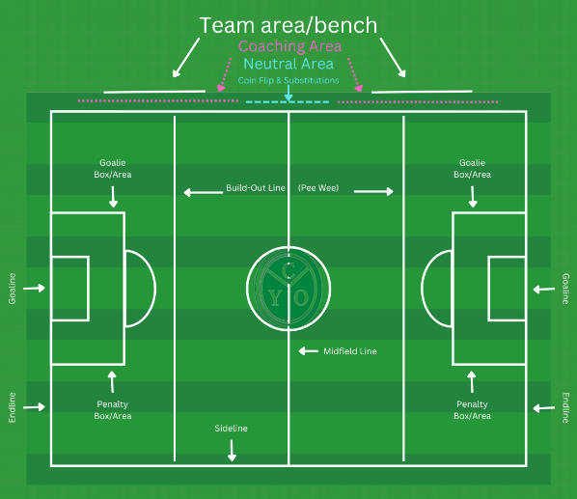
Coach & Player Conduct |
- The CYO Official(s) oversee the match and have the authority to disqualify players, coaches, or spectators for unsportsmanlike conduct.
  - This includes warnings and could result in immediate removal from the match/complex.
  - Yellow Card: Could be issued to an individual (coach or player) or a team. Is a warning and next incident would lead to a Red Card.
  - Red Card: Could be issued to an individual an (coach or player) or team.
    - Issued to coach or player would result in immediate expulsion from the game.
    - Players would be restricted to the team bench/area.
    - Coach would be told to leave the complex.
    - Team Red Card would result in an immediate end of match and forfeit for the team who was issued the Red Card.
  - Any coach or spectator being removed will be removed from the complex for the remainer of the day.
  - An official has the authority to stop a match and if the individual refuses to leave, could result in discontinuing the match and automatic forfeit for the team that individual is a part of.
- An Official report will be made, and the player, coach and/or team may be suspended after review by the CYO Administration/Office. Game reports are available on the CYO Website.
  - This includes damage to the property or misconduct with the building
- Coaching area (for all grade divisions)
  - Coaches and other team officials are not allowed to enter the field of play or interfere with the game. This includes coaches and assistant coaches, who are also known as "team officials".
  - A head coach may stand in the area immediately in front of her/his team area/bench to coach her/his players. This shall be no closer to the court than 5ft from the neutral area on the sideline.
  - Pee Wee Division – One coach may be on the field during game play.
- Team Area
  - During the match, players are to stay in the team area which is 5ft of the sideline and 10ft from the neutral area.
  - Able to stand behind “bench” to warm-up/stretch before subbing in.
- Coaches warning
  - If a warning (Yellow Card) is issued to anyone of the coaching staff or team bench.
    - That Coach is restricted to the coaching area.
    - The head coach and team are restricted to the bench/team area for the remainder of the match on a team bench warning.

Good Sportsmanship |
- CYO wants to praise and promote our faith, community and good sportsmanship.
  - After the match, teams will award a player from the opposing team the “CYO Good Faith and Sportsmanship” Award.
  - This player could have shown good faith and sportsmanship directly towards one’s team or by continually cheering and being a positive light for their own team.

CYO Prayer

Lord God, we thank you for bringing us together today and ask that you watch and guide over us. Help the athletes use their talents to the fullest and remain injury free.
Help the coaches to teach these young athletes not only about the game, but more importantly, about being good Christians.
Help the game officials do their best to enforce the rules and remain fair at all times.
And help the spectators to be considerate of all players, coaches, officials and each other.
Thank you for giving all of us the opportunity to put our faith into action today.
-Amen-

CYO Post Game Prayer

Lord, we thank you for the opportunity and challenge of this game.
You call us to compete well, finish the race, and grow in our faith!
Help us to remember we can do all things through you, who give us strength.
-Amen-

