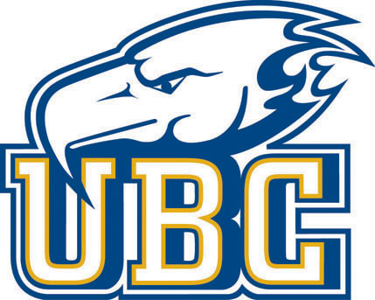

2024 Thunderbird College Baseball Recruiting Showcase

When: Saturday Sept 7th , 2024
Where: UBC Baseball Indoor Training Centre, next to Thunderbird Baseball Park
3085 Wesbrook Mall, Vancouver, BC V6T 1Z3
Time: 9am – 5:30pm Saturday
For Who: Open to 2025-2027 Graduates
Max. Number: 60 maximum:
Cost: $175.00 Pay and register by clicking on this link:
https://ubc.perfectmind.com/24063/Classes/BookMe4LandingPages/CoursesLandingPage?courseId=cf93430e-9a10-4e72-ad29-45a2e7ab3aef

Description:
Welcome to the Thunderbird College Baseball Recruit Showcase. This event is designed to introduce high school baseball players to an elite level baseball showcase with Canada’s best university baseball program. Head Coach Chris Pritchett, Assistant Coaches, Sammie Starr and Mitch Hodge, and Department of Player Performance staff will be on hand to evaluate and assess each player, and to provide players and parents the opportunity to learn more about the UBC Baseball program.

UBC Baseball’s approach to player assessment combines insights from technology and expert coaches to address all of the fundamental skills needed to be an elite baseball player at the college level. Athletes will receive feedback on their skill set displayed during the showcase.
Our assessments will include the following:
Rapsodo® Hitting & Pitching evaluation
Blast® metrics
Offensive and Defensive Assessment
Speed, Power, and Agility assessment
Live Game Action Evaluation
Itinerary
8:30 am - Check In
8:45 am - Baseball Coaching Staff Introduction
9:00 am - Assessments, Campus Tour
12:45 pm - Lunch
1:15 pm - On Field Showcase Game
5:30 pm - Wrap up Talk with UBC Coaches

For More Information please contact Sammie Starr @ sammie.starr@ubc.ca

