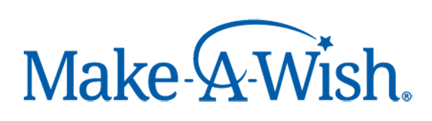
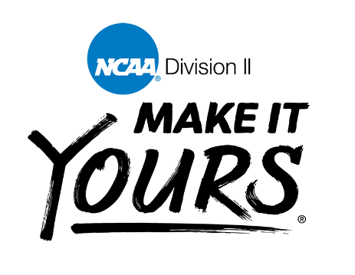

The Division II Make-A-Wish program
While Division II schools engage with their communities locally, the division also recognizes the need to contribute on a national scale.
There’s no better example of that commitment than Division II’s long-standing relationship with the Make-A-Wish Foundation, which grants wishes to children with life-threatening illnesses. The Division II Student-Athlete Advisory Committee, which is the primary student-based group that contributes to policy-making for the division, established the Make-A-Wish partnership in 2003 and has since become one of the foundation’s largest and most consistent contributors.
Division II has raised more than $6.2 million toward granting the wishes of children with life-threatening medical conditions. Almost 740 “wishes” have been granted through Division II contributions. These wishes can serve as a game changer in children’s fights against their illnesses, helping them feel better, and in some cases even get better.

Make-A-Wish Website Link: https://wish.org/

Donate through Limestone SAAC Using:
Venmo: @LimestoneSAAC
Cash App: $LimestoneSAAC

