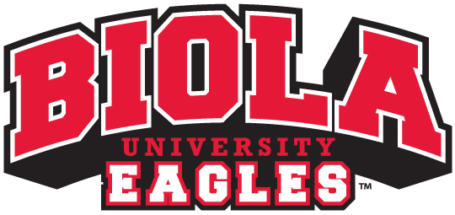

Mission Statement:
Biola Athletics exists to recruit and educate a diverse group of Christian student-athletes to reach their full potential athletically, relationally, emotionally, spiritually and academically — equipping them in mind and character to impact the world for Christ.

Statement of Philosophy:
Biola University Athletics serves to recruit and educate a diverse group of Christian student-athletes to compete in the NCAA Division II. The institution supports its student-athletes in reaching their full potential athletically, relationally, emotionally, spiritually and academically. We believe in the holistic development of a student-athlete — living life in the balance — in order to thrive at Biola and beyond. The following are areas of focus for holistic development, as well as the values shaping the department and university.

- Biola Athletics seeks to foster a balanced and inclusive approach in which student-athletes learn and develop through their chosen academic pursuits, in civic engagement with their communities and in athletics competition.

- We are committed to the physical and educational well-being of student-athletes, including maintaining an environment that values cultural diversity and gender equity among student-athletes and intercollegiate athletics department staff.

- We are committed to ensuring that coaches and administrators exhibit fairness, openness and honesty in their relationships with student-athletes. We seek to empower and give voice to the student-athletes via the Student-Athlete Advisory Committee.

- We believe a positive athletic environment and ethical approach to sport, scholarship and service are important to character development and the overall success of the intercollegiate athletic experience. We value respect, fairness, civility, honesty and responsibility. These values should be manifest in the full spectrum of activities affecting the athletics program.

- In order to create an atmosphere of respect and civility, we are committed to protecting individuals from unlawful discrimination or harassment with respect to governance policies, educational programs, activities, and employment policies.

- We recognize that our student-athletes are not simply members of their team, but also members of the student body as a whole as well as many other outside communities. We therefore strive to protect the time of the student-athlete so they may be fully immersed in outside communities and truly experience “life in the balance.”

- With the goal of being a model NCAA Division II institution, Biola is strongly committed to the principle of rules compliance. We are fully invested in complying with all applicable Association rules. Partnerships with other PacWest Conference institutions provide an important accountability in this area.

Within the scope of the rules of compliance, the institution is committed to maintaining the strictest governance as it relates to recruiting, awarding financial aid, tracking student-athlete eligibility and activity, meeting all sport sponsorship requirements and maintaining ethical accounting practices.

In addition to the above guiding principles, Biola Athletics is focused on the following fundamental philosophies that help define and distinguish who we are:

- Academics - As part of the Living Life in The Balance initiative, Biola University is committed to supporting the academic success of its student-athletes. Biola provides a top tier education for all students and is specifically committed to providing the support necessary to ensure a path to graduation that demonstrates graduation rates for student-athletes that are at least equal to those of the general student population.

- Athletics - Biola University is committed to providing highly competitive programs that aspire to compete for NCAA Division II national championships. We believe the key to accomplishing athletic success is through the quality Christian leadership of coaches and strong administrative support, allowing student-athletes to reach their collective team potential. In addition, we offer top level athletic facilities, equipment, strength training and athletic training support to help our student-athletes realize their full potential. It is our goal to see all student-athletes develop in their sport, so that they are more skilled at the conclusion of their time at Biola than when they began.

- Spiritual Development - Biola University is committed to providing an educational experience that integrates Christian faith with every aspect of the university experience. We believe the intercollegiate athletics experience can play a significant role in the spiritual development of every student-athlete, and we have developed our programs with spiritual growth at the core. We believe athletics at Biola provides an opportunity to invest in the development of the entire student-athlete’s holistic development in mind, body and soul.

- Community Engagement - Biola Athletics is committed to active engagement with our communities to enhance relationships between our student-athletes and community members and develop a shared civic experience in our student-athletes. We believe this commitment goes beyond periodic service work; it should be tied to an active and continuing engagement with our surrounding communities, motivated by our Christian love for others. We seek to not only engage the community off campus, but also to provide opportunities to bring the community onto our campus and engage them in a positive, family-friendly manner.

- Post-Graduation Success - Biola Athletics is committed to developing our student-athletes’ character, rooted in their Christian faith, so that they can successfully transition to become productive members of society after they graduate. We also believe in an athletic model that allows our student-athletes to focus on academic pursuits, obtain internships for career preparedness, and develop a strong spiritual foundation to thrive holistically beyond graduation.

