The electronic recordings of this meeting serve as the official meeting minutes.

A full and accurate account of this meeting’s audio and video can be found at [www.orangetwp.org](http://www.orangetwp.org)

Mr. Grumbles called the meeting to order at 1:00 p.m.

**PRESENT:**  Ben Grumbles, Chair

Lisa Knapp, Vice Chair

Erica Fouss, Trustee

Lisa Kraft, Fiscal Officer

**ALSO PRESENT:** Michele Boni, Township Administrator

Valerie Bunting, Administrative Manager

Nathan McNeil, Fire Chief

Silas Bowers, Director of Operations

Mike Kremnitzer, Senior Human Resources Manager

Robin Duffee, Development and Zoning Director

**APPROVAL OF CONSENT AGENDA**

**1) IN THE MATTER OF APPROVING THE CONSENT AGENDA FOR THE REGULAR MEETING HELD ON DECEMBER 21 2022:**

It was moved by Mr. Grumbles, seconded by Ms. Knapp, to approve the consent agenda for Regular Meeting held on December 21, 2022

Seconded by Ms. Knapp

VOTE: Grumbles – Yes Knapp – Yes Fouss – Yes

NOW, THEREFORE, BE IT RESOLVED THAT THE BOARD HEREBY APPROVES THE FOLLOWING CONSENT AGENDA ITEMS FOUND IN LINE ITEMS A) & B)

1. **RES.22-408 APPROVING THE ELECTRONIC RECORD OF THE PROCEEDINGS FROM THE ZONING HEARINGS AND REGULAR MEETING HELD ON DECEMBER 7. 2022**

**WHEREA**S, the Board of Trustees for Orange Township, Delaware County, Ohio (the “Board”) met in regular session on December 7, 2022.

**WHEREAS**, the Fiscal Officer has certified, pursuant to section 305.11 of the Ohio Revised Code, that the entire record of the proceedings at that meeting is completely and accurately captured in the electronic record of those proceedings;

**NOW, THEREFORE, BE IT RESOLVED** that the Board hereby approves the electronic record of proceedings at the Zoning Hearings and Regular Meeting held on December 7, 2022

1. **RES.22-409 APPROVING PURCHASE ORDERS, THEN AND NOW PURCHASE ORDERS, AND BLANKET PURCHASE ORDERS AS LISTED:**

|  |  |  |  |
| --- | --- | --- | --- |
| **Vendor** | **Description** | **Account** | **Amount** |

|  |  |  |  |
| --- | --- | --- | --- |
| Delco Water | North Road Park Phase 2 | Parks | $25,000.00 |
| National Business Furniture | Office Furniture | Admin | $4,801.04 |
| Oberlander’s Tree Service | Lewis Center Phase 3 | Parks | $28,500.00 |
| Dunrobin | Bale Kenyon ROW | Roads | $51,286.00 |

**RES.22-410 APPOINTMENT OF ANDREW KOENIG TO FULL-TIME POSITION OF ZONING INSPECTOR AND ESTABLISHMENT OF COMPENSATION**

Mr. Grumbles moved the adoption of the following resolution:

**BE IT RESOLVED** that Andrew Koenig is appointed to the non-exempt, full-time, non-bargaining unit employment position of Zoning Inspector, effective January 3, 2023.

**BE IT FURTHER RESOLVED** that the compensation for this position shall be at the rate of $22.48 per hour, with paychecks to be issued based on a 14-day pay period.

**BE IT FURTHER RESOLVED** that the compensation for this position shall also include the standard employee benefits package for all full-time non-union personnel.

**BE IT FURTHER RESOLVED** that appointment to this position was contingent upon the appointee satisfactorily completing and passing all of pre-employment testing.

Seconded by Mrs. Fouss

VOTE: Grumbles – Yes Knapp – Yes Fouss – Yes

**RES.22-411 ADOPTION OF PARK RULES FOR PARKS LOCATED IN ORANGE TOWNSHIP, DELAWARE COUNTY, OHIO**

**ADOPTION OF PARK RULES**

The Board of Trustees of Orange Township, Delaware County, Ohio (“Board”) met in Regular session on December 21st, 2022 with the following members present:

Ben Grumbles

Lisa Knapp

Erica Fouss

Mr. Grumbles moved the adoption of the following Resolution:

**PREAMBLE**

**WHEREAS**, the Board desires to approve and adopt a/an:

Park Rules (“Rules ”).

**RESOLUTION**

**NOW THEREFORE, BE IT RESOLVED:**

1. The Board hereby approves and adopts the rules. A copy of the rules and regulations is attached to this resolution as Exhibit A and by this reference incorporated herein.
2. The rules and regulations shall take effect immediately.
3. All formal actions of this Board concerning and relating to the passage of this Resolution were adopted in an open meeting of the Board, and all deliberations of this Board and of any of its committees that resulted in such formal action were in meetings open to the public in compliance with all legal requirements, including R.C. § 121.22.
4. This Resolution shall be in full force and effect immediately upon adoption.

Ms. Knapp seconded the motion.

VOTE: Grumbles – Yes Knapp – Yes Fouss – Yes

Voted on and signed this 21st day of December, 2022 in Orange Township, Delaware County, Ohio.

**BOARD OF TRUSTEES OF**

**ORANGE TOWNSHIP,**

**DELAWARE COUNTY, OHIO**

__________________________________

Ben Grumbles

Chair

__________________________________

Lisa Knapp

Vice Chair

__________________________________

Erica Fouss

Trustee

Attest:

_________________________________

Lisa Kraft

Orange Township Fiscal Officer

**CERTIFICATE**

State of Ohio, Delaware County

I, the undersigned Township Fiscal Officer of Orange Township, Delaware County, Ohio, certify that the foregoing Resolution No. 22-411 is taken and copied from the record of proceedings of the Board, and that it has been compared by me with the Resolution on the record and is a true and accurate copy. Further, I certify that the adoption of such Resolution occurred in an open meeting held in compliance with R.C. § 121.22.

Date: ________________ __________________________________________

Lisa Kraft

Orange Township Fiscal Officer

Exhibit A

**PARK RULES**

Orange Township Parks (“Parks”) are open daily from dawn to dusk. Except for activities approved by the Township. Parks are closed from dusk to dawn. During such period, no person shall enter or remain in an Orange Township Park (Park).

No person shall engage in illegal activity within a Park.

Defacement, destruction, removal or disturbance of any building, sign equipment or natural vegetation within a Park is prohibited.

Except as to picnic materials and the like, no person shall bring, leave or dump any material of any kind in a Park. All picnic materials and the like shall be placed in trash containers.

Fires, other than in Park grills or fireplaces, are prohibited in Parks. Propane tanks and non-park grills are not permitted. All fires must be extinguished before leaving the Park.

Pets must be leashed at all times. Pet Owners will be responsible for removal and proper disposal of fecal matter from their pets. Pets are not allowed on athletic fields or playgrounds. Farm animals and horseback riding are prohibited in Parks.

No person shall hunt, trap or abuse animals within a Park. Fishing is allowed in accordance with posted rules.

Alcoholic beverages and illegal drugs are prohibited in Parks. No person shall be in a Park while intoxicated by alcohol or under the influence of illegal drugs.

No person shall use, discharge, possess or carry air or gas guns, firearms, bows, knives, crossbows, missile throwing objects or sling shots in a Park.

Commercial solicitation, sales and advertising of any kind are prohibited on Park grounds, unless conducted with the express permission of the Director of Operations.

No person shall operate radios, tape recorders, CD players, similar electronics or musical instruments at a volume audible beyond their immediate area within a Park.

All organized athletic events in Parks, including practices, must have the prior approval of the Director of Operations. If an athletic field is deemed unplayable by the Director of Operations, no person shall be on the field until further notice. Signs shall be posted to announce restrictions.

No person shall fly remote control airplanes or drones, or shoot rockets or fireworks within a Park. Remote control cars are also prohibited in Parks.

No swimming or boating is permitted in Parks.

Ice skating and snow sledding is only permitted in designated Park areas and at designated times.

Skateboarding is only permitted in designated Park areas. Motorized vehicles are allowed only on designated roads. No person shall wash or repair vehicles in a Park. Snowmobiles or unlicensed vehicles are prohibited in Parks.

Parking is permitted in designated areas only.

Any vehicle left in a Park after closing will be towed at the owner’s expense.

No person shall promote or engage in gambling, any game played for money or other thing of value, begging or soliciting for money in a Park.

No Person shall loiter in the vicinity of a Park restroom and no person shall enter restroom facilities provided for the exclusive use of the opposite sex unless the person is (1) under the age of six; (2) assisting a dependent with the use of a universal changing table; or (3) unable to use a same-sex restroom as a result of someone utilizing a universal changing table.

No person shall use insulting, abusive, threatening, profane or indecent language, or assault or commit bodily injury upon another in a Park.

No person shall appear in a state of nudity in a Park or commit, perform or engage in any lewd or obscene act or solicit another to engage in the same.

Camping is prohibited in Parks.

No person shall build a structure on Park property.

Propane tanks and non-Park grills are not permitted within a Park.

No person shall erect a sign in a Park or attach a sign to Park property.

No person shall hit a golf ball or practice golf in a Park.

Feeding of wild animals, including waterfowl (geese and ducks). Is prohibited in Parks.

**Penalties**

*Failure to Comply*.

No person shall refuse to comply with any the rules and regulations set forth herein or any other reasonable order of any Township officer, employee or any person authorized by the Board to enforce these rules, including but not limited to the Delaware County Sheriff Deputies, any other authorized law enforcement officer or any umpire or referee of an athletic event. When, in the opinion of any person authorized to enforce these rules and regulations, any person is not complying with rules and regulations or is participating in any activity that constitutes a hazard to themselves or others or is in any way being a nuisance or disturbing the peace of the parks, may be removed from the park by the appropriate authority and subject to fines and prosecution as set forth in this Section. Any violation of these rules and regulations shall be immediately reported to the Delaware County Sheriff Department.

*Penalties*.

Violation of these rules and regulations may result in permanent expulsion from Township parks and prosecution in a court of law. Pursuant to Ohio Revised Code Sections 505.261 and 511.32, any person violating any of the foregoing rules and regulations and any amendments or additions thereto or any directive from any authorized personnel as set forth above, shall be subject to prosecution and upon conviction shall be fined in any sum not exceeding one hundred dollars ($100.00) for the first offense, nor more than five hundred dollars ($500.00) for each second and further offense.

*Other Regulations*.

In addition to these rules and regulations, all park visitors are also subject to State, Federal and other local regulations, as applicable.

**RES.22-412 MODIFYING THE EMPLOYMENT POSITION OF PART-TIME PARKS MAINTENANCE AND FACILITIES LABORER TO FULL TIME PARKS MAINTENANCE AND FACILITIES LABORER**

Mr. Grumbles moved the adoption of the following resolution:

**WHEREAS**, the Township has had the at-will, non-exempt, part-time, non-bargaining unit employment position known as part-time Parks Maintenance and Facilities Laborer and are requesting the transition to full-time Parks Maintenance and Facilities Laborer and

**WHEREAS**, the Board has been presented a proposal to re-name this employment position and adjust its position description, all to be effective December 21, 2022;

**NOW THEREFORE BE IT RESOLVED** that the full-time Parks Maintenance and Facilities Laborer shall serve under the supervision of the Parks Maintenance and Facilities Manager and under the terms and provisions stated in the position description for the position presented to the Board and bearing in its footer the identifying version date of December 21, 2022.

**BE IT FURTHER RESOLVED** that the employee serving in this employment position on the effective date of this resolution shall continue in such position under its new redefined position and without any break in service, but doing so under the above stated position description.

**BE IT FURTHER RESOLVED** that the aforementioned position description is presented for informational purposes only and can be changed at any time by the Board, with or without notice.

**BE IT FURTHER RESOLVED** that neither the aforementioned position description nor this Resolution are an employment contract, express or implied, and an employee in such position is an employee at will and either the employee or the Board can terminate the employment relationship at any time (for any reason or no reason).

**BE IT FURTHER RESOLVED** that, unless otherwise provided by the Board, all future appointments to this position shall be contingent upon the applicant's satisfactory completion of all pre-employment screenings.

**BE IT FURTHER RESOLVED** that this resolution shall be effective on and after December 21, 2022.

Seconded by Mrs. Fouss.

VOTE: Grumbles – Yes Knapp – Yes Fouss – Yes

**RES.22-413 APPOINTMENT OF NICHOLAS BRIAS TO FULL-TIME POSITION OF PARKS MAINTEANCE AND FACILITIES LABORER AND ESTABLISHMENT OF COMPENSATION**

Mr. Grumbles moved the adoption of the following resolution:

**BE IT RESOLVED** that Nicholas Brias is appointed to the non-exempt, full-time, non-bargaining unit full-time employment position of Parks Maintenance and Facilities Laborer, effective December 28, 2022.

**BE IT FURTHER RESOLVED** that the compensation for this position shall be at the rate of $20.21 per hour, with paychecks to be issued based on a 14-day pay period.

**BE IT FURTHER RESOLVED** that the compensation for this position shall also include the standard employee benefits package for all full-time non-union personnel.

Seconded by Ms. Knapp

VOTE: Grumbles – Yes Knapp – Yes Fouss – Yes

**RES.22-414 AUTHORIZING EXECUTION OF THE DELAWARE COUNTY ENGINEERS 2023 ORANGE TOWNSHIP ROAD IMPROVEMENTS CONSTRUCTION COST ESTIMATE AGREEMENT**

Motion by Mr. Grumbles

**A RESOLUTION AUTHORIZING** that the Board of Township Trustees of Orange Township, Delaware County, Ohio (“Board”), authorize The Director of Operations to enter into and execute agreement for the Delaware County Engineer 2022 Orange Township Road Improvements Project Estimated dated 12/02/2022 (“Estimate”) in the amount of $ 1,559,300.00 attached hereto;

**NOW THEREFORE, BE IT RESOLVED** the Board hereby recognizes and approves the Estimate; All formal actions of this Board concerning and relating to the passage of this Resolution were adopted in an open meeting of the Board, and all deliberations of this Board and of any of its committees that resulted in such formal action were in meetings open to the public in compliance with all legal requirements, including R.C. § 121.22. On behalf of the Orange Township Board of Trustees, the Director of Operations is authorized to execute

the Estimate; This Resolution shall be in full force and effective immediately upon adoption.

Seconded by Mrs. Fouss

VOTE: Grumbles – Yes Knapp – Yes Fouss – Yes

**RES.22-415 AUTHORIZING THE DELAWARE COUNTY ENGINEERS TO PROCEED WITH ADVERTISING THE BID FOR DEL-TR 107-0.05, BALE KENYON ROAD PHASE 1 PROJECT AND APPROVING THE ENGINEERS CONSTRUCTION COST ESTIMATE**

Motion by Mr. Grumbles

**A RESOLUTION AUTHORIZING** that the Board of Township Trustees of Orange Township, Delaware County, Ohio (“Board”), authorize The Delaware County Engineers office to advertise for bid the DEL-TR 107-0.05 Bale Kenyon Road Phase 1 Project and approving the construction cost estimate dated December 6th, 2022.(“Estimate”) in the amount of $3,403,000.00 attached hereto;

**NOW THEREFORE, BE IT RESOLVED** the Board hereby recognizes and approves the Estimate and authorizes The Delaware County Engineers office to bid the DEL-TR 107-0.05 Bale Kenyon Road Phase 1; All formal actions of this Board concerning and relating to the passage of this Resolution were adopted in an open meeting of the Board, and all deliberations of this Board and of any of its committees that resulted in such formal action were in meetings open to the public in compliance with all legal requirements, including R.C. § 121.22. On behalf of the Orange Township Board of Trustees, The Delaware County Engineers Office authority to bid the DEL-TR 107-0.05 Bale Kenyon Road Phase 1 and authorized to execute the Estimate; This Resolution shall be in full force and effective immediately upon adoption.

Seconded by Ms. Knapp

VOTE: Grumbles – Yes Knapp – Yes Fouss – Yes

**RES.22-416 AUTHORIZING THE DIRECTOR OF OPERATIONS TO EXECUTE AN AGREEMENT WITH THE CLEAN OHIO TRAIL FUND THROUGH THE OHIO DEPARTMENT OF NATURAL RESOUCES/ LOCAL PROJECT GRANT AGREEMENT FOR THE LEWIS CENTER TRAIL PHASE III**

Mr. Grumbles moved for the adoption of the following Resolution:

**A RESOLUTION AUTHORIZING** that the Board of Township Trustees of Orange Township, Delaware County, Ohio (“Board”), authorize The Director of Operations to enter into and execute an agreement with Clean Ohio Trail Fund ODNR/Local Project Grant for Lewis Center Trail Phase III.

Seconded by Mrs. Fouss

VOTE: Grumbles – Yes Knapp – Yes Fouss – Yes

**CLEAN OHIO TRAIL FUND**

**ODNR/LOCAL PROJECT AGREEMENT**

This Clean Ohio Trail Fund ODNR/Local Project Grant Agreement (hereinafter referred to as the “Agreement”) is made and entered into by and between the State of Ohio, Department of Natural Resources, (hereinafter referred to as “State” or “ODNR”), acting by and through its Director, pursuant to Sections 1501.02 and 1519.05 of the Ohio Revised Code (“R.C.”) and House Bill No. 687, 134th General Assembly of the State of Ohio and **Orange Township**, an Ohio township (hereinafter referred to as “Grantee”) acting by and through its authorized representative.

**Notices:** All notices, demands, requests, consents, approvals, and other communications required or permitted to be given pursuant to the terms of this Agreement shall be in writing, and shall be deemed to have been properly given when: 1) hand-delivered with delivery acknowledged in writing; 2) sent by U.S. Certified mail, return receipt requested, postage prepaid; 3) sent by overnight delivery service (Fed Ex, UPS, etc.) with receipt; or 4) sent by fax or email, and shall be respectively addressed as follows:

(b) with respect to the Grantee:

**Orange Township**

**1680 East Orange Road**

**Lewis Center, Ohio 43035**

Attn: **Township Administrator**

Email: **mboni@orangetwp.org**

(a) with respect to ODNR:

Ohio Department of Natural Resources

Office of Real Estate

2045 Morse Road, E2

Columbus, Ohio 43229

Attn: Program Manager

Email: D’Juan.hammonds@dnr.ohio.gov

**WHEREAS**, pursuant to House Bill No. 687, the 134th General Assembly of the State of Ohio has appropriated funds for the Clean Ohio Trail Fund in the amount of Twelve Million Five Hundred Thousand Dollars ($12,500,00.00) to make matching grants to grantees for the costs associated with purchasing land or interests in land for recreational trails and for the construction of such trails in line item C72514; and

**WHEREAS**, the General Assembly has identified the Clean Ohio Trail Fund created and existing under R.C. § 1519.05, as the fund from which these monies will be disbursed; and

**WHEREAS**, pursuant to R.C. Chap.151 and Article VIII, §§ 2o and 2q of the Ohio Constitution, bonds (the “Bonds”) have been or will be issued by the Ohio Public Facilities Commission (“OPFC”) for the purpose of paying the costs of environmental revitalization and conservation, all as described in R.C. §§151.01 and 151.09. A portion of those Bonds proceeds will be used by ODNR to provide funding to the Grantee for the Project under this Agreement. Because ODNR is funding the Project with proceeds of those Bonds, ODNR requires that the Grantee make certain representations, warranties, and covenants (both affirmative and negative) concerning the Project and use of the grant funds, as more fully described, or provided in this Agreement, in order to comply with federal and state laws, regulations, and rules relating to those Bonds and the projects funded with proceeds of those Bonds.

**NOW THEREFORE**, for the purpose of providing the funds to Grantee pursuant to House Bill No. 687 of the 134th General Assembly, the parties hereto covenant and agree as follows:

1. **FUNDING AMOUNT.** ODNR shall: (1) obligate for Grantee funding assistance **not to exceed $300,000.00** from ODNR fiscal allocations made available under the provisions of the Clean Ohio Trail Fund and House Bill. 687; (2) upon receipt of acceptable proof of actual eligible costs incurred by Grantee in performing this Agreement, reimburse Grantee no more than seventy-five percent (75%) of such eligible costs. Funds for this Project have been released by the Controlling Board as of December 3, 2018 and encumbered by Contract Encumbrance Record Number 0000041243 and are so certified by the Director of Budget and Management on December 4, 2018**.** Obligations of the State are subject to the provisions of R.C. §126.07. If the Ohio General Assembly fails at any time to continue funding for the payments due hereunder, this Agreement is hereby terminated as of the date that the funding expires without further obligation of ODNR. Any funds provided under this Agreement that are not spent shall be returned in full to the State.
2. **PROJECT DESCRIPTION.** The Grantee shall use the grant funds for **Lewis Center Road Trail-Phase III**, a project to Phase III of the Lewis Center Road Trail will construct 2,610 linear feet of 10-foot-wide asphalt trail providing access to Alum Creek State Park., all as more fully described in Exhibit A attached hereto (the “Project”).
3. **EFFECTIVE, TERMINATION AND COMPLETION DATES.** This Agreement shall be in effect on the date that it is signed by ODNR (the “Effective Date”) and will, unless otherwise earlier terminated as provided herein, terminate on the later of: (i) 15 years from the date that construction of the Project is completed (or property acquisition if the Project is solely for the acquisition of real property)(the “Completion Date”); or (ii) the date upon which the latest Bonds issuance, funding or refinancing of the Project is paid in full (the “Termination Date”). The Completion Date shall be on or before **March 31, 2024.** If Grantee fails to pursue performance of the Project within a reasonable period of time, ODNR, in the exercise of its sole discretion may terminate this Agreement and Project. The period of time between the Effective Date and the Completion Date shall be referred to herein as the “Project Period.” The parties, by mutual written consent, may agree to extend the Completion Date, but in no event shall the Completion Date be more than fifteen (15) months after the Effective Date.
4. **PERFORMANCE OF PROJECT.** The Grantee shall perform its duties and responsibilities under this Agreement in compliance with the terms, promises, conditions, plans, specifications, estimates, procedures, maps, and assurances set forth in the submitted by Grantee (the “Project Proposal”), which is incorporated herein by reference as though fully, set out herein, on which the Project is constructed (the “Property”) as well as the terms set forth in this Agreement. Grantee shall: (1) diligently pursue completion of the Project; (2) promptly submit to ODNR, such reports and documents as ODNR may request; (3) maintain and keep the Property for public recreation; (4) not change the use of the Property unless the proposed change is approved by ODNR; and (5) display a suitable sign acknowledging the Clean Ohio Trail Fund assistance.
5. **COMPLIANCE WITH GUIDELINES.** ODNR and Grantee mutually agree to perform this Agreement in accordance with the policies and procedures set forth by ODNR and the guidelines set forth in the Clean Ohio Trail Fund Project Guidelines and Application Booklet. Failure to comply with or show sufficient progress in complying with such requirements may result in the termination of this Agreement. In the event of termination, all unused funds shall be retained by ODNR. ODNR may issue instructions, interpretations or additional guidelines as necessary for effective program performance. Project assistance may be terminated in whole or in part at any time within the Project Period if ODNR determines that Grantee has failed to comply with this Agreement. Grantee will be promptly notified in writing of such findings and given reasons for this action.
6. **COMPLIANCE WITH LAW.** Grantee shall comply with all applicable federal, state, and local laws in the conduct of the Project. Grantee and its employees are not employees of the State of Ohio with regard to the application of the Fair Labor Standards Act, Federal Insurance Contribution Act, Social Security Act, Federal Unemployment Tax Act, Internal Revenue Code, and state revenue and tax laws. Grantee accepts full responsibility for payment of any and all taxes, and payroll deductions required for all employees engaged by Grantee in the performance of the work on the Project, including without limitation, unemployment compensation, workers’ compensation, and all health care, income tax, social security, and Medicare deductions. ODNR is exempt from federal, state, and local taxes and shall not be liable for any taxes under this Agreement.
7. **NO RESTRICTIONS OF RECORD.** Grantee hereby represents and warrants that there are not now, and there will not be, any restrictions of record or otherwise, with respect to the Project, including without limitation, any encumbrances, liens, or other matters, which would interfere with or otherwise impair the use of the Property as described in the Boundary Map attached hereto as Exhibit A. Grantee represents that it is the fee simple owner, or has a lease or exclusive easement with a term longer than the term hereof, on the Property and that the only restrictions of record, or otherwise, with respect to the Property are: (a) all zoning regulations, restrictions, rules and ordinances, and other laws and regulations now in effect or hereafter adopted by any governmental agencies having jurisdiction over the Property, (b) dedicated public rights-of-way identified on Exhibit A, Boundary Map, and (c) the encumbrances, items, and other matters identified in said Exhibit B, Title Encumbrances.
8. **USE OF PROPERTY.** The Property shall be retained and used only for the purpose of constructing and maintaining a recreational trail. The Property shall be kept open for the general public's use during reasonable hours and during appropriate seasons of the year. The use of the Property shall not be changed from that approved when Clean Ohio Trail Fund assistance is obtained without prior written approval from ODNR. During the term of the bonds issued to provide funds for the Clean Ohio Trails Fund, the Property shall not be converted to another use other than a recreational trail use nor shall the Property be transferred through deed, lease, license, or easement without the approval of ODNR. Should Grantee convert the Property without the approval of ODNR, Grantee may become ineligible for further grant funding through ODNR until the condition of noncompliance is rectified to the satisfaction of ODNR. Grantee shall retain and use the Project and Property in a manner consistent with the purposes of Sections 2o and 2q, Article VIII of the Ohio Constitution.
9. **MAINTENANCE OF PROPERTY.** The Property shall be operated and maintained so as to be safe, attractive, and inviting to the public. Sanitation and sanitary facilities shall be maintained to comply with applicable ODNR and local health standards. All improvements shall be kept in reasonable repair throughout their estimated life expectancy to prevent undue deterioration.
10. **ACCESSIBILITY.** Any new facility constructed on the Property will, whenever possible, be designed to accommodate people with disabilities. The Property and facilities on the Property shall be made available to all persons regardless of race, color, religion, sex, national origin, handicap, military status, age or ancestry. Any modifications to existing structures shall also include design considerations for persons with disabilities. It is understood that this requirement is applicable to any construction occurring on the Property, regardless of the funding source for the improvement. Grantee will require any facility on the Property to be designed to comply with the Americans With Disabilities Act of 1990 as amended (42 U.S.C §§12131 *et seq*.). Grantee will be responsible to ensure compliance with these specifications by any contractors.
11. **USER FEES.** User fees charged for the Property, if any, shall be reasonable for all users and shall not create unfair competition with private enterprises offering similar services. Excess revenues from user fees for the Project shall be returned to the public in the form of expanded facilities or services for the Project.
12. **SIGN.** A Clean Ohio Trails Fund acknowledgment sign shall be prominently displayed at the Property or facilities on the Property.
13. **QUALIFICATIONS TO RECEIVE GRANT.** Grantee affirms that it duly organized local political subdivision or nonprofit organization, qualified to receive grants under the Clean Ohio Trail Fund. Grantee further affirms that if at any time during the term of this Agreement, Grantee for any reason becomes disqualified from participating in the Clean Ohio Trail Fund, Grantee will immediately notify ODNR in writing and will immediately cease performance of the Project.  Failure to provide such notice in a timely manner shall void this Agreement and may be sufficient cause for the State of Ohio to debar the Grantee from future state grant opportunities as may be permitted by law.
14. **PLANS; BIDDING.** If the Project requires construction plans and specifications, all construction plans, and specifications shall be approved and stamped by a registered professional engineer and/or architect. Grantee shall require completion of the work in accordance with the approved construction plans and specifications. Grantee shall follow all applicable laws in determining whether the Project must be competitively bid, and if competitive bidding for the Project is not required by law, to the extent reasonable possible as determined by Grantee, Grantee shall employ an open and competitive process in the selection of its contractors. Bid documents designed to be so restrictive to exclude open competitive bidding and bid documents that do not allow for “or equal” provisions, may not be acceptable. Plans must reflect the intent of the Project as described in the authorizing legislation. Once approved by ODNR, plans and specifications should not be substantially modified. ODNR must be notified of any planned substantial changes, and only approved changes will be eligible for reimbursement.
15. **DISCRIMINATION BASED ON RESIDENCE PROHIBITED.** Discrimination on the basis of residence, including preferential fees, reservations, membership systems, is prohibited, except to the extent that reasonable differences in admission or other fees may be maintained on the basis of residence.
16. **RELOCATION ASSISTANCE.** Grantee shall comply with the requirements of Ohio Revised Code Chap. 163 for all real property acquisitions, and where applicable shall assure that these requirements have been complied with for the Property to be developed with assistance under this Agreement.
17. **RELATIONSHIP OF THE PARTIES.**
18. **Expenses.** Grantee shall be responsible for all its own expenses, including, but not limited to, computers, email and internet access, software, phone service, and office space. Grantee will also be responsible for all licenses, permits, employees’ wages and salaries, insurance of every type and description, and all business and personal taxes, including income and Social Security taxes and contributions for Workers’ Compensation and Unemployment Compensation coverage, if any.
19. **No Control Over Means and Methods.** While Grantee shall be required to perform its obligations described hereunder during the term of this Agreement, nothing herein shall be construed to imply, by reason of Grantee’s obligations hereunder, that ODNR shall have or may exercise any right of control over Grantee with regard to the means or method of Grantee’s performance of its obligations hereunder.
20. **No Right to Bind.** Except as expressly provided herein, neither party shall have the right to bind or obligate the other party in any manner without the other party’s prior written consent.
21. **No Agency.** Neither Grantee nor its personnel shall at any time, or for any purpose, be considered as agents, servants, or employees of ODNR or the State of Ohio.
22. **PERS RETIRANT.** If Grantee is a Public Employees Retirement System (PERS) retirant, as defined by R.C. § 145.38, Grantee shall notify ODNR of such status in writing prior to the commencement of the Project. Notices pursuant to this section shall be sent to ODNR’s Director of Human Resources by mail at 2045 Morse Rd., Building D-1, Columbus, Ohio 43229, by fax at (614) 265-7995, or by email at **HR@dnr.ODNR.oh.us**. ODNR shall not be responsible for any changes to Grantee’s retirement benefits that may result from entering into this Agreement nor shall ODNR make any contributions to the PERS on behalf of any of the individuals employed by Grantee, or its contractors or other agents. Grantee acknowledges and agrees any individual providing personal services under this Agreement is not a public employee for purposes of R.C. Chapter 145. Grantee certifies that it is a business entity with five or more employees as defined at R.C. § 145.037 (A) for the purposes of the application of R.C. Chapter 145, or that Grantee has completed the necessary forms and returned it to ODNR of Ohio if Grantee is an employer with no more than four (4) employees.
23. **LIABILITY; WAIVER OF LIABILITY.** Grantee shall be solely liable for any and all claims, demands, or causes of action arising from its obligations under this Agreement. Each party to this Agreement must seek its own legal representative and bear its own costs, attorney fees and expenses, in any litigation that may arise from the performance of this Agreement or the Project. It is specifically understood and agreed that ODNR does not indemnify Grantee*.* Nothing in this Agreement shall be construed to be a waiver of the sovereign immunity of the State of Ohio or the immunity of any of its employees or agents for any purpose. Nothing in this Agreement shall be construed to be a waiver of any immunity of Grantee granted by statute or the immunity of any of its employees or agents for any purpose. In no event shall ODNR be liable for indirect, consequential, incidental, special, liquidated, or punitive damages, or lost profits. On and after the date of this Agreement, Grantee agrees not to seek any determination of liability against ODNR, OPFC, the Treasurer, or any department, agency, or official of the State in the case of claim or suit arising from the Project including the acquisition of the Property or any future condition, construction, operation, maintenance, or use of the Property or facilities which may be developed in relation to the Project. Grantee forever releases and waives any and all claims, demands, and causes of action it may ever possess or assert against ODNR and its employees, agents, officials, and attorneys arising from, or relating to, the Project.
24. **INSURANCE.**
25. **Adequate Insurance.** Unless otherwise agreed to by ODNR in writing, Grantee shall maintain, or cause to be maintained, at no cost to ODNR, commercial general liability insurance and other insurance, including, casualty insurance, and if applicable, professional liability insurance, and builder’s risk insurance, to insure ODNR, OPFC, the Treasurer, and the State in an amount and type determined by a qualified risk assessor to be sufficient to cover the full replacement costs of improvements funded, in whole or in part, by the State, and for bodily injury, property damage, personal injury, advertising injury, and employer's liability exposures of Grantee. Unless otherwise agreed to by ODNR in writing, such insurance shall remain in force at all times from the Effective Date hereof through the term of this Agreement.
26. **Self-Insurance.** Instead of providing the general liability and casualty insurance above, Grantee may name ODNR, OPFC, the Treasurer, and the State as additional insureds and/or loss payees, as the coverage requires, under a self-insurance program or joint self-insurance pool created under R.C. §§2744.08 or 2744.081, respectively, and operated by or on behalf of Grantee, in order to meet the insurance requirements, set forth herein.
27. **BONDED AND INSURED EMPLOYEES AND AGENTS.** Prior to the release of funds by ODNR, Grantee will provide ODNR with a document that demonstrates that all employees or agents of Grantee who are responsible for maintaining or disbursing funds acquired through this Agreement will be fully bonded or insured against loss of such funds. The bonding agent or insurer shall be licensed to do business in Ohio. No part of the funds acquired by Grantee through this Agreement shall be spent to obtain that bonding or insurance.
28. **RESTRICTIONS ON EXPENDITURES.** Grantee affirmatively states that Grantee is fully aware of the restrictions and guidelines for expending funds granted under this Agreement and intends to comply fully with the same. Grantee will implement appropriate monitoring controls to ensure that funds acquired through this Agreement are expended in accordance with all applicable laws, rules, and requirements.
29. **EQUAL OPPORTUNITY COMPLIANCE.** If Grantee is a political subdivision, Grantee shall comply with the requirements of R.C. § 125.111 for all contracts for purchases under the Project.
30. **PREVAILING WAGE.** Grantee shall comply with the prevailing wage requirements, as may be applicable, described under R.C. Chapter 4115. Grantee shall pay to laborers and mechanics performing work under this Agreement the prevailing wage rates of the locality where the work shall be performed, as determined by the Ohio Department of Commerce, Division of Industrial Compliance, Wage and Hour Bureau. Grantee shall submit payroll reports to the Ohio Department of Commerce that are certified by it that the payroll is correct and complete, and the wage rates shown are not less than those required by this Agreement. Grantee is also responsible for submitting payroll reports of subcontractors to the Ohio Department of Commerce.
31. **LEGAL, FEDERAL TAX, AND OTHER COMPLIANCE.**
32. **Public Funds Compliance.** Grantee will assure compliance with all applicable federal, state, and local laws and regulations pertaining to handling, management, and accountability in relation to public funds. All funds received by Grantee under this Agreement shall be deposited in one or more financial institutions that fully insure, secure, or otherwise protect the funds from loss through federal deposit insurance and/or other deposit and/or collateralization strategies that protect the funds against loss. If Grantee is a political subdivision of the State, grant funds shall be held in compliance with R.C. Chap. 135.
33. **Reports of Expenditures.** Grantee will assure that monies expended under this Agreement are spent in conformity with the intent and purpose of the appropriation, the limitations on use set forth in the legislation containing the appropriation, and R.C. Chap. 151 and all other laws that apply to the expenditure of monies by Grantee. If Grantee is required to submit an annual financial report to the Auditor of State, in accordance with Auditor of State Bulletin 2015-07, then Grantee shall report the funds it acquires through this Agreement as a separate column identified in a manner consistent with the Project description in appropriation item C72514. If Grantee is not required to submit the aforementioned report, Grantee shall file an annual detailed expenditure report of all expenditures associated with the Project with the Auditor of State by March 1st every year until all funds provided in this Agreement have been spent. The above reports shall be filed in accordance with Auditor of State Bulletin 2015-07.
34. **Determination of Ineligibility.** If it is determined by any audit by the Auditor of State or any department, agency, or official of the State or other agency or entity with legal audit authority that any Project expense is ineligible, or not properly documented, Grantee will repay that amount in full to the State.
35. **Record Retention.** Grantee will keep and make all reports and records associated with the Project funded under this Agreement available to the State Auditor, or the Auditor’s designee, ODNR, and OPFC for a period of not less than eighteen (18) years after the Completion Date. These reports and records shall include a description of the Project, a detailed overview of the scope of work, disbursement details (including amount, date, nature/object of expenditure), and vendor information. Grantee acknowledges that the Auditor of State and other departments, agencies, and officials of the State may audit the Project at any time, including before, during, and after completion. Grantee agrees that any costs of audit by the Auditor of State or any other department, agency, or official of the State will be borne exclusively by, and paid solely by, Grantee, and that the funds provided under this Agreement will not be used by Grantee for payment of any audit expenses for any reason at any time.
36. **Compliance with Employment Laws.** Grantee agrees to comply with all applicable federal, state, and local laws and regulations, in the conduct of the Project and acknowledges that its employees are not employees of ODNR with regard to the application of the Ohio Public Employees Retirement law, Fair Labor Standards Act minimum wage and overtime provisions, Federal Insurance Contribution Act, Social Security Act, Federal Unemployment Tax Act, Internal Revenue Code, Ohio revenue and tax laws, Ohio Workers’ Compensation Act, and Ohio unemployment compensation law.
37. **Compliance with Law; Preservation of Tax-Exempt Status of Bonds.** Grantee agrees to use funds provided under this Agreement in accordance with the Ohio Constitution and any state or federal laws and regulations that may apply. Grantee shall repay ODNR any funds improperly expended. Additionally, Grantee agrees to comply with all requirements within its control necessary to preserve the tax status of all tax-exempt or tax-advantaged bonds, the proceeds of which are used to provide the funding to Grantee set forth in this Agreement. Unless otherwise determined by the OPFC, such requirements include, but are not limited to, ensuring that the funds provided under this Agreement finance capital expenditures (as opposed to operating expenses) and are not used to refund or otherwise refinance existing debt of Grantee. Grantee shall be liable for any payments to the Internal Revenue Service or the U.S. Treasury as penalties or to preserve the tax status of tax-exempt or tax-advantaged bonds, and any other costs, resulting in whole or in part from actions taken by Grantee, including the failure of Grantee to comply with federal income tax laws applicable to such bonds. Grantee agrees to consult with OPFC if the Grantee is uncertain as to what expenditures are eligible to be financed with funds provided under this Agreement.
38. **PROJECT NONDISCRIMINATION.** Grantee agrees that any facilities that may be developed now or in the future on the lands comprising the Project will be made available to all persons regardless of race, color, sex, religion, national origin, ancestry, age, military status, handicap, or disability on the same terms and conditions.
39. **EMPLOYMENT NONDISCRIMINATION.** Pursuant to R.C. Chap. 4112, Grantee agrees that Grantee and any person acting on behalf of Grantee or a contractor, shall not discriminate, by reason of race, color, religion, sex, sexual orientation, age, disability, military status as defined in R.C. § 4112.01, national origin, or ancestry against any citizen of this State in the employment of any person qualified and available to perform services relating to the Project. Grantee further agrees that Grantee and any person acting on behalf of Grantee or a contractor shall not, in any manner, discriminate against, intimidate, or retaliate against any employee hired for the performance of services relating to the Project on account of race, color, religion, sex, sexual orientation, age, disability, military status, national origin, or ancestry. If required by R.C. §125.111(B) and O.A.C §123: 2-3-02, Grantee shall have a valid Certificate of Compliance (COC) from the Ohio Department of Administrative Services, Equal Opportunity Division demonstrating compliance with affirmative action program requirements.
40. **DRUG-FREE WORKPLACE.** Grantee shall comply with all applicable ODNR and federal laws regarding drug-free workplace. Grantee shall make a good faith effort to ensure that all of Grantee’s employees, while working on the Property, shall not purchase, transfer, use or possess illegal drugs or alcohol or abuse prescription drugs in any way.
41. **SELF-INSURANCE.** The State of Ohio is self-insured for the indemnification of its officers and employees in the maximum aggregate amount of one million dollar per occurrence in accordance with section 9.87 of the Ohio Revised Code.
42. **GRANTEE’S REPRESENTATIONS AND WARRANTIES**
43. **Ethics Compliance.** Grantee, by signature on this document, certifies that Grantee: (i) has reviewed and understands the Ohio ethics and conflict of interest laws as found in Ohio Revised Code Chapter 102 and in Ohio Revised Code Sections 2921.42 and 2921.43, and (ii) will take no action inconsistent with those laws. Grantee understands that failure to comply with Ohio's ethics and conflict of interest laws is, in itself, grounds for termination of this Agreement and may result in the loss of other contracts or grants with the State of Ohio.
44. **Legal Status.** Grantee affirms that it has been properly formed, and properly exists, as a political subdivision or nonprofit organization in the State of Ohio. Grantee further represents and warrants that it has legal authority to undertake all requirements of this Agreement.
45. **Findings for Recovery.** Grantee affirmatively represents and warrants to ODNR that it is not subject to a finding for recovery under Ohio Revised Code §9.24, or that it has taken appropriate remedial steps required under Ohio Revised Code §9.24 or otherwise qualifies under that section. Grantee agrees that if this representation or warranty is deemed to be false, the Agreement shall be void *ab initio* as between the parties to this Agreement, and any funds paid by ODNR hereunder immediately shall be repaid to ODNR, or an action for recovery immediately may be commenced by ODNR for recovery of said funds. Grantee warrants that it is not subject to an “unresolved” finding for recovery under Ohio Revised Code § 9.24.
46. **Debarment.** Grantee affirms that if at any time during the term of this Agreement Grantee becomes disqualified from conducting business in the State of Ohio, or becomes debarred from doing business with the State of Ohio, Grantee will immediately notify ODNR, in writing, and will immediately cease performance of the work. Failure to provide such notice in a timely fashion shall void this agreement and may be sufficient cause for ODNR to debar Grantee from future state contracting opportunities as may be permitted by law. Grantee represents and warrants that it is not debarred from consideration for contract awards by the Director of the Department of Administrative Services, pursuant to either Ohio Revised Code §§ 153.02 or 125.25.
47. **TERMINATION BY ODNR.** Any time after signing this Agreement, ODNR may terminate the Agreement, in whole or in part, for any reason whatsoever upon written notification to the Grantee. If ODNR terminates this Agreement, the Grantee will be paid for any non-cancelable obligation properly incurred by the Grantee prior to termination. Grantee shall return any unused grants funds to ODNR within forty-five (45) days of termination.
48. **TERMINATION BY GRANTEE.** Grantee may, at any time after execution of this Agreement, terminate this Agreement for any reason whatsoever upon written notification to ODNR. If Grantee terminates this Agreement, Grantee shall not incur any new obligations using grant funds and shall make a good-faith effort to cancel as many outstanding obligations of grant funds as possible. Grantee shall return all unused grant funds to ODNR within forty-five (45) days of such termination.
49. **BREACH; CURE; DAMAGES.**
50. **Notice of Breach.** ODNR may, at any time after a breach, terminate this Agreement, upon written notice to Grantee. ODNR may recover all accounting, administrative, legal and other expenses reasonably necessary for the preparation of the termination of the Agreement.
51. **Opportunity to Cure.** ODNR, in its sole discretion, may permit Grantee to cure the breach. Such cure period shall be no longer than twenty-one (21) calendar days. Notwithstanding ODNR permitting a period of time to cure the breach or Grantee's cure of the breach, ODNR does not waive any of its rights and remedies provided ODNR in this Agreement, including, costs associated with corrective action, and liquidated damages.
52. **MISCELLANEOUS**
53. **Controlling Law.** This Agreement and the rights of the parties hereunder shall be governed, construed, and interpreted in accordance with the laws of the State of Ohio. Grantee consents to jurisdiction in a court of proper jurisdiction in Franklin County, Ohio.
54. **Waiver.** A waiver by any party of any breach or default by the other party under this Agreement shall not constitute a continuing waiver by such party of any subsequent act in breach of or in default hereunder.
55. **Successors and Assigns.** Neither this Agreement nor any rights, duties, or obligations hereunder may be assigned or transferred in whole or in part by Grantee, without the prior written consent of ODNR. Any assignment or delegation not consented to may be deemed void by ODNR.
56. **Headings.** The headings in this Agreement have been inserted for convenient reference only and shall not be considered in any questions of interpretation or construction of this Agreement.
57. **Severability.** The provisions of this Agreement are severable and independent, and if any such provision shall be determined to be unenforceable in whole or in part, the remaining provisions and any partially enforceable provision shall, to the extent enforceable in any jurisdiction, nevertheless be binding and enforceable.
58. **Entire Agreement.** This Agreement, along with documents incorporated herein by reference, contains the entire agreement between the parties hereto and shall not be modified, amended, or supplemented, or any rights herein waived, unless specifically agreed upon in writing by the parties hereto. This Agreement supersedes any and all previous agreements with respect to the subject matter hereof, whether written or oral, between the parties.
59. **Counterparts.** This Agreement may be executed in any number of counterparts, each of which shall be deemed an original, and all of which shall constitute but one and the same instrument.
60. **Electronic Signatures.** Any party hereto may deliver a copy of its counterpart signature page to this Agreement electronically pursuant to Ohio Revised Code Chap. 1306. Each party hereto shall be entitled to rely upon an electronic signature of any other party delivered in such a manner as if such signature were an original.

**IN WITNESS WHEREOF**, the parties hereto have caused this Agreement to be executed by their duly authorized representatives.

**GRANTEE OHIO DEPARTMENT OF NATURAL RESOURCES**

By: By: __________________________________

Printed Name: Printed Name: _________________________

Title: Title: ________________________________

Date: ______________________________ Date: ________________________________

**RES.22-417 AUTHORIZE BID ADVERTISEMENT FOR NORTH ORANGE AQUATIC CENTER POOL MANAGEMENT AGREEMENT FOR 2023, 2024, AND 2025 WITH MODIFICATION**

Motion by Mr. Grumbles

**A RESOLUTION AUTHORIZING** that the Board of Township Trustees of Orange Township, Delaware County, Ohio (“Board”), authorize The Director of Operations to advertise for bids pertaining to the North Orange Aquatic Center Pool Management Agreement with the discussed modification for the following years 2023, 2024, and 2025.

**NOW THEREFORE, BE IT RESOLVED** by the Board of Trustees of Orange Township (Delaware County): hereby authorized The Director of Operations to advertise for bids pertaining to the North Orange Aquatic Center Pool Management Agreement for 2023, 2024, and 2025.

Seconded by Ms. Knapp

VOTE: Grumbles – Yes Knapp – Yes Fouss – Yes

**RES.22-418 REGRETFULLY ACCEPT RESIGNATION OF PART-TIME FIREFIGHTER SARAH ST. JOHN**

Motion by Mr. Grumbles to regretfully accept the resignation of part-time firefighter Sarah

St. John effective December 31, 2022.

Seconded by Mrs. Fouss

VOTE: Grumbles – Yes Knapp – Yes Fouss – Yes

**RES.22-419 APPROVAL OF 2023 BLANKET CERTIFICATES AND PURCHASE ORDERS**

Motion by Mr. Grumbles to approve the following list (Exhibit “A”) of 2023 blanket certificates and Purchase Orders. With the exception of blankets covering fringe benefits, individual purchases of $10,000.00 or more within a blanket certificate require board approval:

**Exhibit A**

|  |  |  |  |  |  |  |
| --- | --- | --- | --- | --- | --- | --- |
|  | |  |  | |  | |
| Account | Description | | | Amount | |  | |
|  |  | | |  | |  | |
| Admin |  | | |  | |  | |
| 1000-110-221-0000 | Medical/Hospitalization | | | 200,000.00 | | Blanket | |
| 1000-110-311-1101 | Accounting & Legal Fees | | | 100,000.00 | | Blanket | |
| 1000-110-318-0000 | Training Services | | | 40,000.00 | | Blanket | |
| 1000-110-319-0000 | Other-Prof. & Tech. | | | 80,000.00 | | Blanket | |
| 1000-110-319-8889 | Other-Prof. & Tech. Special Duty Deputies | | | 5,000.00 | | Blanket | |
| 1000-110-330-0000 | Travel & Meeting Expense | | | 15,000.00 | | Blanket | |
| 1000-110-341-0000 | Telephone | | | 39,000.00 | | Blanket | |
| 1000-110-342-0000 | Postage | | | 10,000.00 | | Blanket | |
| 1000-110-344-0000 | Printing | | | 20,000.00 | | Blanket | |
| 1000-110-345-0000 | Advertising | | | 6,000.00 | | Blanket | |
| 1000-110-360-0000 | Contracted Services | | | 20,000.00 | | Blanket | |
| 1000-110-360-2908 | Contracted Services Community Events | | | 30,000.00 | | Blanket | |
| 1000-110-370-0000 | Pymt to Another Political Subdivision | | | 60,000.00 | | Blanket | |
| 1000-110-383-0000 | Bonds | | | 2,000.00 | | Blanket | |
| 1000-110-410-0000 | Office Supplies | | | 15,000.00 | | Blanket | |
| 1000-110-420-0000 | Operating Supplies | | | 7,000.00 | | Blanket | |
| 1000-110-420-2908 | Operating Supplies Community Events | | | 20,000.00 | | Blanket | |
| 1000-110-420-2407 | Small Tools & Minor Equipment - Computer/IT Equipment | | | 20,000.00 | | Blanket | |
| 1000-110-519-0000 | Other-Dues & Fees | | | 50,000.00 | | Blanket | |
| 1000-110-599-0000 | Other - Other Expenses | | | 10,000.00 | | Blanket | |
| 1000-110-599-1100 | Other - Other Expenses Community Gardens | | | 10,000.00 | | Blanket | |
|  |  | | |  | |  | |
| Building |  | | |  | |  | |
| 1000-120-221-0000 | Medical/Hospitalization | | | 40,000.00 | | Blanket | |
| 1000-120-323-0000 | Repairs & Maintenance | | | 20,000.00 | | Blanket | |
| 1000-120-360-0000 | Contracted Services | | | 20,000.00 | | Blanket | |
| 1000-120-420-0000 | Operating Supplies | | | 8,000.00 | | Blanket | |
| 1000-120-420-8787 | Fuel | | | 2,000.00 | | Blanket | |
| 1000-120-430-0000 | Small Tools & Minor Equip. | | | 1,500.00 | | Blanket | |
|  |  | | |  | |  | |
| Zoning |  | | |  | |  | |
| 1000-130-221-0000 | Medical Hospitalization | | | 60,000.00 | | Blanket | |
| 1000-130-311-0000 | Accounting & Legal Fees | | | 50,000.00 | | Blanket | |
| 1000-130-316-0000 | Engineering | | | 20,000.00 | | Blanket | |
| 1000-130-318-0000 | Training Services | | | 8,000.00 | | Blanket | |
| 1000-130-319-0000 | Other-Prof. & Tech. | | | 28,000.00 | | Blanket | |
| 1000-130-345-0000 | Advertising | | | 7,500.00 | | Blanket | |
| 1000-130-370-0000 | Pymt to Another Political Subdivision | | | 35,000.00 | | Blanket | |
| 1000-130-599-0000 | Other Expenses | | | 5,000.00 | | Blanket | |
|  |  | | |  | |  | |
| Roads |  | | |  | |  | |
| 1000-330-221-0000 | Medical/ Hospitalization | | | 140,000.00 | | Blanket | |
| 1000-330-311-1905 | Accounting & Legal Fees | | | 1,500.00 | | Blanket | |
| 1000-330-323-0000 | Repairs & Maintenance | | | 40,000.00 | | Blanket | |
| 1000-330-360-0000 | Contracted Services | | | 8,000.00 | | Blanket | |
| 1000-330-420-0000 | Operating Supplies | | | 45,000.00 | | Blanket | |
| 1000-330-420-8787 | Operating Supplies FUEL | | | 27,000.00 | | Blanket | |
| 1000-330-430-0000 | Small Tools & Minor Equip. | | | 9,000.00 | | Blanket | |
|  |  | | |  | |  | |
| Cemetery |  | | |  | |  | |
| 2041-410-323-0000 | Repairs & Maintenance | | | 3,000.00 | | Blanket | |
| 2041-410-420-0000 | Operating Supplies | | | 3,000.00 | | Blanket | |
|  |  | | |  | |  | |
| Fire |  | | |  | |  | |
| 2191-220-221-0000 | Medical/Hospitalization | | | 1,450,000.00 | | Blanket | |
| 2191-220-311-0000 | Accounting & Legal Fees | | | 75,000.00 | | Blanket | |
| 2191-220-318-0000 | Training Services | | | 82,000.00 | | Blanket | |
| 2191-220-323-1301 | Repairs & Maint. Vehicles | | | 50,000.00 | | Blanket | |
| 2191-220-323-1302 | Repairs & Maint. Equipment | | | 65,000.00 | | Blanket | |
| 2191-220-323-1303 | Repairs & Maint. Buildings | | | 63,000.00 | | Blanket | |
| 2191-220-330-0000 | Travel & Meeting Expense | | | 2,000.00 | | Blanket | |
| 2191-220-341-0000 | Telephone | | | 22,000.00 | | Blanket | |
| 2191-220-342-0000 | Postage | | | 400.00 | | Blanket | |
| 2191-220-360-0000 | Contracted Services | | | 100,000.00 | | Blanket | |
| 2191-220-410-0000 | Office Supplies | | | 6,500.00 | | Blanket | |
| 2191-220-420-0000 | Operating Supplies | | | 35,000.00 | | Blanket | |
| 2191-220-420-0100 | Operating Supplies - Uniforms | | | 80,000.00 | | Blanket | |
| 2191-220-420-0200 | Operating Supplies - Turn-Out Gear | | | 110,000.00 | | Blanket | |
| 2191-220-420-1301 | Operating Supplies - Vehicles | | | 60,000.00 | | Blanket | |
| 2191-220-420-1302 | Operating Supplies - Equipment | | | 30,000.00 | | Blanket | |
| 2191-220-420-1303 | Operating Supplies - Building | | | 10,000.00 | | Blanket | |
| 2191-220-420-1304 | Operating Supplies - Intergovernmental Vehicles | | | 20,000.00 | | Blanket | |
| 2191-220-420-2401 | Operating Supplies FUEL | | | 95,000.00 | | Blanket | |
| 2191-220-420-2402 | Operating Supplies EMS Supplies | | | 90,000.00 | | Blanket | |
| 2191-220-430-0000 | Small Tools & Minor Equip. | | | 15,000.00 | | Blanket | |
| 2191-220-430-2407 | Small Tools & Minor Equip. - Computer/IT | | | 20,000.00 | | Blanket | |
| 2191-220-519-0000 | Other -Dues & Fees | | | 6,000.00 | | Blanket | |
| 2191-220-599-1903 | Other - Background & Driver Checks | | | 5,000.00 | | Blanket | |
| 2191-220-599-1907 | Other - Physicals | | | 5,000.00 | | Blanket | |
| 2191-220-599-1908 | Other - Candidate Testing/Assessments | | | 5,000.00 | | Blanket | |
|  |  | | |  | |  | |
| Fire and EMS Services | | | |  | |  | |
| 2281-220-319-0000 | Other Professional Services- EMS Billing | | | 25,000.00 | | Blanket | |
|  |  | | |  | |  | |
| Parks |  | | |  | |  | |
| 2901-610-221-0000 | Medical/Hospitalization | | | 70,000.00 | | Blanket | |
| 2901-610-311-0000 | Accounting & Legal Fees | | | 3,000.00 | | Blanket | |
| 2901-610-323-0000 | Repairs & Maintenance | | | 75,000.00 | | Blanket | |
| 2901-610-323-2903 | Repairs & Maintenance NOAC | | | 50,000.00 | | Blanket | |
| 2901-610-330-0000 | Travel & Meeting Expense | | | 6,000.00 | | Blanket | |
| 2901-610-360-0000 | Contracted Services | | | 50,000.00 | | Blanket | |
| 2901-610-370-0000 | Payment To Another Political Subdivision | | | 6,000.00 | | Blanket | |
| 2901-610-420-0000 | Operating Supplies | | | 125,000.00 | | Blanket | |
| 2901-610-420-2902 | Operating Concession Supplies | | | 50,000.00 | | Blanket | |
| 2901-610-420-2903 | Operating Supplies NOAC | | | 50,000.00 | | Blanket | |
| 2901-610-420-8787 | Operating Supplies Fuel | | | 7,500.00 | | Blanket | |
| 2901-610-430-0000 | Small Tools & Minor Equip. | | | 15,000.00 | | Blanket | |
| 2901-610-519-0000 | Other - Dues & Fees | | | 2,500.00 | | Blanket | |
| 2901-610-599-0000 | Other - Other Expenses | | | 5,000.00 | | Blanket | |
|  |  | | |  | |  | |
| POs |  | | |  | |  | |
| 1000-110-223-0000 | Dental Insurance | | | 11,000.00 | | Delta Dental | |
| 1000-120-223-0000 | Dental Insurance | | | 4,000.00 | | Delta Dental | |
| 1000-130-223-0000 | Dental Insurance | | | 3,500.00 | | Delta Dental | |
| 1000-330-223-0000 | Dental Insurance | | | 9,000.00 | | Delta Dental | |
| 2191-220-223-0000 | Dental Insurance | | | 85,000.00 | | Delta Dental | |
| 2901-610-223-0000 | Dental Insurance | | | 6,000.00 | | Delta Dental | |
|  | 118,500.00 | | |  | |  | |
| 1000-110-222-0000 | Life Insurance | | | 1,800.00 | | Mutual of Omaha | |
| 1000-120-222-0000 | Life Insurance | | | 700.00 | | Mutual of Omaha | |
| 1000-130-222-0000 | Life Insurance | | | 800.00 | | Mutual of Omaha | |
| 1000-330-222-0000 | Life Insurance | | | 1,500.00 | | Mutual of Omaha | |
| 2191-220-222-0000 | Life Insurance | | | 8,200.00 | | Mutual of Omaha | |
| 2901-610-222-0000 | Life Insurance | | | 600.00 | | Mutual of Omaha | |
|  | 13,600.00 | | |  | |  | |
| 1000-110-381-0000 | Property Insurance Premiums | | | 40,000.00 | | Rinehart-Walters-Danner & Associates | |
| 1000-120-381-0000 | Property Insurance Premiums | | | 7,500.00 | | Rinehart-Walters-Danner & Associates | |
| 1000-330-381-0000 | Property Insurance Premiums | | | 27,000.00 | | Rinehart-Walters-Danner & Associates | |
| 2901-610-382-0000 | Property Insurance Premium | | | 45,000.00 | | Rinehart-Walters-Danner & Associates | |
| 2191-220-381-0000 | Property Insurance Premiums | | | 80,000.00 | | Rinehart-Walters-Danner & Associates | |
|  | 199,500.00 | | |  | |  | |
| 1000-110-313-0000 | UAN Fees | | | 6,500.00 | | Treasurer State of Ohio | |
|  | 6,500.00 | | |  | |  | |
| 1000-110-230-0000 | Workers' Compensation | | | 75,000.00 | | Bureau of Workers Compensation | |
| 2191-220-230-0000 | Workers' Compensation | | | 175,000.00 | | Bureau of Workers Compensation | |
| 2901-610-230-0000 | Workers' Compensation | | | 12,000.00 | | Bureau of Workers Compensation | |
|  | 262,000.00 | | |  | |  | |
| 1000-110-343-0000 | Postage Machine Rental | | | 1,250.00 | | Pitney Bowes | |
|  | 1250 | | |  | |  | |
| 1000-110-342-0000 | Postage | | | 3,000.00 | | Pitney Bowes Reserve Account | |
|  | 3,000.00 | | |  | |  | |
| 2231-330-420-0000 | Operating Supplies | | | 70,000.00 | | Delaware County | |
|  | 70,000.00 | | |  | |  | |
| 1000-110-224-0000 | Vision Insurance | | | 3,000.00 | | Vision Benefits of America | |
| 1000-120-224-0000 | Vision Insurance | | | 600.00 | | Vision Benefits of America | |
| 1000-130-224-0000 | Vision Insurance | | | 1,200.00 | | Vision Benefits of America | |
| 1000-330-224-0000 | Vision Insurance | | | 2,200.00 | | Vision Benefits of America | |
| 2191-220-224-0000 | Vision Insurance | | | 14,000.00 | | Vision Benefits of America | |
| 2901-610-224-0000 | Vision Insurance | | | 800.00 | | Vision Benefits of America | |
|  | 21,800.00 | | |  | |  | |
|  |  | | |  | |  | |
| 1000-120-351-0000 | Electricity | | | 250,000.00 | | AEP | |
|  | 250,000.00 | | |  | |  | |
| 1000-120-353-0000 | Natural Gas | | | 2,500.00 | | Suburban Natural Gas | |
|  | 2,500.00 | | |  | |  | |
| 1000-120-353-0000 | Natural Gas | | | 50,000.00 | | Columbia Gas | |
|  | 50,000.00 | | |  | |  | |
| 1000-120-352-0000 | Water and Sewage | | | 60,000.00 | | Delco Water | |
|  | 60,000.00 | | |  | |  | |
| 1000-120-352-0000 | Water and Sewage | | | 20,000.00 | | Delaware Co Region Sewer District | |
|  | 20,000.00 | | |  | |  | |

Seconded by Ms. Knapp

VOTE: Grumbles – Yes Knapp – Yes Fouss – Yes

**CERTIFICATE**

State of Ohio, Delaware County

I, the undersigned Township Fiscal Officer of Orange Township, Delaware County, Ohio, certify that the foregoing Resolution No. 22-419 is taken and copied from the record of proceedings of the Board, and that it has been compared by me with the Resolution on the record and is a true and accurate copy. Further, I certify that the adoption of such Resolution occurred in an open meeting held in compliance with R.C. § 121.22.

Date: ________________

___________________________________

Lisa Kraft

Township Fiscal Officer

Orange Township, Delaware County, Ohio

**RES.22-420 APPOINTMENT OF MIKE KREMNITZER TO ACTING TOWNSHIP ADMINISTRATOR FROM JANUARY 14TH TO JANUARY 21ST 2023 AND ESTABLISHMENT OF COMPENSATION**

Mr. Grumbles moved the adoption of the following resolution:

**BE IT RESOLVED** that Mike Kremnitzer is appointed as Acting Township Administrator effective January 14, 2023 to January 21, 2023.

**BE IT FURTHER RESOLVED** that the compensation for this acting position shall be eight (8) hours of additional personal time.

Seconded by Mrs. Fouss

VOTE: Grumbles – Yes Knapp – Yes Fouss – Yes

**RES.22-421 UPDATE THE EMPLOYMENT POSITION OF PART-TIME RECEPTIONIST TO FULL-TIME STAFF ASSISTANT**

Mr. Grumbles moved the adoption of the following resolution:

**WHEREAS**, the Township has had the at-will, non-exempt, part-time, non-bargaining unit employment position known as Receptionist and would like to change the position to full-time Staff Assistant and

**WHEREAS**, the Board has been presented a proposal to re-name this employment position and adjust its position description, all to be effective December 21, 2022;

**NOW THEREFORE BE IT RESOLVED** that the Staff Assistant shall serve under the supervision of the Administrative Manager and under the terms and provisions stated in the position description for the position presented to the Board and bearing in its header the identifying version date of December 21, 2022.

**BE IT FURTHER RESOLVED** that the employee serving in this employment position on the effective date of this resolution shall continue in such position under its new redefined position and without any break in service, but doing so under the above stated position description.

**BE IT FURTHER RESOLVED** that the aforementioned position description is presented for informational purposes only and can be changed at any time by the Board, with or without notice.

**BE IT FURTHER RESOLVED** that neither the aforementioned position description nor this Resolution are an employment contract, express or implied, and an employee in such position is an employee at will and either the employee or the Board can terminate the employment relationship at any time (for any reason or no reason).

**BE IT FURTHER RESOLVED** that, unless otherwise provided by the Board, all future appointments to this position shall be contingent upon the applicant's satisfactory completion of all pre-employment screenings.

**BE IT FURTHER RESOLVED** that this resolution shall be effective on and after December 21, 2022.

Seconded by Ms. Knapp

VOTE: Grumbles – Yes Knapp – Yes Fouss – Yes

**RES.22-422 APPOINTMENT OF LIA LOFRESO TO THE FULL-TIME POSITION OF STAFF Assistant AND ESTABLISHMENT OF COMPENSATION**

Mr. Grumbles moved the adoption of the following resolution:

**BE IT RESOLVED** that Lia Lofreso is appointed to the non-exempt, full-time, non-bargaining unit employment position of full-time Staff Assistant, effective December 28, 2022.

**BE IT FURTHER RESOLVED** that the compensation for this position shall be at the rate of $ 22.41 per hour, with paychecks to be issued based on a 14-day pay period.

**BE IT FURTHER RESOLVED** that the compensation for this position shall also include the standard employee benefits package for all full-time non-union personnel.

Seconded by Mrs. Fouss

VOTE: Grumbles – Yes Knapp – Yes Fouss – Yes

**RES.22-423 ACKNOWLEDGE AND ACCEPT DONATION**

Motion by Mr. Grumbles to accept a donation of 3 gift cards for $500 each (total donation of $1,500) from Park Place for the fire department.

Seconded by Ms. Knapp

VOTE: Grumbles – Yes Knapp – Yes Fouss – Yes

**RES.22-424 FIRST TRUSTEE MEETING DATE FOR 2023**

Motion by Mr. Grumbles to schedule the first meeting for Friday, January 6, 2023 at 1:00 p.m. which will be the Organizational Meeting.

Seconded by Mrs. Fouss

VOTE: Grumbles – Yes Knapp – Yes Fouss – Yes

**RES.23-425 EMPLOYING TOWNSHIP’S ATTORNEYS BROSIUS, JOHNSON & GRIGGS, LLC ON AN ANNUAL BASIS FOR THE YEAR 2023**Motion by Mr. Grumbles

**WHEREAS**, the Orange Township Board of Trustees ("Board") is authorized by Section 309.09(B) of the Revised Code to employ attorneys on an annual basis other than the prosecuting attorney to represent the Township and its officers, boards, and commissions in their official capacities and to advise them on legal matters; and  
  
 **WHEREAS**, Section 309.09(B) of the Revised Code provides that no such attorney may be employed except on the order of the Board, duly entered upon its Journal, in which the compensation to be paid for the attorney's legal services shall be fixed; and  
  
 **WHEREAS**, the Board finds it necessary to appoint attorneys to counsel and represent the Township on an annual basis for calendar year 2023 in such matters as the Board or its designee may refer to them; and

**WHEREAS**, the Board has appropriated the sum of $100,000.00 for legal services for 2023;

**NOW THEREFORE, BE IT RESOLVED** by the Board of Township Trustees of Orange Township, Delaware County, Ohio, that:

SECTION 1. Peter N. Griggs of Brosius, Johnson & Griggs, LLC and the law firm of Brosius, Johnson & Griggs, LLC, are hereby employed on an annual basis for calendar year 2023 as the Township's legal counsel to represent the Township and its officers, boards, and commissions in their official capacities and to advise them in connection with such matters as may be referred to said Counsel by or on behalf of the Board or its designee.

SECTION 2. The compensation for such counsel during 2023 shall be paid as follows:

$185.00 per hour attorney time; $107.00 per hour law clerk time; and $95.75 per hour legal assistant time; plus, out-of-pocket expense reimbursements; provided that the total compensation shall not exceed $100,000.00 without further action by this Board.

SECTION 3. The attorneys may be discharged at any time by a majority vote of the Board.

SECTION 4. The Township Fiscal Officer is directed to send a copy of this Resolution to the law firm.

SECTION 5. It is found and determined that all formal actions of this Board concerning and relating to the passage of this Resolution were taken in an open meeting of this Board, and that all deliberations of this Board and of any of its committees that resulted in such formal actions were in meetings open to the public in compliance with all legal requirements including, without limitation, Section 121.22 of the Revised Code.

SECTION 6. This Resolution shall take effect and be in force from and after the date of its adoption.

Seconded by Ms. Knapp

VOTE: Grumbles – Yes Knapp – Yes Fouss – Yes

Voted on and signed this 21st day of December, 2022 in Orange Township, Delaware County, Ohio.

**BOARD OF TRUSTEES OF  
ORANGE TOWNSHIP,  
DELAWARE COUNTY, OHIO**

__________________________________   
Ben Grumbles  
Chair

__________________________________  
Lisa Knapp  
Vice Chair

__________________________________  
Erica Fouss   
Trustee

Attest:

_________________________________  
 Lisa Kraft  
 Orange Township Fiscal Officer

**CERTIFICATE**

State of Ohio, Delaware County

I, the undersigned Township Fiscal Officer of Orange Township, Delaware County, Ohio, certify that the foregoing Resolution No. 22-425 is taken and copied from the record of proceedings of the Board, and that it has been compared by me with the Resolution on the record and is a true and accurate copy. Further, I certify that the adoption of such Resolution occurred in an open meeting held in compliance with R.C. § 121.22.

Date: ________________ __________________________________________   
 Lisa Kraft   
 Orange Township Fiscal Officer

**RES.22-426 TO ACCEPT FIRE PERMIT FEE SCHEDULE FOR 2023**

Motion by Mr. Grumbles to accept the fire permit fee schedule shown in Exhibit A:

Seconded by Mrs. Fouss

VOTE: Grumbles – Yes Knapp – Yes Fouss – Yes

***EXHIBIT A***

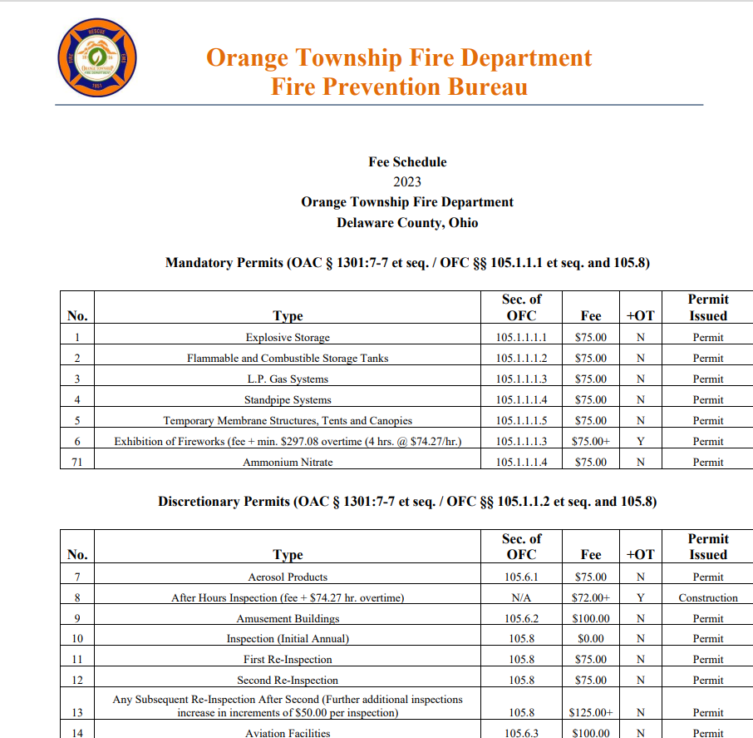

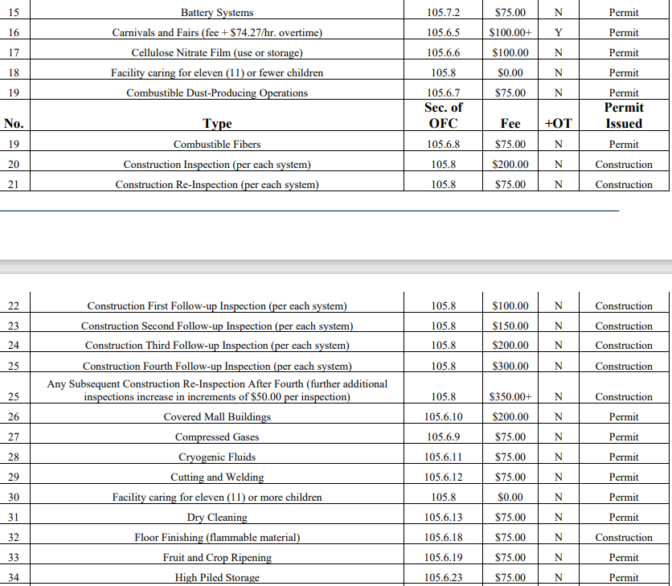

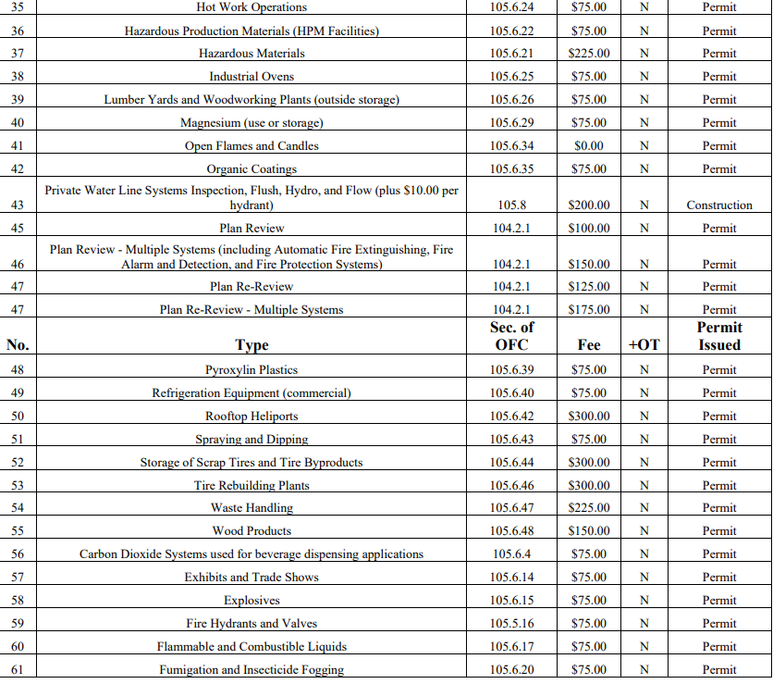

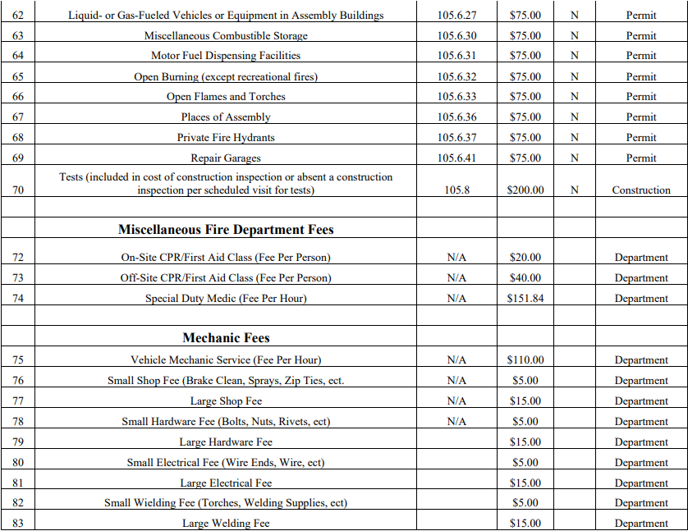

**RES.22-427 ESTABLISH SALARIES AND METHOD OF COMPENSATIONS FOR TRUSTEES AND FISCAL OFFICER**

Mr. Grumbles moved the annual salaries of the Orange Township Trustees and Fiscal Officer be paid equal monthly payments in accordance with ORC Sections 505.24 and 507.09.

Seconded by Ms. Knapp

VOTE: Grumbles – Yes Knapp – Yes Fouss – Yes

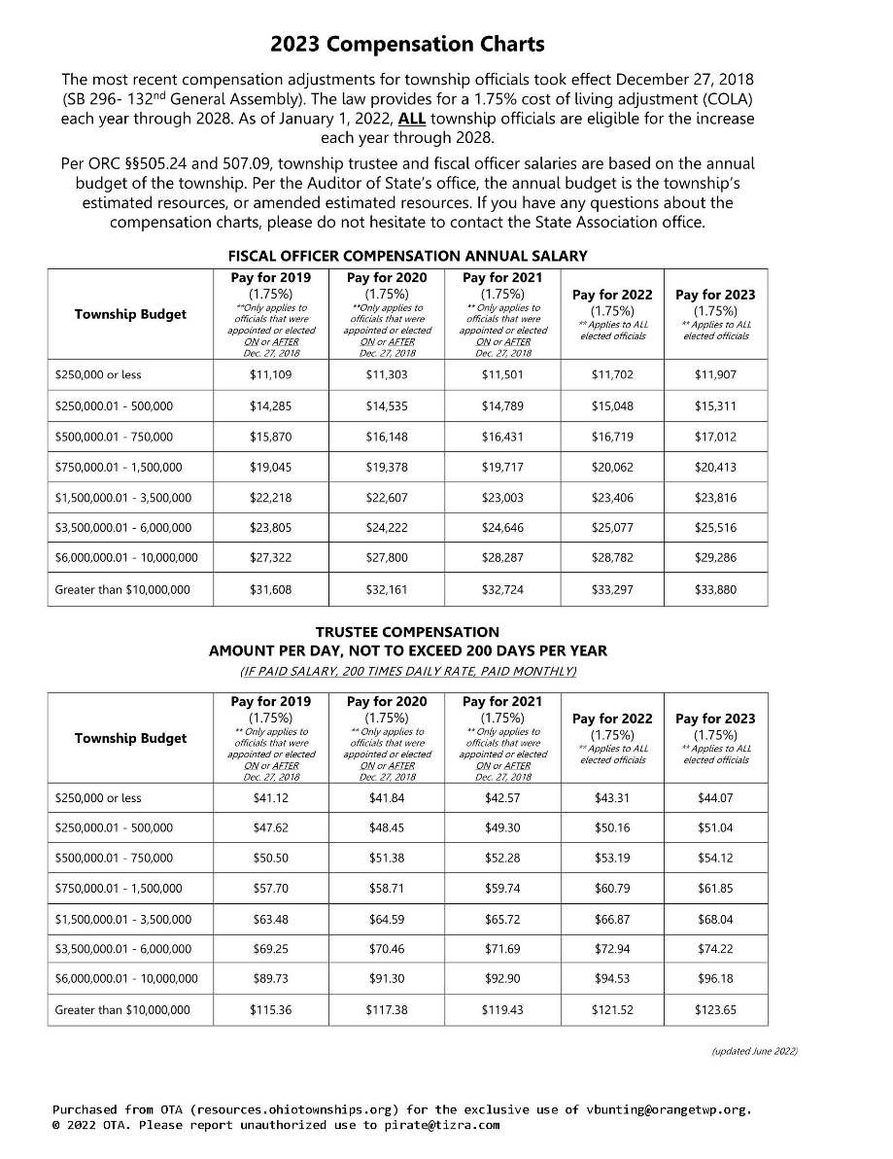

**RES.22-428 APPROVAL OF WAGE RATE INCREASE**

Motion by Mr. Grumbles approve a 4.0 percent (4.0%) wage rate increase effective January 11, 2023 for the listed non-bargaining employees noted in Exhibit “A”

Seconded by Ms. Knapp

VOTE: Grumbles – Yes Knapp – Yes Fouss – Yes

*Exhibit “A”*

|  |
| --- |
| Zoning Assistant – Nancy Fay |
| Director of Development and Zoning – Robin Duffee |
| Senior Zoning Officer – Brett Wiemken |
| Director of Operations – Silas Bowers |
| Project Manager – Alex Rozanski |
| Administrative Assistant to the Director of Operations – Kimberly Mahaney |
| Automotive Mechanic – William Wohrle |
| Public Works Manager - Aaron James |
| Public Works Assistant Manager – David Gilson |
| Parks Maintenance & Facilities Assistant Manager – Gregory Butts |
| Parks Maintenance & Facilities Laborer - Richard Spellman |
| Parks Maintenance & Facilities Laborer - Nicolas Brias |
| Assistant Fiscal Officer – Todd Thobe |
| Fiscal Office Assistant – Lee Anne Neuman |
| Administrative Manager – Valerie Bunting |
| Staff Assistant – Lia Lofreso |
| Fire Support Coordinator – Patricia Lewis |
| Events and Communications Coordinator – Sydney Herbert |
| Fire Chief – Nathan McNeil |
| Senior Human Resources Manager – Mike Kremnitzer |
| Township Administrator – Michele Boni |

All members of the bargaining units shall receive their agreed upon rate increase, if any, for 2023.

**CON.22-12.21.01 THE BOARD GAVE CONSENSUS FOR THE ORANGE TOWNSHIP 2023 PLANNED EVENTS**

**Orange Township 2023 Events**

**Orange Township 2023 Events**

* Business Appreciation Breakfast
  + Early February
* Photo Scavenger Hunt
  + Spring
* Independence Day Parade
* Founders Festival
  + Late September/ October pending on Ohio State football schedule
* Holiday Event
  + First Saturday or Sunday in December
* Holiday Light Fight
* Blood Drive
* Shredding Event
* Opioid Awareness/Drug takeback day
* Touch A Truck
* Fire Department Open House
  + October

**RES.22-429 MEETING ADJOURNMENT**

Motion by Mr. Grumbles to adjourn.

Seconded by M.

VOTE: Grumbles – Yes Knapp – Yes Fouss – Yes

**Notice:**            Copies of documents referred to in this journal can be obtained by contacting the Orange Township Administrator.

_______________________________________

Ben Grumbles

Chair

_______________________________________

Lisa Knapp Vice Chair

_______________________________________

Erica Fouss Trustee

Attest:___________________________

Lisa Kraft, Fiscal Officer