SCS Global Services does hereby certify that an independent audit has been completed and conformity to the applicable standard(s) has been confirmed for: ProAmpac
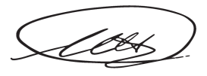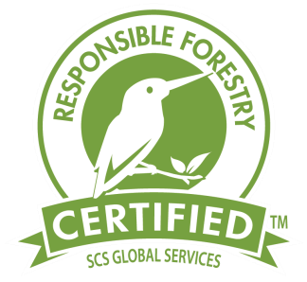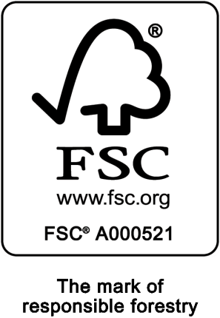

Maggie Schwartz, Vice President, Program Developement

SCS Global Services

2000
Powell Street, Ste. 600, Emeryville, CA 94608 USA

East 55th Place
10405
,
Tulsa
,

74146
,

Oklahoma,

United States

This multisite certificate covers the production of paper bags using the transfer
system.

The facility(s) are hereby Chain
of Custody certified to sell products as
:

FSC 100%, FSC Mix, FSC Recycled

The assessment has been conducted by SCS Global Services in accordance with the protocols of the Forest Stewardship
Council® A.C.
FSC®
)
(
.

FSC Standard: FSC
-
STD
-
40
-
003

V2
-
1
;FSC
-
STD
-
40
-
003
V
2
-
(M);FSC
1
-
STD
-
40
-
004
V
3
-
;FSC
1
-
STD
-
40
-
007
;FSC
-
STD
-
50
-
2
001
V
-
0

Certificate Code

:
SCS
-
COC
-
001706

Trademark License Code
:

FSC
-
C001662

Valid from
:
29/07/2023

Expiry
d
ate
:

28/07/2028

This certificate itself does not constitute evidence that a particular product supplied by the certificate holder is FSC
-
certified (or FSC Controlled Wood where applicable). Products offered, shipped or sold by the
certificat
e holder can only be considered covered by the scope of this certificate when the required FSC claim is clearly stated on sal
es and delivery documents. The scope of this certificate is considered accurate on
the date of issuance. The current validity and s
cope, including the full list of products, shall be verified o
n

http://info.fsc.org
.

he certificate shall remain the property of SCS, and this certificate and all copies or
T
reproductions of this certificate shall be

returned to SCS immediately upon request. Where a certificate covers more than one site, the covered products and processes/
activities are performed by the network of
Participating Sites, and not necessarily by each of them.

Printed: 11/18/2024

Certification Addendum
ProAmpac
This addendum contains the additionally certified locations approved by SCS Global Services to participate in the use of the FSC® Chain of Custody Certification.
Certificate Number: (SCS-COC-001706)

Additional Locations


Addendum

Page

2

Ft. Worth
:

3250
West Seminary Drive Fort Worth, Texas 76133, United States
, (
SCS
-
COC
-
001706
-
H
)

Mobile
:

2050 6
th St. Mobile,

Alabama 36615, United States
, (
SCS
-
COC
-
001706
-
B
)

Portland
:

7400
SW Landmark Lane Portland, Oregon 97224, United States
, (
SCS
-
COC
-
001706
-
F
)

ProAmpac

:
10405
East 55th Pl. Tulsa, Oklahoma 74146, United States
, (
SCS
-
COC
-
001706
-
C
)

ProAmpac

:
Coldenham Rd
30
Walden, New York 12586, United States
, (
SCS
-
COC
-
001706
-
A
)

ProAmpac
:

12025
Tricon Rd. Cincinnati, Ohio 45245, United States
, (
SCS
-
COC
-
001706
-
G
)

Rosenbloom Groupe Inc.
:

1225
rue Hodge Montreal, H4N 2B5, Canada
, (
SCS
-
COC
-
001706
-
E
)

Twisted Paper Products Inc.
:

7100
Cessna Drive Greensboro, North Carolina 27409, United States
, (
SCS
-
COC
-
001706
-
D
)

