Objectives
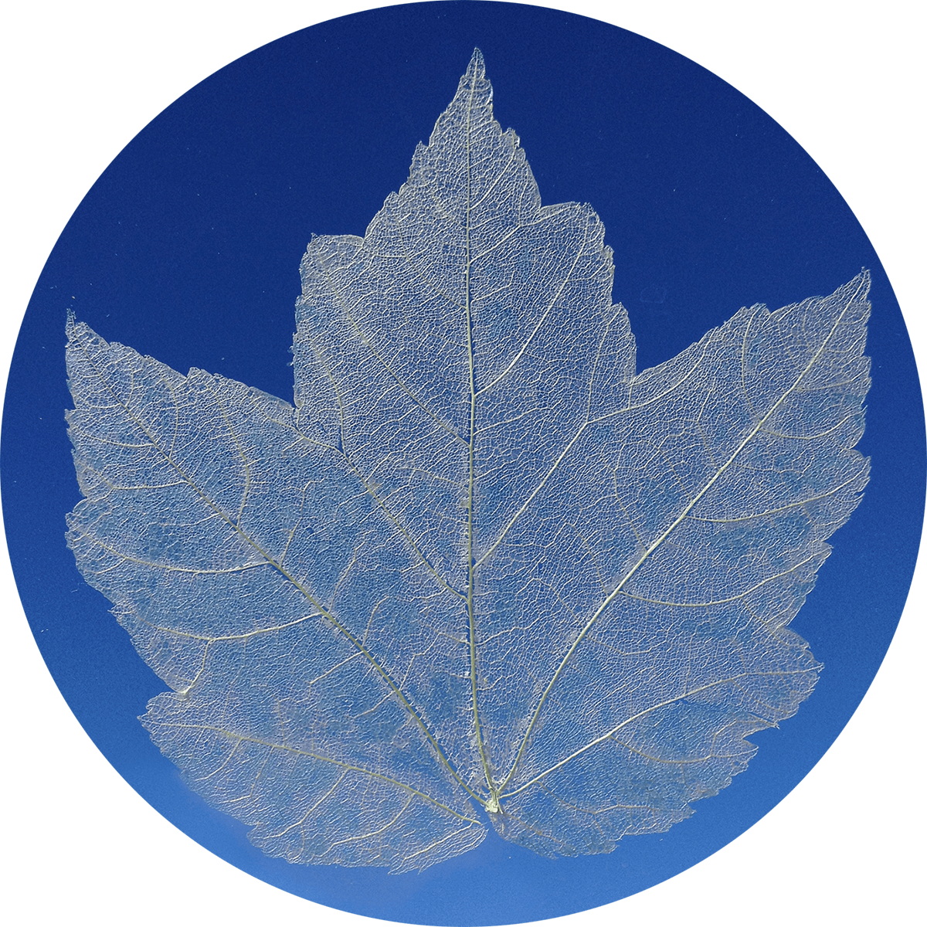
In this lab you’ll be examining the vein structure of a leaf. Your leaf has been pre-treated (by your hard working teacher) in a strong base. The base has dissolved and loosened the lamina of the leaf. You will be using a small brush to clear the remaining lamina from the leaf to expose the veins.
- Leaves – whole or cut into small sections
- Sodium Hydroxide, Washing Soda or another strong base.
- Beaker – 300mL and up depending on the number and size of leaves you’ll be treating.
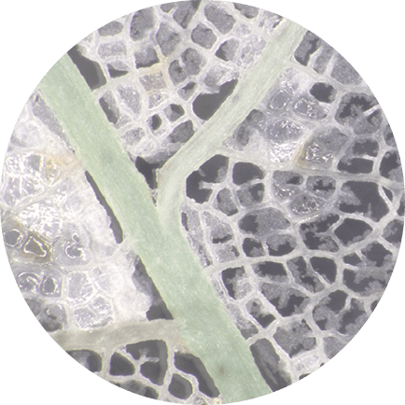
- Hot plate, we prefer a stirring hot plate but it’s not required.

Procedure
- Place your leaf in a shallow dish of water. You may need to gently swish the leaf around to remove any folds or wrinkles. Using your brush to move the leaf around can also help.
- Use a dabbing motion to remove the remaining lamina from the vascular structures. If you wipe at the leaf it will tear! Dab-dab-dab for best results.
- Carefully remove your leaf from the dish and place it on the drying surface provided by your teacher.
- You may need to gently run water over the leaf to get all the wrinkles and folds out. If you try to smooth it without running water it will likely tear.

Questions
- Try to determine the following about your leaf. If you don’t have an entire leaf you’ll need to talk with your fellow students to find some of the information.
  - What kind of margin does your leaf have?
  - What is the vein structure?
  - What vein structure do you think is the most efficient for nutrient transport?

- If you knew the diameter (of the side touching the cuticle) of a single cell in the palisade layer, how would you estimate the total number of cells that were in the palisade layer of your leaf?

