Introduction:
During photosynthesis, plants convert light energy into usable chemical energy. The process of photosynthesis involves two reaction systems: light dependent (light) and light independent (dark) reactions. In light reactions, light energy is captured and converted into high energy molecules. In dark reactions, the high energy products from the light reactions are used to fix CO₂ into carbohydrates, such as glucose.
In today’s lab, you will replace the air inside the spongy mesophyll of leaf disks with sodium bicarbonate solution, causing the disks to sink. You will then expose the leaf disks to light and record observations as photosynthesis takes place.
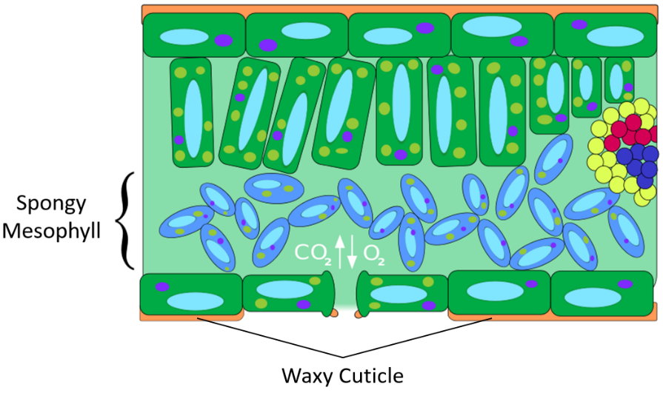
Objective:
To observe the effect of environmental variables on
photosynthesis.
Materials:
- Hole punch
- Spinach leaves
- 1 large beaker
- 300 mL water
- 1.5 g baking soda (sodium bicarbonate)
- Plastic spoon
- Eyedropper
- Liquid dish soap
- 20-65 mL plastic syringe, without needle
- 2 small beakers
- Timer
- Light source
- Paper towels

Procedure:
- Using the hole punch, cut 20 leaf disks from the spinach leaves.
- Make the sodium bicarbonate solution by adding 300 mL of water to the large beaker and 1.5 g of baking soda to the water.
- Using the plastic spoon, stir the solution until the baking soda is totally dissolved.
- Using the eyedropper, add about 2 drops of liquid dish soap to the solution and carefully stir. There should be no bubbles.
- Remove the plunger from the syringe. Place the leaf disks into the syringe. As you reinsert the plunger, avoid damaging the leaf disks by making sure they are near the tip of the syringe.
- Insert the tip of the syringe into the sodium bicarbonate solution and draw 15-20 mL into the syringe. The leaf disks should be floating.
- Seal the syringe by holding it tip-side-up, tightly placing the thumb of your left hand over the tip, and pulling back on the plunger with your right hand to create a partial vacuum. If you have a good seal, it should be hard to pull on the plunger and bubbles should form around the edge of the leaf disks. Hold for ten seconds and release your index finger and the plunger simultaneously. Some of the leaf disks should begin shrinking. Tap the side of the syringe or shake gently to pop any bubbles on the disks.
- Repeat steps 6 and 7 until all the disks sink. Do not repeat these steps more than necessary. It will be complete once the leaf disks have sunk to the bottom.
- Remove the plunger from the syringe and pour equal parts of the solution into the 2 small beakers. There should be 10 disks per beaker. Make sure the disks sink to the bottom of the beakers.
- Cover one of the beakers in order to block light from reaching the disks. Place the second beaker approximately 6-8 inches below a light source. Begin timing the experiment as soon as the light is turned on. Record your observations in the data table.
- Periodically tap the side of the beakers to make sure the leaf disks are not sticking to the beakers. When checking the covered beaker, remove and replace the cover quickly so that the leaf disks are not exposed to light.

Data Table
Time (Minutes) | Number of Disks Floating (Light) | Number of Disks Floating (Dark)
0
1
2
3
4
5
6
7
8
9
10
11
12
13
14
15

Analysis:
- Why was sodium bicarbonate added to the solution?

- Why was dish soap added to the solution?
- What was the purpose of steps 6-8?
- Which beaker had the most leaf disks rise during the experiment? Why?
- How does light intensity affect the rate of photosynthesis?

