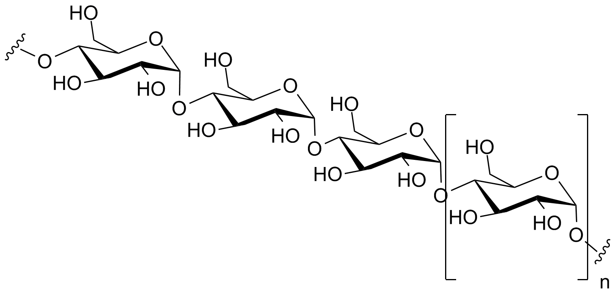
- Carbohydrates are polymers composed of
sugar monomers.
- Disaccharides contain 2 monosaccharides joined by
condensation.
- Which type of carbohydrate is made up of glucose chains? Polysaccharides

- Simple sugars like glucose are called monosaccharides.

- Carbohydrates are used for short-term energy storage, and fats are used for long-term energy storage.
- Fatty acids are the monomers of what group of macromolecules? Lipids
- Fat molecules (triglycerides) are composed of:
(1) Glycerol backbone
(2) Fatty acid tails

- Saturated fatty acid tails are straight and unsaturated fatty acid tails are bent.
- Steroids are composed of 4 fused carbon rings.
- Waxes are composed of fatty acids linked to long-chain alcohols.

