SAMPLE OPS NETWORK AGENCY POLICY

PROCEDURE:
I. National Law Enforcement and Community Policing Integrated Network (aka: OPS Network™)
A. OPS Network™
1. The OPS Network™ Application is focused solely on creating a gateway and partnership between law enforcement agencies and the communities they serve, while ensuring technological growth, agency efficiency and cuttingedge operational connectivity.
2. A cloud-based network application and software solution, the OPS Network™ provides proprietary interactive community policing tools designed specifically to promote police to public partnership in public safety, while improving agency efficiency and services.
3. The OPS Network™ is a Partnership Project and has been developed and designed for law enforcement by law enforcement. Each partner agency helps the next by supporting the network by collectively helping to improve its services and expand on its ability. All partner agencies play a critical role in ensuring the growth of the network for all law enforcement agencies and their communities, long into the future.
4. Agency members are only granted access to the network by an official law enforcement agency and by that virtue; the agency has the right to dictate the way in which they want agency membership to utilize the application. Members of different functional areas of the agency may be granted different levels of functionality within the platform.
5. The OPS Agency Administrator, or his/her designee, is responsible to remove any agency member when they sever service with the agency for any reason (transfer, retires, terminated, etc...) Utilizing the OPS Network™ Staff Management System, the OPS Agency Administrator shall ensure that any member who severs service will have his/her agency access to the OPS Network™ suspend immediately.
6. This agency adopts the OPS Acceptable Use Policy (attachment A) as an addendum to this Standard Operating Procedure.
B. Mandatory Usage
1. It shall be the duty of every sworn member/employee assigned access to the OPS Network™ to access the system at the beginning or their tour of duty, where practical, and monitor the system throughout their tour. The platform may be used for the dissemination of notifications by both agency administrators and other network users. Therefore, monitoring the network is required for timely access to information.
2. OPS users may utilize the network for communication with other agency members or users from other agencies. This can be done by either participation in a specific group or by use of the messenger feature. These features can be controlled by the user by accessing their individual account settings and adjusting their notification preferences.
3. OPS users shall create and maintain an accurate professional biography on the network. This is to include, at a minimum:
a. Name
b. Rank
c. Professional Address
d. Professional Telephone Number
e. Professional Photograph of the User or Agency Logo Image
f. Email Address
g. Brief Professional Biography Narrative
h. Any Special Interests (areas of expertise)
4. OPS users may utilize features such as Tips, Alerts, and Flyers as permitted by their user privilege level.
5. The OPS Network™ shall serve as the centralized access point and “desktop” operating system for all sworn users.
6. Members can access the OPS Network™ from any computer, laptop or smartphone when working remotely.
7. By accessing the OPS Agency Command Center, users can read and respond to agency-wide announcements, quickly access critical systems (RMS, Evidence, etc), agency documents and policies, as well as a myriad of other functions. (see sample screenshot)
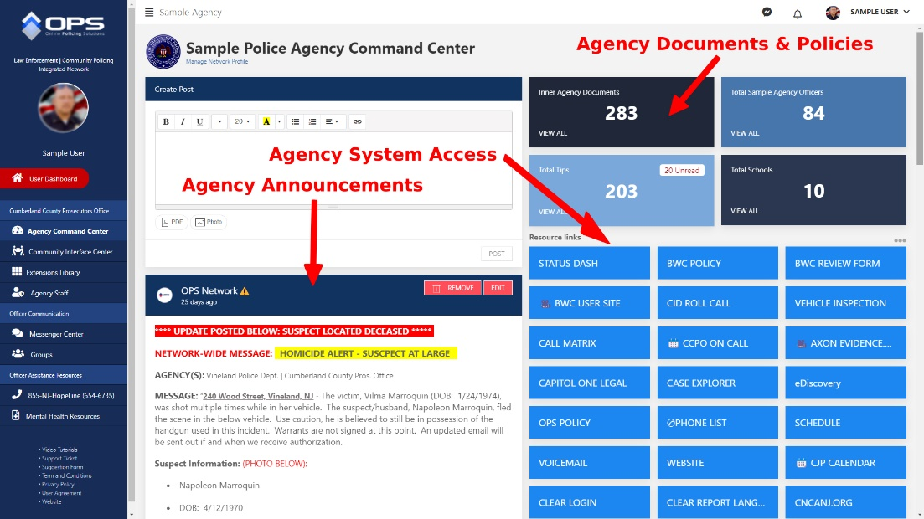

C. Prohibited Usage
1. The OPS Network™ is not a “social media” platform. It is a secure law enforcement network and shall be used for official use/purposed only. No attempts shall be made to disrupt the operation of the OPS Network™.
2. The posting of personal ideologies has no place on the OPS Network™. Offensive comments may result in suspension from the platform and/or discipline by the agency.
3. Use of the OPS Network™ for harming or attempting to exploit or harm any person in any way by exposing them to inappropriate content, asking for personally identifiable information, or in any way not intended by the network is prohibited.
4. Use of the OPS Network™ in any way that violates any applicable federal, state, local or international law or regulation is prohibited. Additionally, the use of the OPS Network™ is also governed by all the Agency Standard Operating Procedures, as well as the Agency’s Rules and Regulations with regard to conduct.
5. The OPS Network™ includes several tools used for communication and the sharing of information. While “social” connection and communication is encouraged, the OPS Network™ is not a “social network” and should not be mistaken for one. By setting up a user profile and participating on the OPS platform each member agrees, understands and acknowledges that all communication and activity that takes place on the OPS platform is subject to agency review for a legitimate investigative purpose which shall include ensuring adherence to any and all agency policies and regulations.
D. Operational Security
1. Users of the OPS Network™ are reminded that operational security is to be maintained at all times while communicating on the platform. This includes not sharing case sensitive information or intelligence outside the sphere of personnel who would need to know it.
2. All users should be aware that items are never completely deleted from the OPS Network™. While they may be removed from view for users, they are stored indefinitely on the network and may be retrieved by an engineer upon receipt of proper legal demand or other bona fide request consistent with the OPS Network™ Basic Acceptable Use Policy.

