

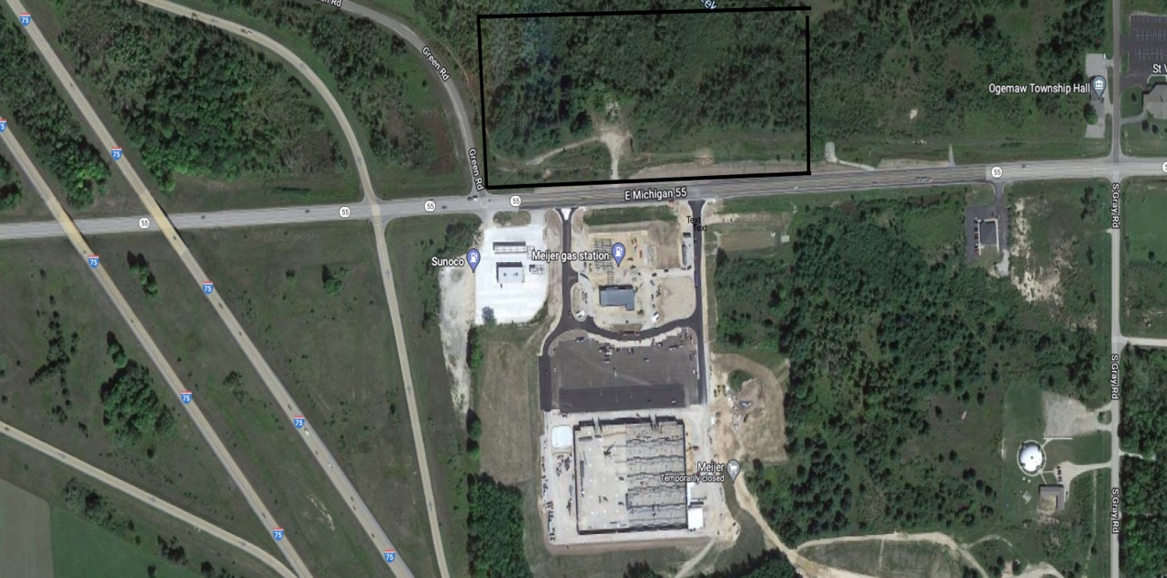

20 Acres Vacant
1200+ Frontage M-55
For More Information Mason Group LLC
Lonny Gregory 11394 N Linden RD
810-618-2939 Suite L
Lonny@masongroupllc.com Clio, MI 48420

Sewer-Water-Electrical-Natural Gas
Easy Access to I-75
Located Across from New Meijer Store

We obtained the information above from sources we believe to be reliable. However, we have not verified its accuracy and make no guarantee, warranty or representation about it. It is submitted subject to the possibility of errors, omissions, change of price, rental, or other conditions, prior sale, lease or financing, or withdrawal without notice. We include projections, opinions, assumptions or estimates for example only, and they may not represent current or future performance of the property. You and your tax and legal advisors should conduct your own investigation of the property and transaction.

