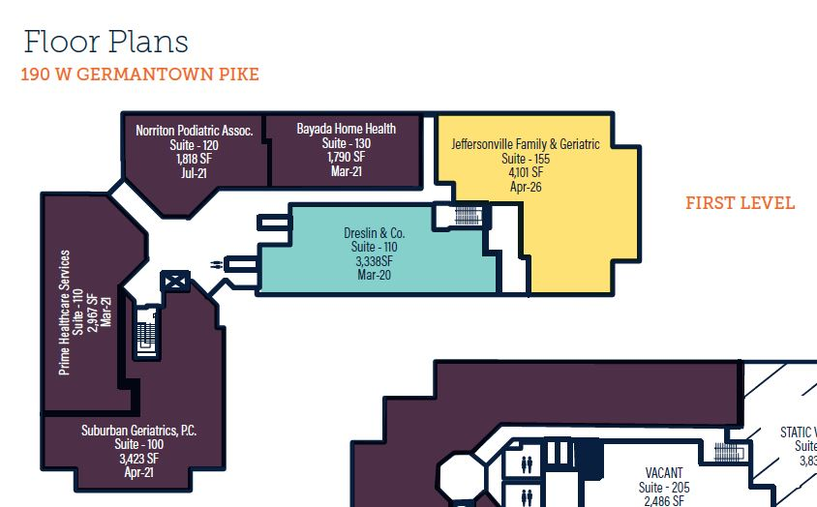
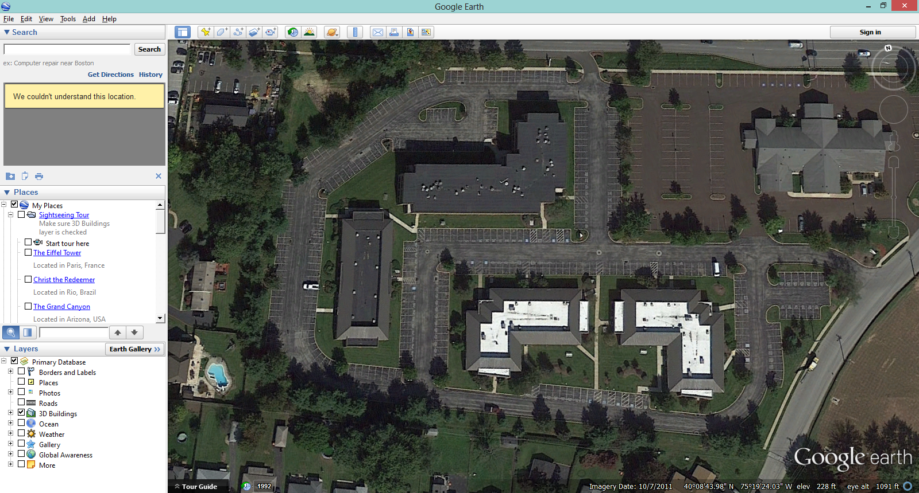

190 W. Germantown Pike
1,790 SF
2,486 SF
3,338 SF
Norriton Medical Campus
190 W. Germantown Pike • Norristown, PA 19401

