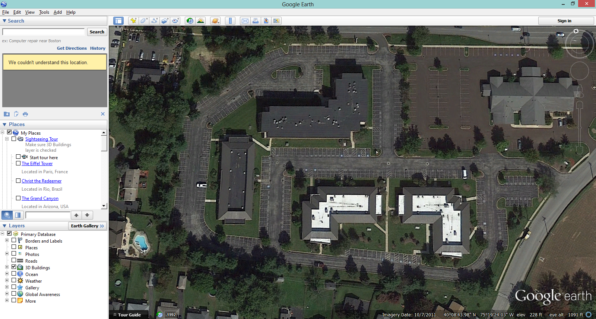
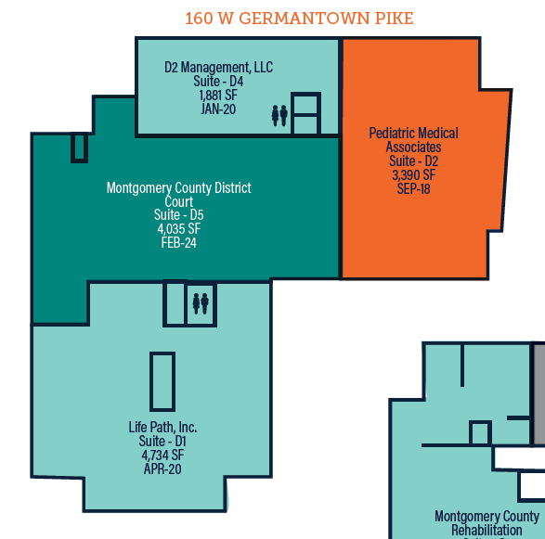

160 W. Germantown Pike
1,881 SF
Norriton Medical Campus
160 W. Germantown Pike • Norristown, PA 19401

