503 North Main Street, Borger, TX 79007 – Mixed Use – 11,800 square feet 
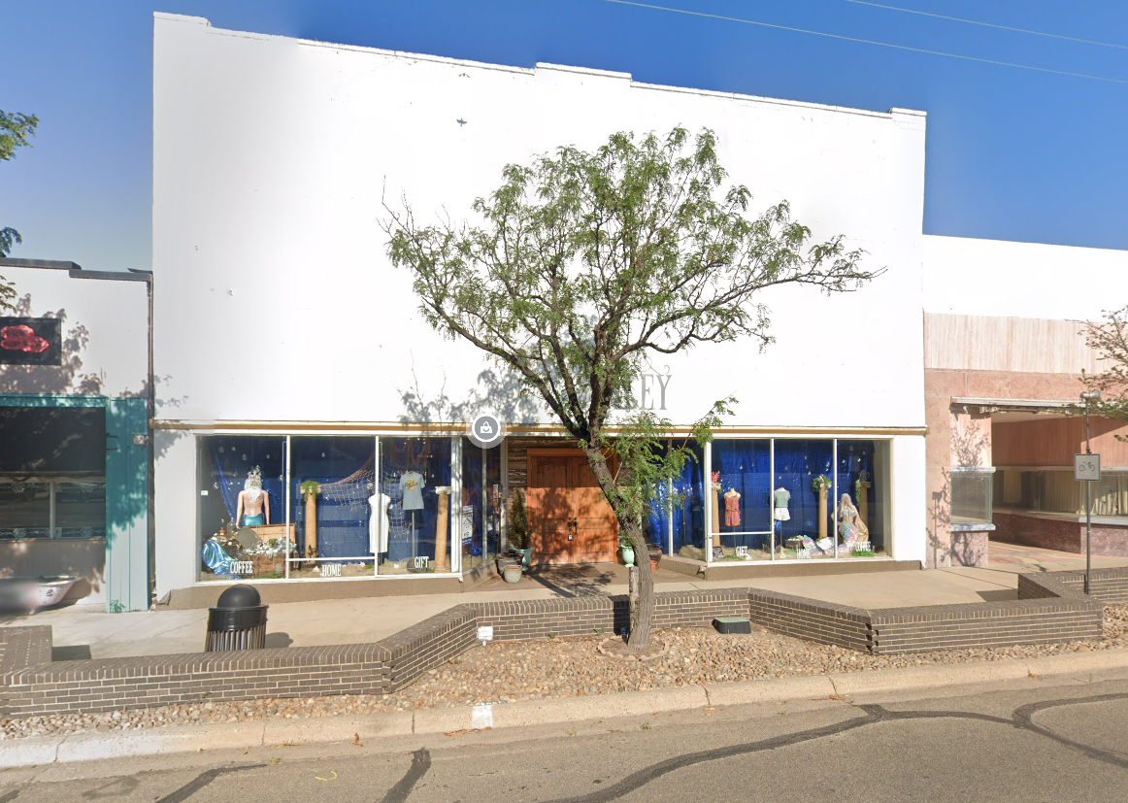
Auction Opportunity: Historic Retail Building in Downtown Borger, TX
503 N Main St, Borger, TX
Don't miss this rare opportunity to own a piece of history in the heart of downtown Borger, Texas! This historically designated retail building offers incredible potential for both investors and owner-occupiers alike.
Property Overview:
- Address: 503 N Main St, Borger, TX
- Building Size: 11,800 sq. ft.
- Lot Size: 0.14 acres
- Year Built: 1926
- Original Use: Bailey Clothing Store
- Previous Use: Fully-equipped Coffee House
This stunning, multi-use building was originally the Bailey Clothing Store, a cornerstone of the downtown Borger retail scene since 1926. With its historical charm and central location, this property presents a wealth of possibilities for a variety of commercial ventures, from retail to office space or a café. It’s the ideal opportunity for a visionary investor or an owner-occupier looking to capitalize on a prime, walkable location with deep roots in the community.
Property Highlights:
- Historical Designation: Located in the heart of downtown Borger, the property’s status as a historically designated building adds character and offers potential for tax incentives or preservation grants.
- Interior Features: The building boasts beautiful hardwood floors throughout, a spacious open floor plan, and abundant natural light, providing a versatile layout for any type of business.
- Climate-Controlled Basement: The property includes a fully climate-controlled basement, perfect for storage or additional rental space. This unique feature offers the potential for extra income, making it an even more attractive investment opportunity.
- Electric Escalator: The basement is accessed by the first electric escalator ever installed in Texas, offering a unique historical touch and an eye-catching feature that can serve as a talking point for future tenants or customers.
Investment Potential:
- This vacant property presents an excellent opportunity for either an owner-occupier seeking to establish their business in a historic building or an investor looking to add a high-potential property to their portfolio.
- With a prime location and flexible space, the building can be adapted for a variety of uses, from retail and dining to office space or creative ventures.
- The basement’s climate-controlled space offers an additional revenue stream through rental opportunities, increasing the property’s potential return on investment.
- Located in the bustling downtown area, the property enjoys high visibility and foot traffic, enhancing its appeal for commercial tenants and businesses.
Property Taxes:
2024 Total Taxes = $2,688.53 | 2024 Assessed Value = $95,280

