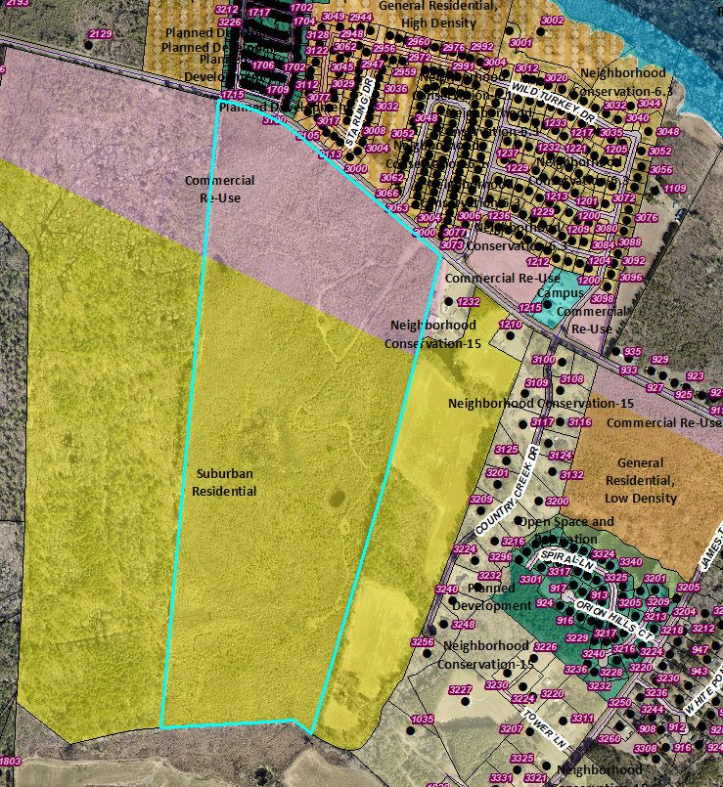 Tax Map Number 00126-01-002

Table 1-2.2.1A Florence Zoning Districts Dstricts
Abbreviation |  | District Name | Principal Function |  | Character |  | Description
Residential Zoning Districts
RE | Estate Residential |  | Single-Family Residential | Estate |  | The RE district is intended to provide for single-family development with an estate character.
RS | Suburban Residential |  | Single-Family Residential | Suburban |  | The RS district is intended to provide for single-family development with a suburban character.
RG | General Residential |  | Variety of Residential Housing and Neighborhood Types | Auto-Urban |  | The RG district is intended to provide for a variety of residential housing and neighborhood types with an auto-urban or new-urban character.
RU | Urban Residential |  | Variety of Residential Housing and Neighborhood Types | Urban |  | The RU district is intended to provide for a variety of residential housing and neighborhood types with an urban character. This district is more intensely developed than the RG district.
NC | Neighborhood Conservation |  | Protect Character and Function of Established Neighborhoods | Varies by Subdistrict |  | The NC district is intended to protect the character and function of established neighborhoods in the manner described in Subsection B. below.
Business and Commercial Zoning Districts
CR | Commercial Re-use |  | Low-impact, small- scale commercial uses | Suburban |  | The CR district is intended to provide for low-impact commercial uses that are small-scale and thus, may be appropriate in certain residential settings, as well as adaptive re-use of residential buildings for limited commercial uses along major corridors.
CA | Campus |  | Corporate business, light industry, education, medical, and research uses | Suburban |  | The CA district is intended for suburban campus settings for general, professional, and medical offices; educational and institutional facilities; hospitals; research and development; and light industries.
CG | Commercial General |  | Commercial, office, retail, institutional, and service uses | Auto-Urban |  | The CG district is intended for a broad range of retail, restaurant, entertainment, office, institutional, and service uses.

