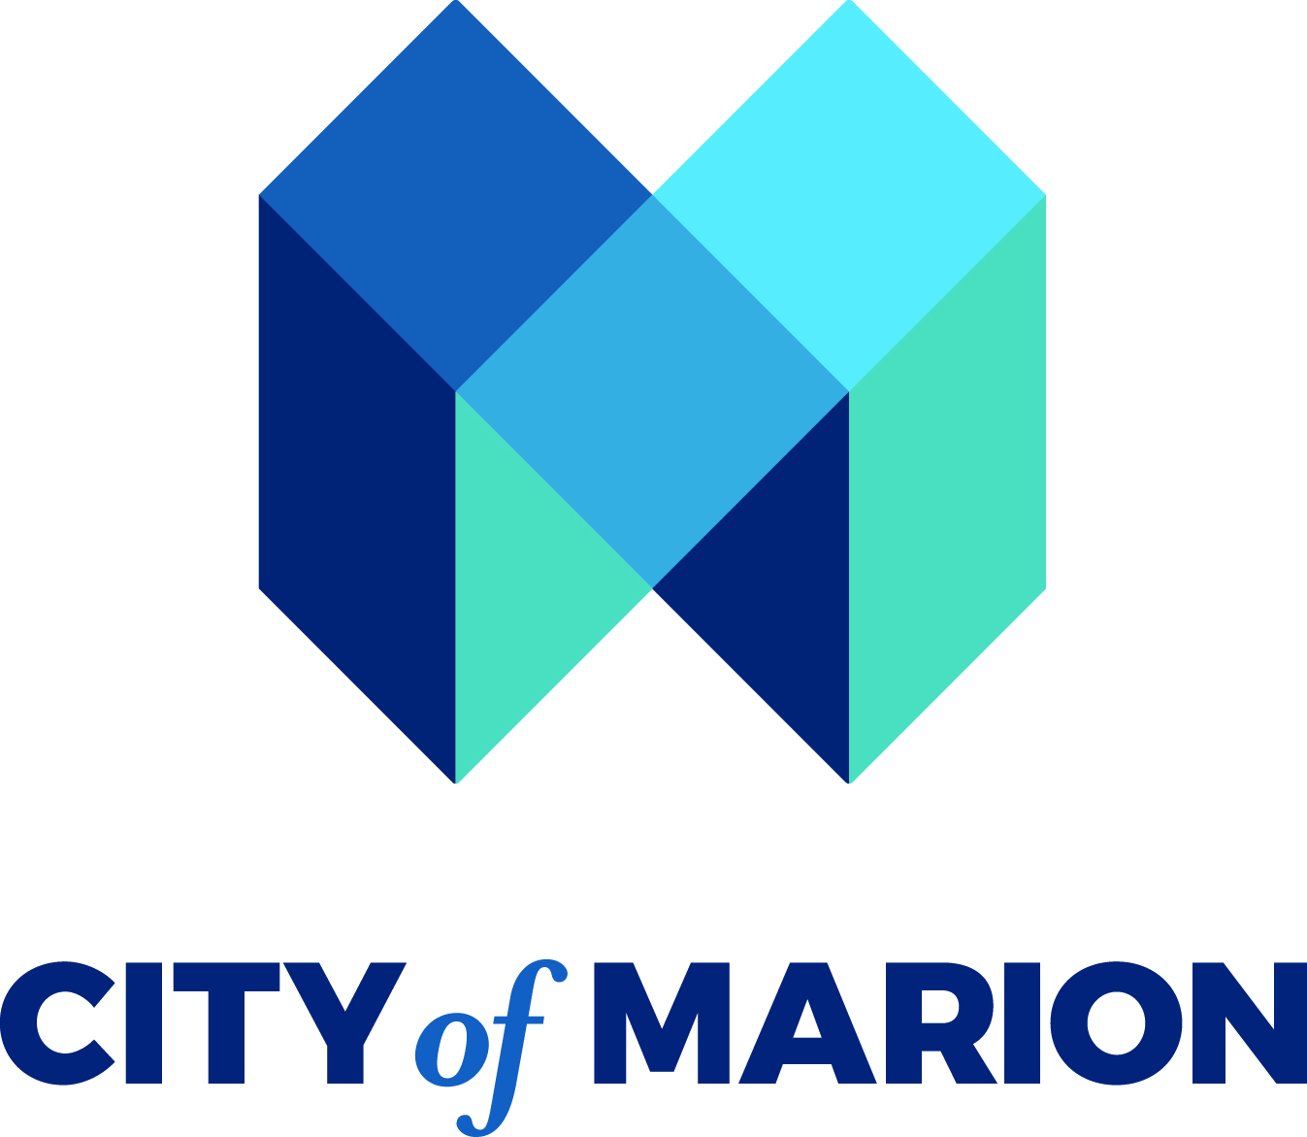
FOR IMMEDIATE RELEASE
City of Marion Awards $75,000 in Opioid Settlement Funds to Expand Access to Recovery, Treatment, and Community Support
MARION, Ind. — The City of Marion is pleased to announce the award of $75,000 in Opioid Settlement Access Grants to five local organizations working to address substance use, recovery, behavioral health, and related needs throughout Marion and Grant County.
The Access Grant initiative is funded through the City of Marion’s opioid settlement funds and is designed to strengthen local services, reduce barriers to care, and connect individuals and families impacted by the opioid crisis with critical community resources.
The City has awarded funding to the following organizations:
- Family Recovery Court — $15,000 to support services for families impacted by substance use and involved with the court system.
- Grant County Rescue Mission — $15,000 to expand access to supportive services for individuals experiencing homelessness, substance use, and other barriers to stability.
- Radiant Health — $5,000 to support behavioral health and substance use services and improve access to care.
- BIGJAWS Youth for Christ — $15,000 to support prevention, intervention, and supportive programming for local youth.
- Bridges to Health — $25,000 to support community-based services and provide contracted community trainings aimed at increasing knowledge, prevention, and response related to substance use and behavioral health needs.
“These investments allow us to put opioid settlement dollars directly into programs that are serving people in our community,” said Mayor Ronald Morrell Jr. “Addressing the impact of the opioid crisis requires a comprehensive approach from prevention and education to treatment, recovery, and support for families. These organizations are important partners in that work.”
The Access Grants are part of the City of Marion’s broader strategy for utilizing opioid settlement funds to address the ongoing effects of the opioid epidemic. By investing in established community organizations, the City seeks to expand access to services while supporting coordinated, locally driven solutions.
Funded organizations will be responsible for using the awards for approved opioid remediation activities and providing required documentation and reporting to the City.

Media Contact:
Dr. Jayda Monteiro
City of Marion
Opioid Settlement Coordinator
jmonteiro@cityofmarion.in.gov

