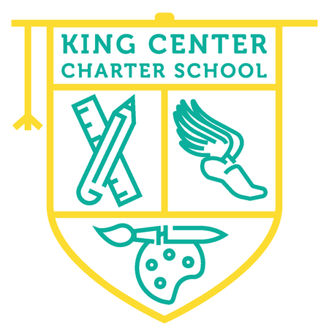
King Center Charter School
2nd Grade Supply List

1 package of #2 pencils
2 pink erasers
1 package of crayons (24 count)
1 package of washable markers (8 count – primary colors)
2 glue sticks
1 pair of kid safe scissors (pointed tip)
4 Expo dry erase markers
2 highlighters
1 Pencil box/pouch (no bigger than 9x13)
2 boxes of tissues
3 notebooks of your choice (wide ruled)
3 packs of disinfectant wipes
2 bottles of hand sanitizer
mask (disposable or cloth)

*If you have any questions or concerns, please feel free to reach out to any of us and we will be glad to help you!
Amanda Dixon – adixon@kccs.org
Fawn Barlow – fbarlow@kccs.org
Mary Pat Moley – mmoley@kccs.org

