King Center Charter School
Distance Learning Plan- Revised
Spring 2020

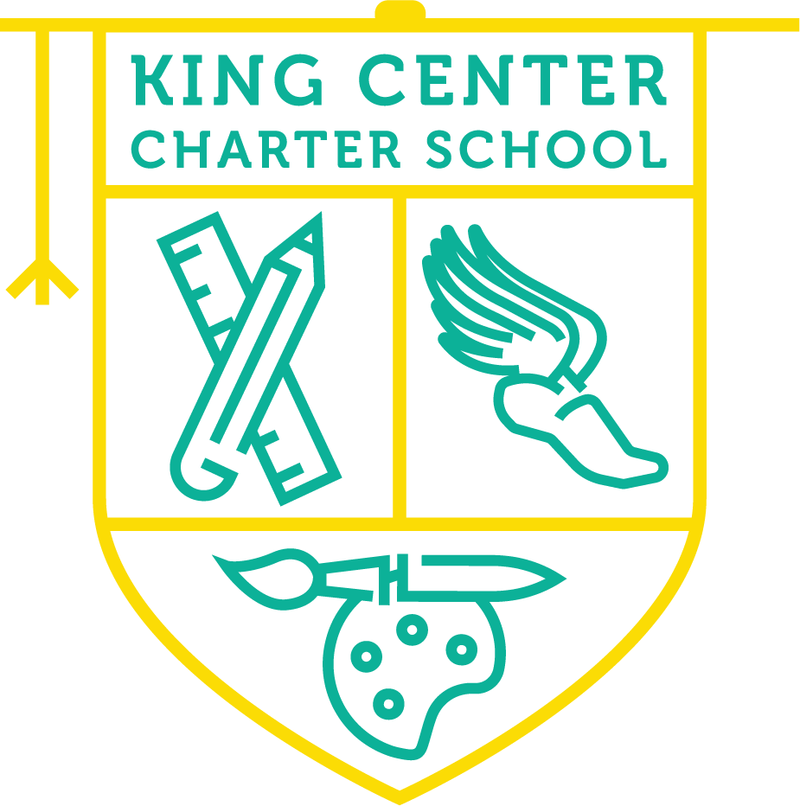

TABLE OF CONTENTS
- OVERVIEW
- PARENT NOTICE
- TECHNOLOGY
- INSTRUCTIONAL PLAN
- APPROVED TECHNOLOGY PLATFORMS
- SPECIAL EDUCATION SERVICES
- INTERVENTION
- SCHOOL COUNSELORS
- NURSE
- COMMUNICATION
- GUIDELINES FOR STUDENTS AND PARENTS
- STAFF AVAILABILITY
ADMINISTRATIVE SECTION
- LEAD TEACHER RESPONSIBILITIES
- SUPPORT STAFF AND BUILDING SUBSTITUTES
- CURRICULUM PRIORITIES
- ASSESSMENT PRIORITIES
- STAFF MEETINGS
- PROFESSIONAL DEVELOPMENT
- STAFF ACCOUNTABILITY/ EVALUATION
- COMMUNICATION TEAM
- DATA COLLECTION
- LEADERSHIP TEAM
- BOARD GOVERNANCE

OVERVIEW
The King Center Charter School has developed this Distance Learning Plan in response to an extended school closure during a Public Health Emergency during the 19-20 school year. This plan is designed to provide quality educational opportunities for our students while the school building is closed. This plan is effective April 27, 2020 until further notice.

PARENT NOTICE:
Parents are our key partners in the effective education of students. This plan will only work with the support of our King Center parents. We need you to support students in showing up for live teaching sessions, completing assignments and submitting assignments. We understand this is a challenging time for all of us, however we are committed to offering quality educational opportunities for King Center students. Assignments will be posted at the beginning of the week and are due at the end of the week. This allows flexibility for students and parents to complete assignments at their own pace. However, attendance at LIVE sessions are strongly recommended for teachers to support the students learning.

TECHNOLOGY
All students in grades K-8 who are in need of a device will be provided with a Chromebook in order to access the distance learning platforms. All education will take place in GOOGLE CLASSROOM. LIVE TEACHING SESSIONS will take place on GOOGLE MEET. An information letter and tech support videos will be provided at Tech Distribution to support families in navigating these platforms. Effective April 26, 2020 Facebook will be for social interaction only. All education will take place on the GOOGLE platform. Zoom services will be discontinued as well.
Parents are asked to sign the Technology Agreement and return Chromebooks to school as requested in the agreement. For additional information in this agreement, please contact our Tech Team- www.kccs.org/tech

INSTRUCTION PLAN
- Weekly lessons will post to Goggle Classroom for all grade levels (some modifications may be made for Kindergarten. All modifications will be communicated by the Kindergarten Instructional Team) Each lesson will post with a due date for submission.
- K-6 Students will receive LIVE INSTRUCTION twice each week for both Math and English Language Arts. Teachers will communicate the exact schedule for live sessions for each grade level.
- K-2 students will also have LIVE INSTRUCTION for SKILLS lessons. These lessons are vital to the curriculum for students in grades K-2. Teachers will communicate the exact schedule for live sessions for each grade level.
- 7-8 Students will receive LIVE INSTRUCTION twice each week for all core classes: Math, ELA, Social Studies, and Science. Teachers will communicate the exact schedule for live sessions.
- All LIVE INSTRUCTION sessions will be recorded and posted in Google Classroom for students to review as often as needed.
- Pre-recorded lessons and Independent Study assignments will post on days without live instruction sessions.
- All students will receive Special Area classes (Art, Music, Library, Technology, Physical Education, Latin [7-8 only]) each week. A pre-recorded lesson and assignment will post each week for every grade level.
- Teachers and Support Staff will track student attendance, participation, and work submission. Staff will reach out to support students who may be struggling or non-participatory. Compassion and understanding will always be considered in family communication.
- Grading- we will follow the guidance from NYS as it relates to grading work and preparing final decisions for grade promotion and graduation. Please note, attendance, participation, and work submission are under consideration in making these decisions. Technology gaps and personal circumstances will also be considered on a case-by case basis dependent upon detailed communication between our Leadership Team and families. More information will be shared as guidance from NYS is released.
- Students without access to Wi-Fi will receive home instruction packets and arrange submission procedures with grade level teams. KCCS will work to assist all families with WIFI access as it becomes available.

APPROVED TECHNOLOGY PLATFORMS
During this time, it can be very challenging for parents and students to navigate unfamiliar technology platforms. We would like to make this time at home as smooth as possible for our students and families. Therefore, we are limiting the use of technology sites that we are recommending for student use to the following pre-approved list only:

Google Classroom (All Grades)
Google Meet (All Grades)
Reading Eggs (K-2)
Math Seeds (K-2)
Castle Learning (7-8 Math)
Moby Max (3-8 Math and ELA)
Amplify (7-8 Science)
Khan Academy (6-8)
Epic (All Grades)
In most cases, these platforms are familiar to students. By focusing on these familiar platforms, students will have a more seamless distance learning experience.

Exceptional Education and ENL Departments

According to NYSED “School districts must ensure that, to the greatest extent possible, each student with a disability can be provided the special education and related services identified in the student’s individualized education program (IEP). However, FAPE may be provided consistent with the need to protect the health and safety of students with disabilities and those individuals providing special education and related services to students. During this emergency, schools may not be able to provide all services in the same manner they are typically provided” (Provision of Services to Students with Disabilities During Statewide School Closures Due to Novel Coronavirus (COVID-19) Outbreak in New York State).

In addition, the USDE encouraged schools and parents to collaborate creatively to continue to meet the needs of students with disabilities and consider practices such as distance instruction, teletherapy and tele-intervention, meetings held on digital platforms, secure online options for data tracking, and documentation. Additionally, that guidance indicated the provision of FAPE (Free Appropriate Public Education) may include, as appropriate, special education and related services provided through distance instruction provided virtually, online, or telephonically” (Supplemental Fact Sheet Addressing the Risk of COVID-19 in Preschool, Elementary and Secondary Schools While Serving Children with Disabilities).

In accordance with the school closing and guidelines from NYSED, the King Center Charter School Exceptional Education Department has adopted the following program plan in order to continue providing a FAPE for our students with IEPs:

Consultant Teacher/Resource Room/ENL services: These inclusion services will be continued by Exceptional Education and ENL Teachers alongside the classroom teacher’s Google Classroom lives and posts. Exceptional Education/ENL Teachers will post resources, modifications and accommodations weekly on grade level pages. These posts will be specially designed and differentiated in order to address the individual academic and study skill IEP goals for the students in that grade. In addition, Exceptional Education/ENL Teachers will directly contact families via phone call, text and email in order to provide individual assistance to our families and students. Teachers will document this contact using the provided “parent communication log”. A photo of this log will be sent to the Coordinator of Exceptional Education on a weekly basis. Teachers will schedule and host weekly open resource room hours using Google Meet for students and/or parents to attend when extra assistance is needed. Additional hours will be available on parent request. In the event that an ENL or EXED teacher is unable to carry out services, a building sub will continue to carry out services.

“Where technology itself imposes a barrier to access or where educational materials simply are not available in an accessible format, educators may still meet their legal obligations by providing children with disabilities equally effective alternate access to the curriculum or services provided to other students” (Provision of Services to Students with Disabilities During Statewide School Closures Due to Novel Coronavirus (COVID-19) Outbreak in New York State).

Physical Therapy and Occupational Therapy: These therapies will continue via our contract with Buffalo Hearing and Speech with some modification. Therapy will be provided by via private YouTube links in order to improve accessibility for parents. Individual videos will be recorded in accordance with the child’s physical IEP goals. Therapists will also be providing services via phone conferences in order to meet therapy mandates by consulting with families. Digital logs will be kept by therapists which will include progress monitoring data. All documentation will be filed with BHSC, copies provided upon request. In the event that the current therapists are unable to carry out services, services will be continued through BHSC using an alternative therapist.

Speech Language Therapy: Speech Language Therapy will continue with some modification as well. The Speech Therapist will work alongside the classroom teachers as well, providing differentiated IEP specific therapy activities and resources on grade level Google classroom pages. In addition, the therapist will be in contact with families on a regular basis offering assistance and providing resources via phone, email and text. These efforts will also be documented and submitted on a weekly basis to the Coordinator of Exceptional Education Services via the parent communication log. In the event that the SLP is unable to carry out services, services will be continued through BHSC.

Counseling: Mandated IEP counseling will continue with some modification. Counselors will post resources and therapy activities alongside the classroom teachers in grade level Google Classroom pages. The information posted will be specific to the Social Emotional IEP goals of the students in that grade level. Counselors will also reach out to individual families in order to provide options for continuation of counseling services. Parents will be provided with a choice to continue with consultant counseling, phone conferencing or video conferencing using Zoom which is FERPA and HIPPA compliant. Weekly sessions will be documented using the parent communication log which will be submitted weekly to the Coordinator of Exceptional Education Services. In the event that one school counselor is unable to provide services the other school counselor will do so.

CSE Meetings: All CSE meetings will continue to be scheduled and carried out in conjunction with Buffalo Public Schools. Meetings will be held via phone conference. All information will be directly communicated with parents. All documentation and paperwork will be completed by the Exceptional Education Teacher and submitted to the Coordinator of Exceptional Education.

“As indicated above, Committees would not be required to meet in person while schools are closed. When conducting Committee meetings, the parent of a student with a disability and a school district may agree to use alternative means of meeting participation requirements, such as video conferences and conference calls” (Provision of Services to Students with Disabilities During Statewide School Closures Due to Novel Coronavirus (COVID-19) Outbreak in New York State).

Amendments: Although an amendment meeting (With parent and teacher attendance) would normally be required at this time to adjust the program plan on the IEP, an exception has been made due to the global pandemic. The above-mentioned changes can be made without amending IEPs.

“During the time period the school district is closed pursuant to NYS Governor Executive Order, school districts are not required to amend students’ IEPs if continuing the provision of related services via tele practice is part of a school closure recommendation” (Provision of Services to Students with Disabilities During Statewide School Closures Due to Novel Coronavirus (COVID-19) Outbreak in New York State).

Evaluations: According to Buffalo Public schools, no new evaluations will be completed at this time. Initial evaluations as well as Re-Evaluations will resume upon school opening. The USDE has waived the 60-day requirements for this.

“Consistent with the March 21, 2020 Supplemental Fact Sheet Addressing the Risk of COVID-19 in Preschool, Elementary and Secondary Schools While Serving Children with Disabilities provided by USDE, a state may be able to extend the 60-day timeline, without agreement of both parties, in exceptional circumstances. USDE indicated that the Coronavirus pandemic could be deemed an exceptional circumstance if a large number of State Educational Agency staff are unavailable or absent for an extended period of time” (NYSED,USDE).

Progress Reports: Reports will still need to be sent to parents via mail 4x/year. The Coordinator of Exceptional Education will generate and mail the IEP Progress Reports written in March. If school remains closed for the 2019-20 school year the Exceptional Education Department will complete the final Progress Reporting term in June. The Coordinator of Exceptional Education will mail the progress reports for the final quarter
LEA Contact: The Coordinator of Exceptional Education will continue to work with the LEA (Local Education Agency) Buffalo Public Schools as they will dictate any necessary changes that need to be made in order to meet mandates. The Exceptional Education Coordinator will make regular contact with the school psychologists and CSE chairs in order to maintain open lines of communication regarding CSE meetings and IEP implementation.

Absence of Coordinator of Exceptional Education Services: In the event that Coordinator of Exceptional Education Services is unable to carry out services, the Dean of students will provide services.

ACADEMIC INTERVENTION SERVICES
- Academic Intervention Services are available to all students who were receiving services prior to the school closure date of March 16, 2020.
- In an attempt not to overwhelm parents, our intervention team will allow parents to request addition support during this time of distance learning.
- If you wish to request Math or ELA support for your student please contact our Director of Curriculum and Instruction – Mrs. Roulhac: Oroulhac@kccs.org

ENRICHMENT PROGRAM (ACES)
- All students enrolled in the ACES program at the time of school closure are welcome to continue participation in this academic enrichment program.
- The Enrichment team will post project -based learning activities for the students with due dates in the Google Classroom platform.

SCHOOL COUNSELORS
Our school counselors are available for Mental Health Check-ins for both students and staff during this time of distance learning. Services are available by appointment, please contact Ms. McGrady: Bmcgrady@kccs.org or Ms. G.: Bguisintanner@kccs.org to schedule an appointment.

SCHOOL NURSE
Our school nurse is committed to offering continued support by sharing important public health notices with our school community as they are released by Erie County Department of Health and the CDC. The nurse is available via email at: Lmarshall@kccs.org

COMMUNICATION
- All urgent messages will be sent to families using our School Messaging Service. This service will send messages in the form of a voicemail, email and/or text message using the contact information we have on file at the school. If your contact information has changed, please provide updated information to your child’s teacher so that we may update our system.
- Facebook- KCCS Facebook page is where all school news and announcements will post daily. Please monitor this site for the most recent school news and announcements.
- Website- the KCCS website (www.kccs.org) has a special section for COVID-19 announcements and resources. Please check this site for all matters related to this public health emergency.
- Email- feel free to email any member of our school community with your questions or concerns.
- Remind- Classroom Teacher have invited all parents to join the grade level Remind App. This app allows parents to text teachers with any questions or concerns.
- PARENT MEETINGS- the KCCS Leadership team will periodically host Parent Meetings via the Zoom platform to exchange information with families as we work together to support the academic success of our students. Access links will be sent out via our School Messaging Service.

GUIDELINES FOR STUDENTS AND PARENTS
- Please remember the Chromebook are educational tools. Some websites are not accessible on the school device.
- Please make sure Chromebooks are charged prior to daily sessions.
- Make sure you have the log on information for Google Classroom and School email. If you have any technology questions, please contact our tech team at: www.kccs.org/tech
- Note weekly schedule for Live Teaching Sessions for your child’s grade level, so you know when your child should be ready for live sessions.
- Check Google Classroom daily for classroom assignments and messages from teachers.
- Comply with KCCS Technology Policy, including online etiquette.
- Stay connected to teachers and staff to communicate all questions and concerns.
- Attend Parent Meetings to connect with school leadership and exchange information regarding academic and urgent needs.

STAFF AVAILABILITY
- All members of the instructional team will hold a minimum of 3 hours of “office hours “each week. These hours are for parents to contact teachers with questions regarding classroom assignments and for teachers to reach out to parents to check-in on students. Hours will include both day and evening times. Each teacher will share their OFFICE HOURS with parents.
- KCCS Leadership Team is available at:
  - Tamaira Coleman- Executive Director: tcoleman@kccs.org
  - Antoinette Rhodes- Principal: arhodes@kccs.org
  - Melissa Rivera- Assistant Principal: mrivera@kccs.org
  - Omarlla Roulhac- Director of Curriculum and Instruction: oroulhac@kccs.org
  - Joellen Thurman- Dean of Students: jthurman@kccs.org
  - Barbra Lindaman- Chief Finance Officer: blindaman@kccs.org

This plan is effective April 27, 2020 until further notice.
This plan may be amended in response to updates in policies and/or circumstances.

