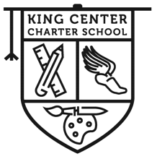

Student Re-Enrollment/Exit Form

Student Name: ______________________________ Teacher: _________________Grade: ____

Address: _____________________________ City: ____________________ Zip Code: ______

Please check one box:
Yes, my child will be attending King Center Charter School for 2021-2022 School Year.
No, my child will not be attending King Center Charter School for 2021-2022 School Year.
No, my child will transfer out of King Center Charter School Immediately Date: ___________

My child will be transferring to: ________________________________________

Reason for transfer: __________________________________________________
By checking No, I understand that my child’s space/seat will
be given to the next available applicant.

Legal Parent/Guardian Name (PLEASE PRINT)_______________________________________

Signature of Parent/Guardian: _______________________________________ Date: _________

Best Phone Number to Reach This Parent/Guardian: (_____) ___________-_____________

King Center Charter School is a public school. King Center Charter School does not discriminate on the basis of gender, race, religion, disability or national and ethnic origin in administration of its educational policies, admissions policies, athletic and other school-administered programs.

