 |  | BUSML 4258 | eCommerce Digital Advertising
Sem: SPR 2022 | Class Day/Time: Wednesdays 11:10am – 12:30pm |  |  | Room: Gerlach 285
Instructor: | Jon Quinn |  |  | E-mail: | quinn.402@osu.edu
Office Hours: | Wednesdays 2 – 4pm & by Appointment |  |  | Location: | Fisher 340
Course Description: Many large retailers are integrating their own advertising platform within their eCommerce site, including Wal-Mart, Target and very recently Lowe’s “One Roof” advertising network. The advertising division of Amazon and their representatives will co-lead the course sessions. This course is a hybrid of traditional coursework and a hand-on project experience. In the first half of the semester, students will learn about Amazon’s retail business, sponsored ads, programmatic display ads, OTT (over-the-top, aka “streaming” television), and audio ads. In the second half of the semester, students will apply the knowledge they obtained in the first half of the semester to a “real-life” client assigned through one of Amazon’s partner agencies and deliver a ‘Prepare and Present’ presentation to Amazon Advertising employees, agency representatives and the client. As supported by the course curriculum, students will be required to complete the official Amazon certification in advertising and analysis-based assignments.
Course Objectives:
- Understand the basics of and the toolkit for eCommerce advertising
- Gain hands-on experience with the common tools used in eCommerce advertising
- Understand how to critique, track, measure, and create eCommerce advertising campaigns
- Learn to use, experiment with and tabulate eCommerce advertising analytics to formulate an insight-driven campaign proposal
- Obtain a set of eCommerce advertising certifications (can be used in CVs, LinkedIn profiles, etc.)
Course Format: There are 10 class sessions in this course held in the first 10 weeks of the course. The following 5 weeks will be reserved for team meetings with the course instructor and Amazon partners in preparation for their final client presentation at the end of the semester. Class sessions will include a combination of lectures, discussion of assigned articles and current digital advertising trends/events, team in-class exercises and Amazon Advertising certifications. Please refer to Course Schedule at the end of this document for details about topics and activities for each session.
Course Materials: Textbook: There is not an assigned textbook for this course. There will be weekly readings procured from industry articles and Amazon proprietary documents.
Pre-Requirements: BUSML 3250 Co-Requirements: BUSML 4232 or 4233 (can be taken concurrently with this course.
Evaluation Criteria:
Requirements for each form of graded component.
Failing to follow these will represent academic misconduct. See below.

Independent Work [N]: Strictly non-collaborative, original individual work. You may discuss this assignment with your instructor only. Discussions with other individuals, either in person or electronically, are strictly prohibited.
Collaboration Required [C ]: An explicit expectation for collaboration among students either in class or outside of class (i.e. group work).
Collaboration Optional [O]: Students are permitted, but not required, to discuss the assignment or ideas with each other. However, all submitted work must be one’s original and individual creation.

Graded Components | % of Total | Type
Homework Assignments (4) | 20% | N 
Final Client Presentation | 35% | C 
Amazon Certifications | 35% | N 
Attendance & Participation | 10% | N 

Academic Conduct:
If a student is suspected of, or reported to have committed, academic misconduct in this course, I am obligated by University Rules to report my suspicions to COAM. If you have questions about the above policy or what constitutes academic misconduct in this course, please contact me. See OSU Prohibited Conduct – Section 3335-23-04(A)
University Policies, Services and Resources (go.osu.edu/UPolicies) | 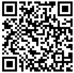 | Fisher Undergraduate Handbook and QuickLinks (www.bsbalinks.com) |  | Fisher Navigator Resource Portal (www.nav-1.com) | 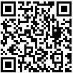
University Healthy and Safety Guidelines can be found at safeandhealthy.osu.edu/ For disability services, go to slds.osu.edu or contact slds@osu.edu.
Course Format and How this Course Works:

Mode of Delivery: This course will hybrid modality in that about half the sessions will be held in-person and half virtually via Zoom. However, all sessions will synchronous. The course will typically consist of one weekly in-person session of 80 minutes.

Credit hours and work expectations: This is a 1.5-credit-hour course. According to Ohio State policy, students
should expect 1.5 hours per week of time spent on direct instruction (e.g., instructor content, Carmen activities,
simulations, quizzes, etc.) in addition to 3 hours of homework (reading and assignment preparation, for example) to
receive a grade of (C) average.

Attendance and participation requirements:
- Participation attendance: You are expected to attend each scheduled class session and participate in class discussions. A record will be kept of the level of participation for each student.
- Dis-enrolled: Any student who fails to attend an in-person class or complete an assignment, without giving prior notification to the instructor, will be dis-enrolled after the third instructional day of the term, the first Friday of the term, or the second class meeting of the course, whichever occurs first.

.

Grading Scale
Below is the minimum required percentage to earn each grade. The instructor does NOT round up or down. Grades are based on %, not the letter grade assigned by Canvas (Canvas makes assumptions that the instructor does not). Note: To earn an A or A-: Students must complete all the graded components in the course AND earn the minimum required %. For example, if a student earned 92%, but did not complete all the quizzes, then the student will earn a B+. It is NOT required that students complete everything on time. Each assignment has a final deadline 24hrs after the assignment is due. If that is missed, then the student is not eligible for the “A or A-”.
Letter |  | A |  |  | A- |  |  | B+ |  |  | B |  |  | B- |  |  | C+ |  |  | C |  |  | C- |  |  | D+ |  |  | D |  |  | E
(Points) |  | (4.0) |  |  | (3.7) |  |  | (3.3) |  |  | (3.0) |  |  | (2.7) |  |  | (2.3) |  |  | (2.0) |  |  | (1.7) |  |  | (1.3) |  |  | (1.0) |  |  | (0.0)
Range | 100% |  | - | 93% |  | - | 90% |  | - | 87% |  | - | 83% |  | - | 80% |  | - | 77% |  | - | 73% |  | - | 70% |  | - | 67% |  | - | 60% |  | - | 0%
- The instructor DOES NOT change grades (except for clerical/math errors). Students may appeal, but their grade may go up or go down based on a re-evaluation. Appeals must be made in writing via email within 7 days of students receiving the grade. Students must explain the appeal as best as possible. Appeals will not be considered if it is a verbal complaint. The instructor does not promise to change the grade but will consider the appeal carefully and fairly.
- Once the final course grading scale is set, it is set. Even if a student misses the next letter grade by one point, the grade stands.
- The BSBA program recommends a GPA of 2.9-3.3 in all business 4000-level classes. The actual grade assigned will be based on what students earn. All sections of Principles of Marketing follow the same grading policy.
Assessment
The following grade structure will be utilized for this course:
- (20%) Homework Assignments (4 individual assignments, each worth 5% of final grade)
- (10%) Attendance & Participation
- (35%) Amazon Certification Exam scores (can be take up to 3 times, highest score retained for assessment)
- (35%) Final Client Presentation

Course Policies: Expectations for Students
Late Work: Late work will not be accepted. Digital marketing is a fast-moving field that depends on timely action. Late work in the field may result in a missed opportunity or worse.
Plagiarism and Academic Dishonesty:
Plagiarism and other forms of academic dishonesty are unacceptable in this course. Your ideas are innovative and intelligent. Please have enough confidence in your own ideas rather than passing the work of others off as yours. All “ICE” assignments are be submitted through CarmenCanvas and may be scanned through Turnitin to detect any unoriginal content.
Attendance:
Please be present and prepared to contribute.
Additional Policies

Testing Policy:
- The certification exams are open-note. However, the exams are timed so there will not be enough time for the student to refer to their notes on most questions.

Course Technology:
- Baseline technical skills for online courses.
  - Basic computer and web-browsing skills
  - Navigating Carmen: for questions about specific functionality, see the Canvas Student Guide.
- Required Technology Skills (only if this course is moved to an online format)
- CarmenZoom virtrual meetings
- Recording a slide presentation with audio narration
- Recording, editing, and uploading video
- Required Equipment
- Use of electronic devices in class: We will rely heavily on technology both in and outside of class. If you have a tablet or laptop, please plan on bringing it to class on a regular basis.
- Additional required equipment if this course is moved to an online format:
  - Computer: current Mac (OS X) or PC (Windows 7+) with high-speed internet connection.
  - Mobile device (smartphone or tablet) or landline to use for BuckeyePass multi-factor authentication. It is recommended that you register multiple devices in case something happens to your primary device.
  - Webcam: built-in or external webcam, fully installed and tested
  - Microphone: built-in laptop or tablet mic or external microphone
- Required Software. Microsoft Office 365: All Ohio State students are now eligible for free Microsoft Office 365 ProPlus through Microsoft’s Student Advantage program.
- Carmen Access. You will need to use BuckeyePass multi-factor authentication to access your courses in Carmen. To ensure that you are able to connect to Carmen at all times, it is recommended that you take the following steps:
  - Register multiple devices in case something happens to your primary device. Visit the Duo Mobile application help article for step-by-step instructions.
  - Request passcodes to keep as a backup authentication option. When you see the Duo login screen on your computer, click Enter a Passcode and then click the Text me new codes button that appears. This will text you ten passcodes good for 365 days that can each be used once.
  - Download the Duo Mobile application to all of your registered devices for the ability to generate one-time codes in the event that you lose cell, data, or Wi-Fi service.

If none of these options meet the needs of your situation, contact the IT Service Desk at 614-688-4357 (HELP), visit ocio.osu.edu/help or email servicedesk@osu.edu and IT support staff will work out a solution with you.

COURSE CALENDAR (Draft, timing of assignments may vary slightly, and Amazon participants may change by Jan 2023):
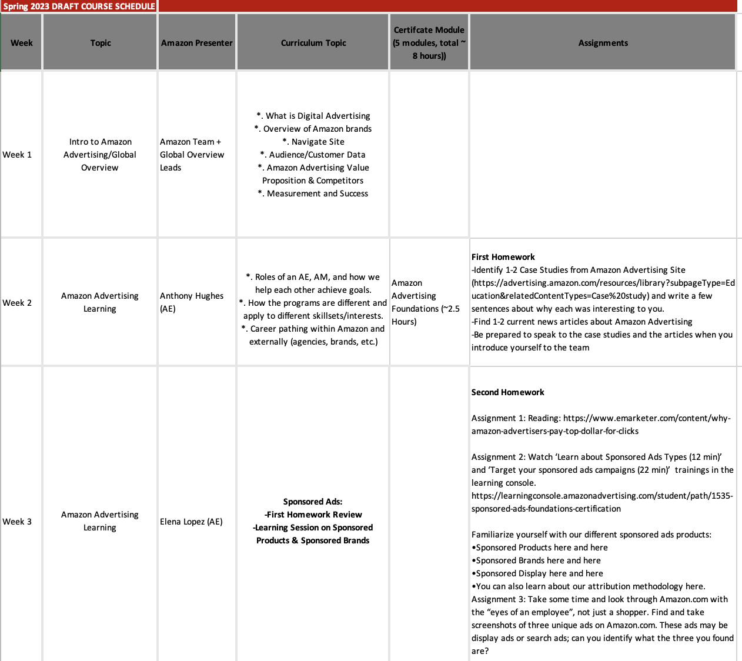

Course-specific Copyright Policy: Material provided by the instructor may not be re-posted anywhere without the explicit permission of instructors. See University Copyright Policy. [Additional rules if applicable]

