Email#4 – Putting it all together
(Reminder: this is part four of a four-part series. If you haven't already, please read the first, second and third emails.)

Let's start with orienting ourselves.

We've covered a lot!

We started with the problem:

Why your business likely isn’t growing as fast as it should?

This problem is made worse by three factors that even most successful businesses have:

- Flipped-flopped marketing mindset
- Owner-dependent business
- Wrong use of tools & tactics

You then learned how to solve this problem with three ingredients to predictable and profitable growth and scale:

- Value-based marketing mindset
- System-level business execution
- Growth gap marketing framework

Having a value-based marketing mindset means you redefine marketing as the way you create happy, successful customers- not just a means to an end.

You also redefine your business questions towards answers that make growth easier.

Lastly, you make marketing a journey that both you and your (potential) customers are on, It becomes the guide that points you in the right direction.

You learned that system-level business execution means that you spend significant time working ON your business and less time IN it.

This gives you the 'growth perspective', which allows you to clearly see what must be done.

This cannot effectively be done from withIN the business.

And as we've said before, the truth is often hidden if you're looking by yourself…

…so it's important that you get some kind of 'objective enough' outside partner (a business colleague, a friend or family member outside of your business or a growth coach, whose job it is to see what you cannot see and help you see it for yourself)

This gives you the time to scale in a way that won't break your business

Recall: growing an owner-DEPENDENT business too fast, without the right framework and processes in place can lead to accelerated decline.

Finally, we spoke about the growth gap marketing framework.

Instead of chasing the latest and greatest shiny tool or tactic peddled by the 'gurus'…

…we used our documented customer journey and actionable metrics to tell us which tool/tactic needs to be deployed at what time and in which stage of the customer journey.

Hopefully, you've internalized these three ingredients and have started to integrate them into your business.

But what's next?

If you're ready to accelerate this transformation, we created something that directly helps you to get started on solid ground- but (in full transparency) it's not for everyone…not even most people.

In fact, we require that you raise your hand before we send you our offer.

Not to hide anything but to honor your (precious) time and attention.

If something in you is saying 'yes!" to the next step, then click on the link below to be included in our offer emails:

[LINK]

It's for people who believe that what may have gotten them to their current level is not what will take them the next level…and beyond.

We’ll focus on people who want to take dedicated action towards predictable and profitable growth. .

We promise that engaging in what we offer will help you to start implementing that proven frameworks and processes that we've touched upon so far…

Frameworks processes that have been tested by over 126,000 marketers on teams of all shapes and sizes.

If you you're just not quite there, no worries. :)

We will continue to send you tips and resources if we find them worthy of your time.

If you ever come to the place in your journey when you're ready to begin the next step, simply come back to this email and click on [this link].

See you soon,
Brian

Email#5 – The next step

You already know how important having the right marketing mindset is.

But this goes beyond redefining marketing…beyond reframing our business questions.

To truly have the right mindset, marketing has to become a worthwhile journey…

A worthwhile journey for our customers…

A worthwhile journey for our business…

And even more importantly…

It needs to be a worthwhile journey for ourselves.

It needs to CHANGE us, EVOLVE us, GUIDE us…to where we naturally impact the world.

WE become the change we've been waiting for…not through tricks and gimmicks…

…but by our willingness and commitment to making a difference for a group a people…letting that commitment grow us into the person we need to be…

…and we will not be the same person.

Trying to go to the next level by resisting the required evolution of ourselves misses the point…and is doomed to fail long-term.

…but this can be incredibly difficult without spending time in the 'growth perspective': looking into your business from the OUTSIDE.

You can do this on your own but it's impossible to know what you don't know you don't know.

And when you're trying to grow and scale profitably and predictably, chances are near 100% that you have blindspots to seeing what's missing.

In fact, your brain itself needs to switch from reaction mode (day-to-day implementation of tools and tactics)…

…to creation mode (optimizing the entire business system for happy, successful customers, evolving ourselves in the process) in order to clearly see what needs to happen next.

The brain chemistry is totally different.

Once you give yourself permission to set aside quality time blocks of about 60-90 minutes, your brain begins to develop a habit and look forward to it.

It will literally begin processing ideas it never has…in anticipation of the next 'creation time block'.

Can you imagine the kind of business a-HAs and ideas you can generate when you make this a habit?

Where would your business (and you) be 12 months from now if you did this?

This is why we created the "Double Your Sales" Session.

It is a 60-90 minute creation block where we spend quality time working on YOUR business.

You'll understand where you are and specifically what you need to do to go to the next level.

You'll gain access to frameworks and models that have helped businesses, big and small, grow predictably…

…tools and resources forged from learnings from literally hundreds of thousands of hours of trial and error to see what really works in the marketplace.

Frameworks and models that evolves as the market place and digital environment evolves.

(I'll say more about this and how it works in tomorrow's email)

And the end, you'll not only better understand your business and what's keeping it from growing, you'll have the beginnings of a roadmap that will help you double your sales!

You'll have one of the most elusive but desired quality in any business: more CLARITY!

So if this resonates with you and you're ready to do the hard but rewarding work to chart a "double your sales' roadmap, click on the link below…

[LINK]

We look forward to helping you get unstuck and truly leap to the level of your dreams.

See you soon,
Brian

Email#6 – A bunch of half-built bridges
Yesterday, we talked about the framework, models and tools that have been created from the blood, sweat and tears of more than 126,000 marketing teams of all sizes.

But, as you know, the world never stays the same.

That’s why we constantly make sure that our frameworks, tools and models are constantly tested and upgraded, when needed, based on the real world experiences of 1000s of businesses around the world.

Imagine having access to an ever-evolving brain trust like this?

But before we move too far, it's important that we address a HUGE elephant in the room.

You may even be doing it right now..

It's the Huge A-HA that Changed Everything!

(Chances are good that you'll have an a-ha too!)

It's by far the biggest business-killer we've seen

It's the dark side of a 'tools & tactics'-focused business.

And here’s what I mean…

If we only shared a bunch of tools and tactics with you.

Sure, you'll be able to implement them in your business and have a decent level of success.

And that’s great. Believe me.

But if you leave here and you just began implementing the latest tool or tactic without a broader plan…

…or an even broader overarching strategy, my fear is that it could wind up being just another…

Half-Built Bridge

…in your business.

And that's the last thing in the world that I want you to do.

And so I want to close with this concept called half-built-bridges that I got from Ryan Deiss.

Here's how it works…

Let’s pretend that this is you…and you’re over here on this mountain:

And ultimately, where you want to be is over here on this mountain.

Your pot of gold is on the other side.

And the reason that you came here today is because you're looking for a bridge.

Right?

Now, I don’t know what the thing is that you want. It could be more business growth, more sales.

Maybe you want to grow your company because you want to put your kids through college.

Or maybe you simply want to help more people improve their lives.
I don’t know what your pot of gold is.

But I know that if you’re here today, if you’re reading this today, you probably don’t have it.

Right?

And you came here to day looking for a bridge that will take you from where you are to where you want to be.

Make no mistake, what we are about to share with you can help you build a bridge.

But here’s my concern: I bet this is not the first time that you really had a really cool, novel idea.

In fact, I bet there are times when you’ve read an emails like this, you’ve read blog post, or attended a webinar and you heard something about Facebook Advertising.

And you go, “Oh, Facebook Advertising!”

"There’s this new strategy where we can implement shorter videos. I think it's going to work."

And so you start building that bridge and then you stop.

And the reason that you stop is because the next week (or month) you read about a new strategy that someone else is doing and you go:

"Forget Facebook, now we need to be doing Instagram stories."

So you cut off the previous bridge and you start building a new bridge.

And then the next week you say “no, no, no, no", we don't need to be doing this. What we need to be doing is chatbots”.

And now used are building the chatbots bridge.

And it’s again and again and it’s over and over…

And what you’re left with at the end of the day is a bunch of…

Half-Built Bridge

And my guess is if you’re like I am, if you’re like a lot of entrepreneurs, then I know is not a unique experience.

This happens time and time and time again.

Right?

And what we have in these half-built-bridges is an enormous amount of work.

An enormous amount of effort.

An enormous amount of investment.

But what’s a half-built bridge worth?

Nothing!

…because it’s not getting us to the other side.

So, if you’re sitting here today and you’re frustrated.

If you’re sitting here today and your feeling like "UGH!"

Saying to yourself…

"I’m just tired! I’m exhausted and yet I’m not seeing the results I want!"

I submit to you that the reason you're tired…

The reason that you're exhausted…

The reason that you feel like your flailing around is that you’re currently building up an inventory of…

Half-Built Bridges

So, if it seems hard, if it seems difficult, if it seems like you are working, working, working in your not seen the results.

I submit to you it’s because of these half-built bridges that you see here today.

So here’s my message to you:

We're going to spent a lot of time talking about some really cool, strategic and tactical stuff.

Don’t get me wrong, it works.

But if it’s not fully deployed, it's simply going to be yet another half-built bridge.

So what I want to leave you with is this message and it’s really, really simple:

I want you to pick ONE bridge…

…whether it’s something I share or something someone else talks about…

…whether it's something you’ve heard or something you'll read about in a blog post next week.

It doesn’t matter.

If the only thing you take from what I share today is this…then it would have been worth your time.

And I feel like I would’ve delivered value to you today.

Even if everything I’ve shared, previous to now, you didn’t care about, you didn’t understand, or you thought it wasn’t all that particularly useful.

If you take this key point with you today, then I know I would have delivered value:

Pick ONE bridge!

I want you to pick one bridge and I want you to finish that ONE bridge.

And then when you finished at one bridge, I want you to pick a second bridge and I want you to finish that…

Again it can be something that I share with you or can be something else.

I really don’t care because I know...when you pick one bridge, and then you finish another bridge, and then you finish another bridge…

…you'll have enough bridges to get what you want.

You see…

It’s not about the tactics.

It’s about the execution.

It’s about the implementation.

But mostly it’s about the strategy.

And that’s what’s going to allow you to cross that bridge and get to the other side.

So, my advice to you is that you just have to pick that ONE bridge.

Because I know once you cross over and get what you want…and get that thing you’re after…

…you’re going to be able to cross over and build more bridges, and more bridges, and the bridges will become stronger.

And you’re going to be able to get everything that you’re after.

Here’s why this is so important…

You see, we have identified that there are 73!

73 possible bridges that you could be building.

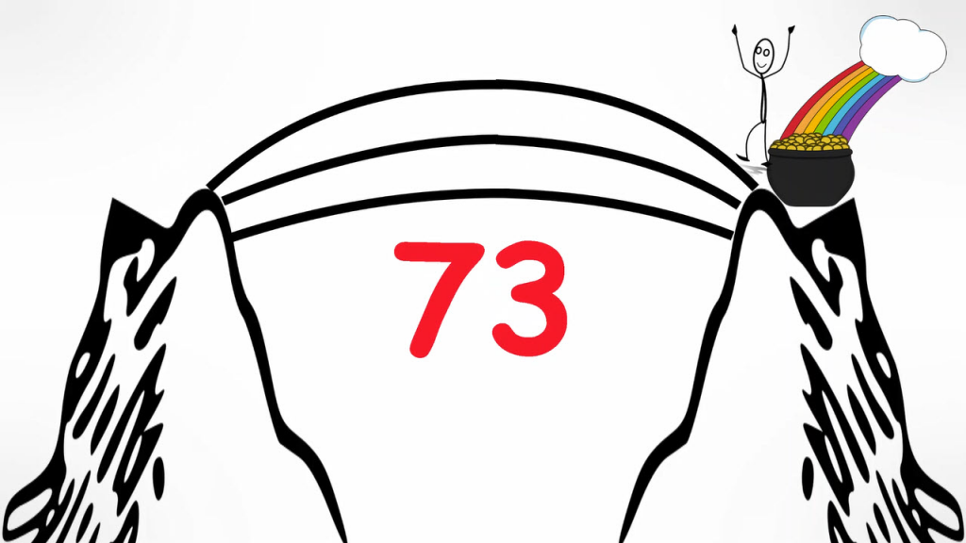

SEVENTY THREE!

No wonder we all get shiny-object syndrome. Right?

That's where the Double Your Sales comes in.

Essentially, in 60 to 90 minutes, we map out a plan for how you can double your sales in 90 days.

Obviously, we're not going to guarantee that your sales will double in the next 90 days…

…but we’re going to begin working out a plan so that you can double your sales in 90 days.

Now, here’s the secret behind the whole thing…

What we’re really doing through this Double Your Sales discovery process is

…we are going to identify YOUR one bridge.

We’re identifying that first thing that you positively need to do now.

Not the only thing.

We’re just going to help identify the first thing.

So if you’re sitting there today and you know you got shiny-object syndrome.

If you’re sitting there today in you know that you have a warehouse full of half-built bridges.

You want to finish something and make sure your finishing the right bridge.

That’s what I would love to help you with…

Click on the link below to book your session now (only a limited number of slots available)…

[link]

See you soon,
Brian

