The New Standard in
Braille N
tetaker
o
888-520-4467 | www.hims-inc.com

BrailleSense Polaris
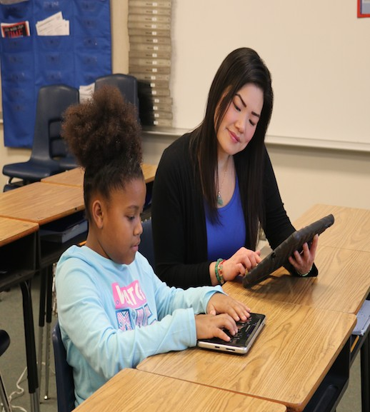
Seamless efficiency tool for school, work, and play
Polaris at School
BrailleSense Polaris offers a new standard in blind-friendly applications with the latest in cutting edge technology. BrailleSense Polaris levels the playing field with specialized applications built around Polaris Office Suite, while providing comprehensive access to popular Google Apps such as Docs, Slides, Sheets, and Classroom. Surf the Web with Google Chrome just like our traditional web browser. Use Polaris Word to write a report and other documents with the same feel as Word Processor. Sync your calendar to Google Calendar while using our Organizer. You can even enjoy a book from BookShare, BARD, or other sources in our DAISY reader, word processor, or via countless blindness and mainstream services.

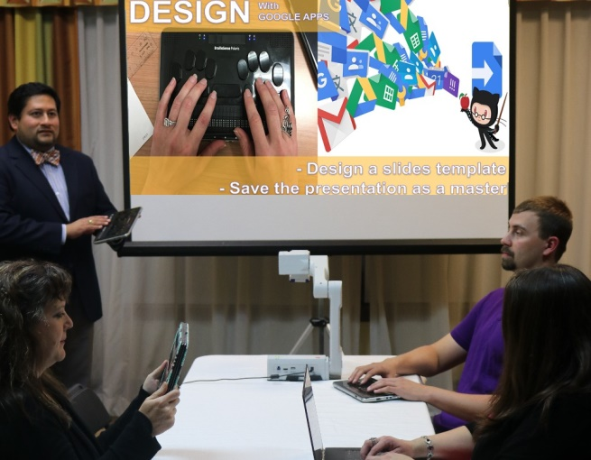
BrailleSense intuitive interface with a touch of mastery
Polaris at Work
We’ve kept the traditional computer interface that has contributed to the popularity of other BrailleSense models. BrailleSense Polaris has a Perkins-style keyboard, a 32-cell braille display with cursor routing buttons, and touch sensors above the display for enhanced navigation. There are also touch sensors on the media buttons making them user definable.

Blind-friendly Notetaker Features Standard Programs
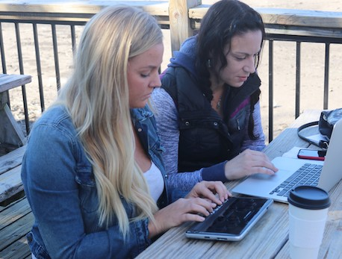
Use our optional thesaurus and multilingual dictionaries to broaden your vocabulary or find an equivalent app in the Google Play Store. BrailleSense Polaris, lets YOU decide! Analyze spreadsheets with our popular Excel Viewer, or read and edit spreadsheets in Google Sheets. Read or give a presentation using our PowerPoint Viewer, or create your own presentation from scratch in Slides.
Polaris On the Go

Tools for Today’s Students
BrailleSense Polaris supports Google Apps, making it easy to utilize Google services like Drive, Docs, Sheets, and Slides as millions of other students do everyday. But, there’s more! BrailleSense Polaris provides unparalleled access to Google Classroom for blind students and teachers alike. Collaboration among students and teachers has NEVER been this easy. There’s support for Nemeth and UEB Math, too. BrailleSense Polaris allows for display on the built-in LCD display, tablets via Miracast, or an external monitor via the HDMI port.

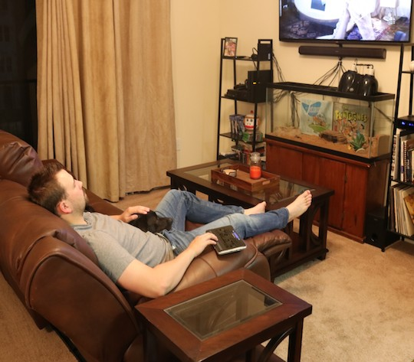
Polaris at Home
Easy Connectivity with Your Favorite Devices
Connect BrailleSense Polaris via Wi-Fi, Bluetooth 4.2, or USB3 to your computer, iOS device, Android device, tablet, or phone. Enjoy your own MP3 while listening through the Stereo Speakers, or use headphones with the audio jack for your private listening. BrailleSense Polaris is even equipped with an on- board “Flippable” LCD display. Allowing for more effective interactions between blind students, visual teachers, parents, co-workers, and friends. Don’t use BrailleSense Polaris just for work. Use it for play with the built-in IrDA as a remote, or you can even relax while using Chromecast on your TV.
BrailleSense Polari
s

Specifications | BrailleSense Polaris
Model # | H532B
Braille Display | Multi-touch enabled 32-Cells
Keyboard Type | Perkins-style
Platform | Android OS 5.1.1 (Lollipop), 2.1GHz Octa-core (CPU), 3GB (RAM)
Flash Memory | 64 GB
Video Display | HDMI output, built-in LCD
Interface | USB 3.0 micro OTG, USB 2.0, HDMI, SD Card slot, Touch-enabled Multi Function Buttons
Network | WLAN: 802.11 b/g/n/ac, Wi-Fi Dual-band, Wi-Fi Direct Bluetooth: Bluetooth 4.2, IrDA, Ethernet: USB to Ethernet (Optional)
Navigation | Voice Trigger (“Hey Polaris”), Built-in GPS, RTC, Accelerometer, Compass, Gyroscope
Media | 13MP AF Camera, Alert (Vibration, Buzzer, Proprietary ringtones), Stereo speaker, Stereo MEMS and ANC  microphone
Applications | App Store: Google Play Store Preinstalled Apps: Polaris Office (Word, Slides, Sheets, Email), Web Browser, Terminal for Screen Reader, DAISY, File Manager, Schedule Manager, Address Manager, Calculator, Calendar, Media Player, Time & Date, Alarm, Stopwatch, FM Radio Optimized Apps: Google Docs, Sheets, Slides, Drive,  Classroom, APH Nearby Explorer
Supported File Formats | Documents: HBL, DOC, DOCX, XLS, XLSX, CSV, PPT, PPTX, RTF, TXT, BRL, BRF, EPUB, PDF, HTML/XML (in Web browser).  Media:YouTube, MP3, MP4, WAV, ASF, OGG, WMA, M4A, M3U, PLS, Audible (with appropriate app), WMV, FLAC, MID, ACC. DAISY: DAISY 2.0/2.02/3.0, NIMAS 1.1, BookShare.org, Open Library, NLS, Learning Ally (with appropriate apps)
Battery | 18 hours, 5 hours to charge(AC adapter and USB), Wireless charging(Qi compatible)
Size & Weight | 9.66” x 5.66” x 0.74” (W x D x H), 1.65 lbs
Security & Safety | Kensington Lock, TPU Carrying Case
Warranty | One-year limited parts and labor warranty

d
888-520-4467 | www.hims-inc.com
4616 W. Howard Lane, Suite 960, Austin, Texas 78728

r-bsu150801

