Fatal Alliances –The Great War
“Taming the Bear” - Simple Scenario and Walkthrough

If you’re new to Fatal Alliances and haven’t played World in Flames (or if you just want to play a simple 2 player scenario that lets you get into combat quickly), this is the one for you. See below for a walkthrough with pictures.

The goal for this scenario is for the Central Powers player to knock out Russia and Serbia, while the goal of the Russian player is to survive. If the Central Powers conquer Serbia (including Albania) and force Russia to surrender (by dropping its morale to 0) by the end of 1917, they win a major victory. If they achieve this by the end of J/A 1918, they win a minor victory. Otherwise, Russia wins.

One player plays the Central Powers and another plays Russia (or you could have 3 players with 1 player running Germany and another running Austria & the Ottomans). The game starts as a regular Fatal Alliances game, except only Russia, Austria, Serbia, Bulgaria, Rumania, and some German and Ottoman units are in play (set aside all other units). Partisans may appear, but no other minors may be liberated (even e.g., Finland, which normally could). Units may only enter areas controlled by these countries. The World Map is not in play except that Russia may use resources and factories it would normally control there.

Unlike in the campaign, you may not scrap land and air units before the game starts (you may still scrap naval units that are 4+ years old, e.g., to get a better transport). All Russian units are in play (but see setups for actual units to setup at start). All Austrian land and air units are also in play, except 1 MTN corps and the Austrian (but not Hungarian) INF reserves (these are considered to be guarding the Italian border; remove them from the game). Remove from the game all Austrian naval units. Germany and the Ottomans receive half their reserves (randomly selected from all their reserves; remember that halves always round up to the nearest whole number).

See setup charts for a full list of units to remove from the game (randomly selected). For future year HQ reinforcements, Germany receives the HQ-Falkenhayn (only) and the Ottomans receive no additional HQs (except those listed in the setup). Germany and the Ottomans receive half of all future reinforcements by force pool (INF, GAR, CAV, MTN, GAS, STOSS/MECH, FTR, LND, ART, INF-div, CAV-div, etc. Note: in practice means they receive most future units into their force pools based on the way this rounding works). Add half of all non-reserve MIL to the German and Ottoman force pools. See the setup for other starting (dated 1914 and prior) German and Ottoman units to remove from the game. All major powers get their full activity limits.

Germany may use all factories and resources in Germany, but German and the Ottomans may only use half their production for this scenario (half of their build points before any bonuses for units lost in home country). In addition, Germany receives: 3 resources from Sweden and 1 from Norway (these must be transported by convoy across the Baltic); 2 resources from the Netherlands (1 from overseas but ignore this transport); 2 resources and 1 factory from Belgium; 2 resources and 1 factory from France; and 1 resource from each of Rumania and Bulgaria while these are neutral (a total of 12 resources and 2 factories beyond Germany).

The Ottoman Empire must be joined in on the first Central Powers impulse of N/D 1914, but may be declared war on by Russia before that. Bulgaria must be joined in on the first Central Powers impulse of S/O 1915, but may be declared war on by Russia before that. Rumania must be joined in on the first Allied impulse of J/A 1916, but may be declared war on by the Central Powers before that. Ignore all US and CW entry for this scenario. Ignore politics except for the automatic join-ins and declarations of war.

Initiative starts at +2 Central Powers in the first impulse of J/A 1914 (Central Powers go first). The weather roll is ‘4’. All major powers start the scenario neutral. After setting up units in the normal order (Austria, Russia, Germany), on the first Central Powers impulse, Austria must declare war on Serbia (which must align to Russia, even though Russia is neutral). Germany must PASS on the first impulse. Then on the first Allied impulse, Russia must declare war on Austria. Then on the second Central Powers impulse (Impulse #3), Germany must declare war on Russia.
Setup:

Country | Location | HQ | INF | GAR | Other corps | LND¹ | Naval units | Offensive points | Guns | Divs | Other
Austria  (Austrian/  Hungarian) | Europe | Conrad, Fredrich | 7/5 | 1/1 | CAV/CAV | LND2, 2B |  | 15 | 3 | 2Inf, Cav, Eng, Mtn | 3 Fort hexsides
Austria  (Austrian/  Hungarian) | Nov/Dec |  | 1/1 |  | 0/CAV |  |  |  |  | Cav, Mtn
Austria  (Austrian/  Hungarian) | [Remove from game] |  | 4 Res/0 |  | MTN |  | All
Russia | Europe | Yudenich, Rennenkampf, Ivanov | 23 | 6 | 3CAV, MTN | LND2, LND4, B | Trs, 3 CP | 20 | 3 | 3Inf, 2Eng, 2Cav | 2 Fort hexsides
Russia | Baltic ports |  |  |  |  |  | Note 2
Russia | Black Sea ports |  |  |  |  |  | Note 3
Germany | Germany |  | 5 | 1 | 2CAV, MTN | LND2, B | Note 4 | 5 |  | Inf
Germany | Sept/Oct | Hindenburg | 3 | 1 | CAV |  |  | 10 | 4 | Cav, Mtn, Eng
Germany | Mar/Apr | Bulow |  |  |  | LND2 |  | 15
Germany | May/June | Moltke |  |  |  |  |  | 15 |  | Eng
Germany | [Remove from game]⁶ | All other HQs except Falkenhayn | 8 | 1 | CAV, Maritz | LND2, B, Z | SCS Goeben, Brandenburg |  |  | Inf | All Terr
Ottoman Empire  (setup when activated) | Europe | Enver Pasha | 3 | 1 | CAV, MTN | LND2 | Note 5 | 5 | 1 | Inf, Eng
Ottoman Empire  (setup when activated) | [Remove from game]⁶ | All other HQs | 3 |  | CAV |  |  |  |  | Inf, Cav | All Terr
Note 1: Add a pilot to each non-balloon aircraft
Note 2: SCS~Retvisan, Poltava, Gangut, Evstafii
Note 3: SCS~Potemkin, Pavel I, Borodino, Oriol, Suvarov
Note 4: Half of all SCS <1913 (add all available and select half), Trs, Amph, 16 CP
Note 5: 3 CP, Trns, SCS~B. Heyreddin, Mesudiye, Gamidieh, Selim Yavuz
Note 6: Also remove Reserves not selected for setup from the game

Scenario Walkthough (Setup & first impulse tutorial with pictures).
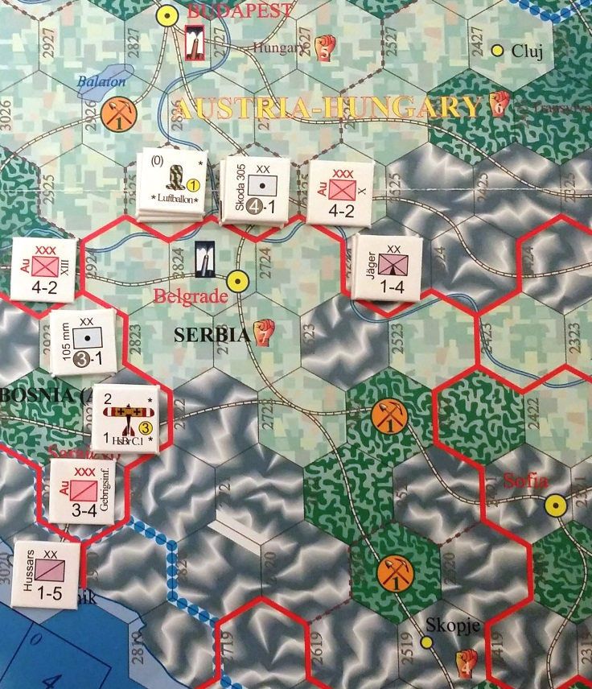
Austrian setup vs. Serbia
At the start of the game, sort available units into ‟force pools” of unit types. Each type of unit (INF, MIL, GAR, CAV, GAS, FTR (fighter), LND (land bomber/recon), B (balloon), Z (Zeppelin), ART (artillery), SCS (surface combat ship), TRNS (transport), AMPH (amphibious ship), convoy points, seaplane carrier, SUB (submarine), etc.) gets its own force pool. Further divide the force pools to separate divisions from corps of the same type (e.g., INF vs. INF div). You don’t separate units by cost into different force pools (e.g., artillery that cost 3 vs. artillery that cost 4). In practice, it’s best to get some little paper cups or (even better) a tackle/organizer box with small compartments to hold your force pools.

Whenever you draw a unit for setup or production, you draw randomly from that force pool. (However; when you build units, you may choose to select only from units of the cost you spent; i.e., you could choose an artillery that costs 3 over an artillery that costs 4). Note that this could allow you to, say, produce a cruiser (first cycle cost = 1) instead of a battleship (first cycle cost = 2), even though they are in the same force pool. Note also that for setup, some columns specify units by cost (LND-2 = land bomber that costs 2 build points), and that pilots are included for the setup airplanes but these are not added to the pilot track unless you choose to place your airplanes in the reserve pool instead of the track (also not that balloons and zeppelins don’t need pilots). Some ships start face-up (in their second cycle of production), while others start [fd] (face-down; in their first cycle of production, slated to arrive into the construction pool. Before setting up, take all units marked ‘Res’ or ‘Ge’ (anti-German reserves) and place them in the Reserve Pool. Force pools at the start of the game will include all units marked ‘1914’ or earlier, but you can normally scrap any units at least 4 years old or older (though not land/air units in this scenario).

Austria sets up first in this scenario (setup order is the order listed in the setup tables). Remember that you can stack up to 3 land units in a hex, provided at least one is a division-scale unit (‟XX”). Units marked as arriving in future turns are placed on respective slice of the production circle. Aircraft can setup one per hex in most hexes but none mountains or swamp (3 in cities/major ports or 2 in minor ports no matter the terrain).
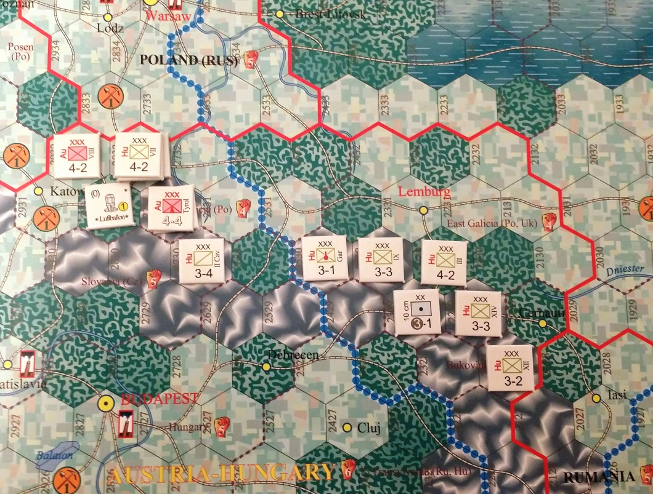
Austrian Carpathian setup
Austrian units can setup anywhere within Austria’s starting territory (Austria-Hungary home country plus Bosnia). Note that the Austrians set up before the Serbians (who will only be setup when they become active by the Austrian declaration of war on the first impulse). Austria also decides to concentrate the bulk of her pure Austrian units (as opposed to Hungarian units) against Serbia where she expects to be doing the majority of the attacking. (Note that when Austrian and Hungarian units attack together, they receive a -1 attack penalty; see the Austria-Hungary section of the rules for more information and other restrictions.)

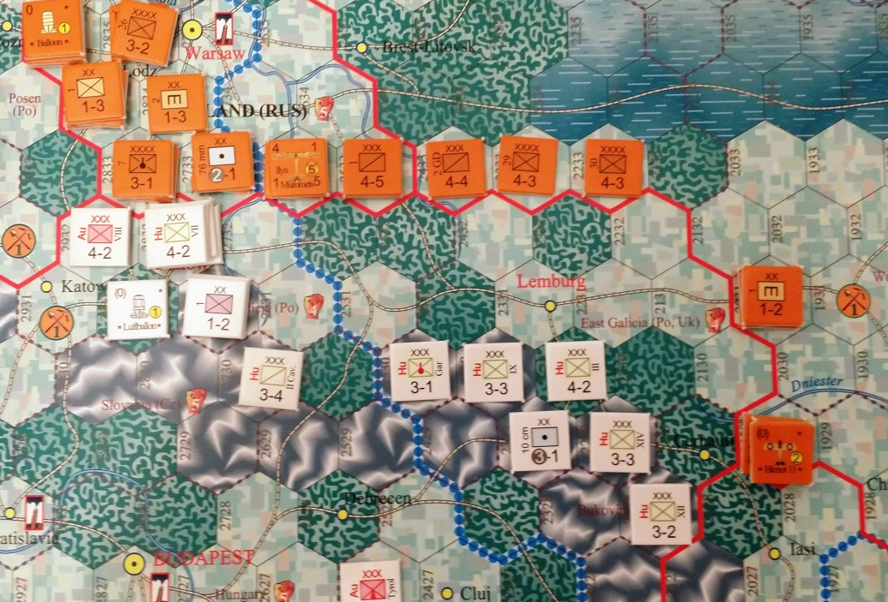With so much attention on Serbia, the Austrian setup is rather weak in the Carpathians to face the Russians.
Russian setup near the Carpathians

Now the Russians set up. The bulk of the Russian army chooses to set up in Poland and Ukraine opposite the Austrian forces in the Carpathians, however, strong forces also face Germany and East Prussia.

Smaller forces also set up to guard the Turkish border and the Baltic region to guard against German invasion of Finland (a Russian-conquered minor country).

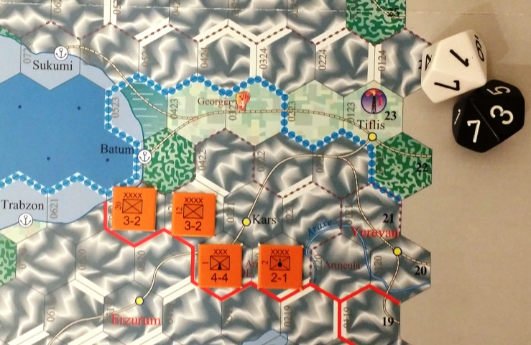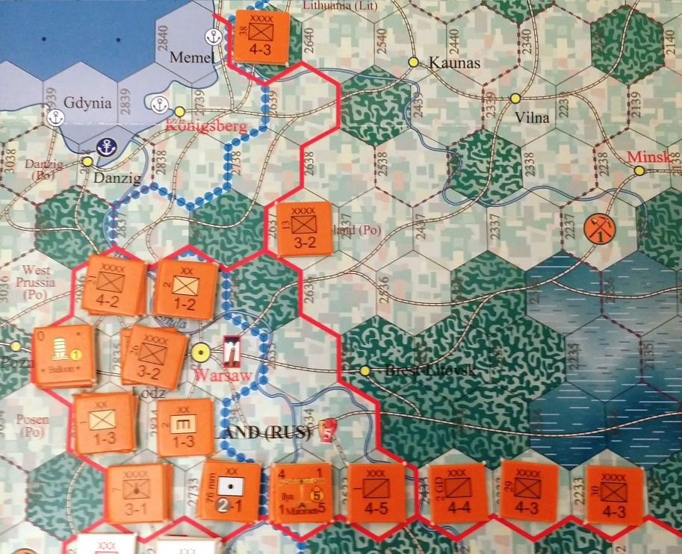
Turkish border
Russian setup in Poland
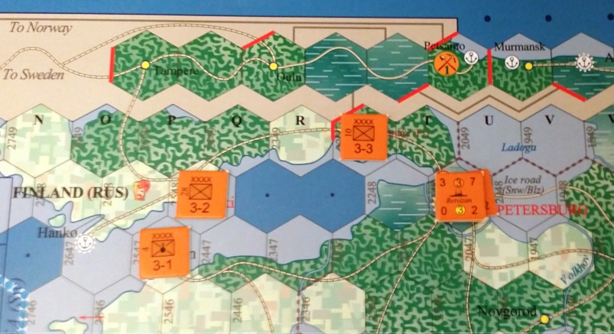
Baltic defense

Finally, the Germans set up in Germany (including East Prussia).

The Germans set up 4 convoys in the Baltic to carry resources from Sweden and Norway (convoys always occupy the 0-box at sea; neutral major powers can start with convoys at sea in sea zones they could reach from their bases).

The German forces are somewhat weak in the first turn because the main German focus is against France in the West. Thus, the German setup is mostly defensive, while looking out for counterattack opportunities like Tannenberg. The good news for the Central Powers is that most future German reinforcements will be strongly allocated to the Eastern front. The bad news is that the Eastern front is so weak at first that Russia may have significant attack opportunities.

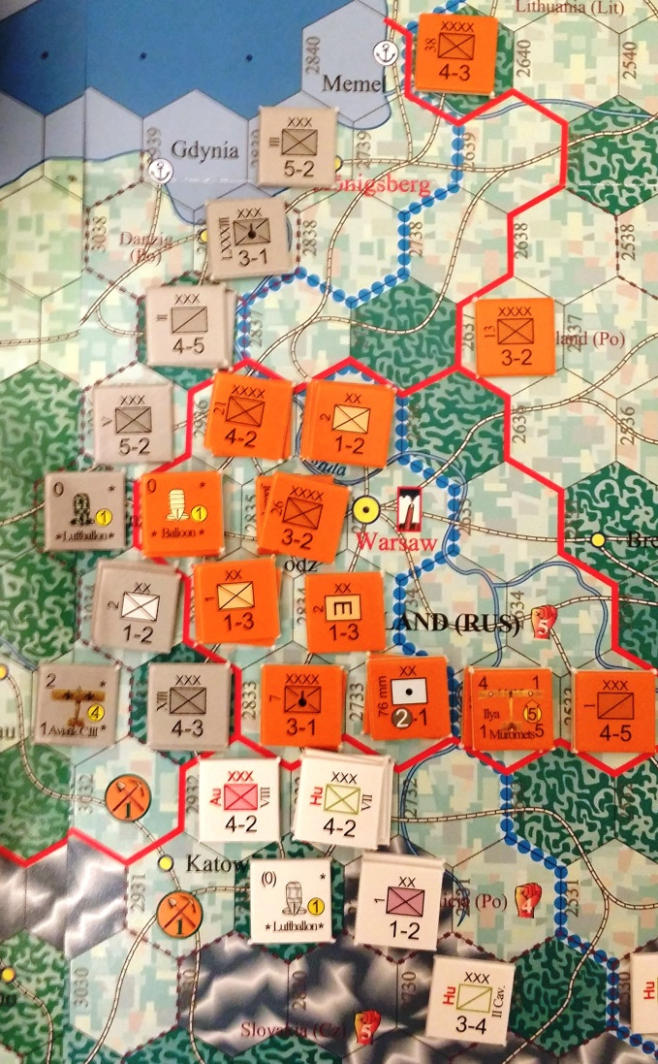After you’ve set up the major powers (except Ottomans who always set up only when activated - like Italians in the campaign game), you’re almost ready to start. Place the initiative marker (Central Powers/Allied) on the initiative track (on Production Sheet). This gives a bonus to the die roll for initiative, and can shift throughout the game. Place the year marker on the year track (1914), and the turn marker on the current slice of the production circle (July/August). Set up offensive points for the major powers and pilot markers on the track. Set up the impulse marker on the impulse track. This tells you who is currently moving, and what the current chance to end the turn is at the end of their impulse (how fast it moves is determined by the weather chart, but often just one space per turn).
German setup

Set up major powers morale markers on the morale chart in the indicated box. For a full campaign, you’d also set up US and CW ("Commonwealth", i.e. British Empire) entry markers, and flags for minors on the influence track surrounding the morale track (Italy is the only country with 2 flags [using its morale marker for one] because it can be pulled in 2 directions at the same time).

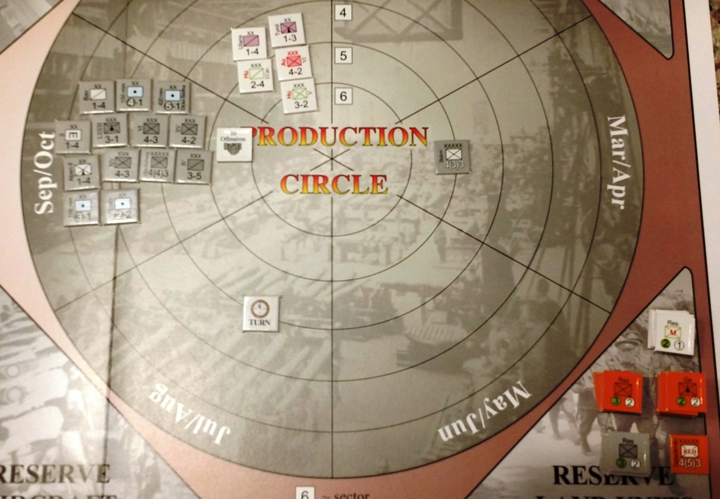
Production Circle - Reserves & Future reinforcements (setup in progress - not showing all units!)

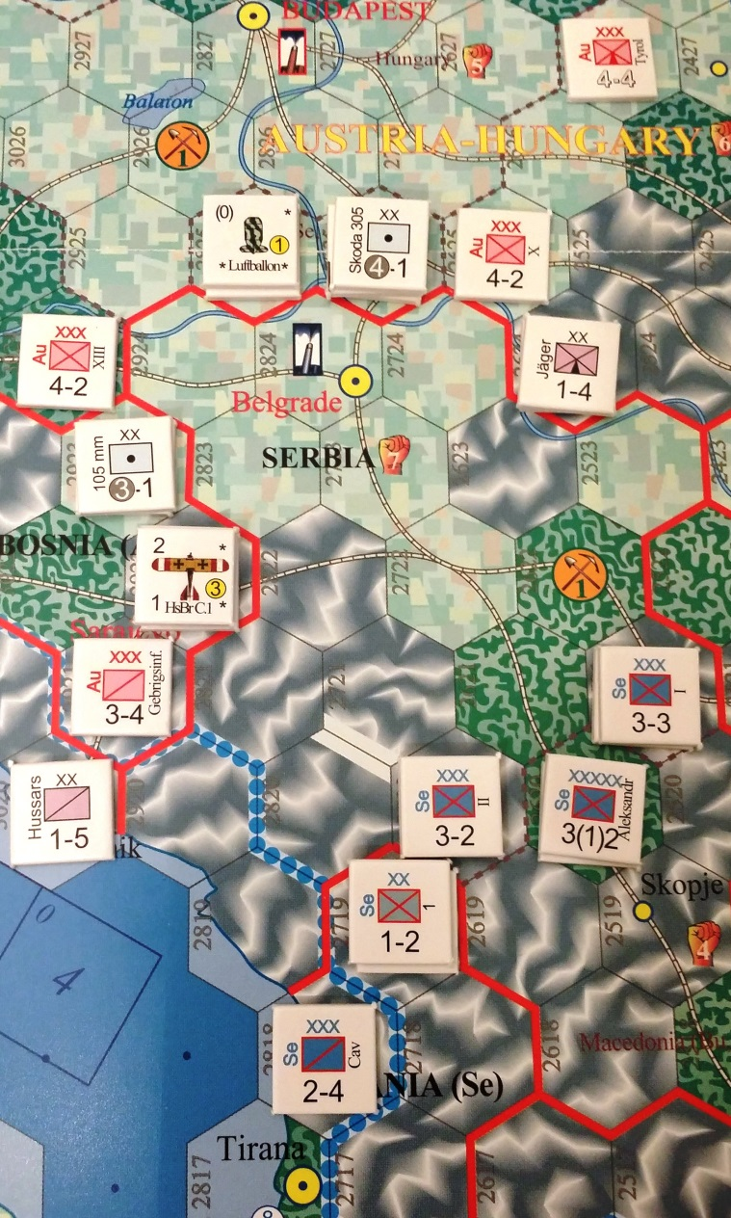Now that setup is complete, you’re ready to start. The Central Powers move first (1st impulse), and start off the game by declaring war on Serbia. This triggers a Serbian alignment with Russia and Serbian setup (all non-Res/MIL) forces marked 1913 or older. For minors, current-year (1914 in this case) units and reserves set up to arrive as reinforcements next turn, and MIL units are added to the force pool (which is shared with the Russians, but only if the Russians want to add Serbians to their force pools to be able to build Serbian units).
Serbian setup

Normally, declarations of war would cost political points (except for automatic forced declarations of war, of which this is one – plus there are no political points in this scenario), and you’d roll for US and CW entry markers (based on the Entry Action chart). US and CW entry are how the US and Commonwealth enter the war (and in the case of the United States, select options against the Central Powers). However, you ignore US & CW entry in this scenario.

Because the Austrian setup is so strong vs. Serbia, the Russian player decides to abandon Belgrade and set up the Serbian units in the Southern mountains. This means that the Serbian Belgrade MIL will never arrive, but the Russians decide that’s a cost worth paying. Note that for most minors this would not be a valid strategy because they’d be conquered at the end of a turn when their capital and all their factories fell, but Serbia has a special rule so that it fights until Skopje is also taken (and it is only incompletely conquered until Albania is also conquered, which is considered an aligned minor of Serbia).

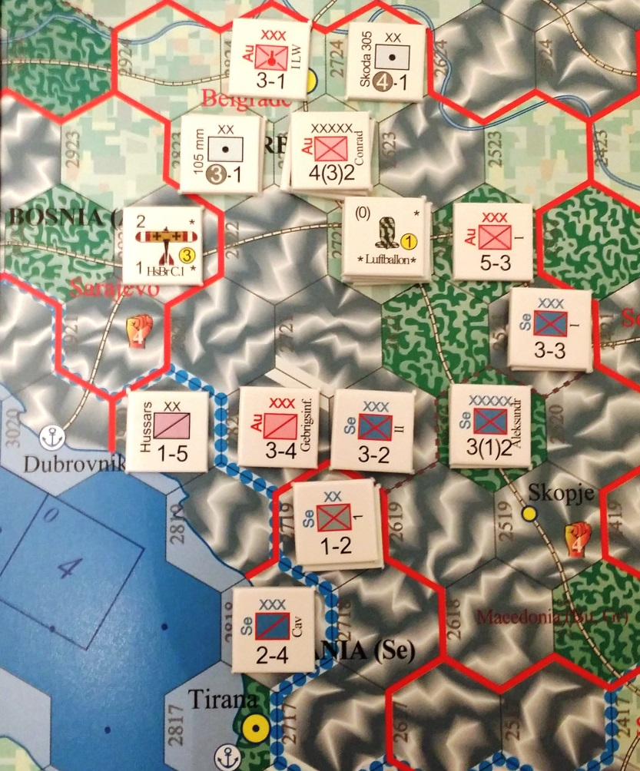The Austrians select a land impulse, which allows unlimited land moves and attacks, along with some rail and air moves, but no naval moves (normally this is not allowed by a neutral major power, which Austria still is considered until at war with a major power, but there is a special rule for the first impulse of the game).
Austrian first impulse

One thing to keep in mind when moving and attacking is supply range. The Austrian units are in supply provided they’re in range of one of their HQs, home country cities, or an aligned or conquered minor capital city (in this case Sarajevo counts, being the capital of Bosnia). Normal supply range is 4 hexes, but this is affected by weather (snow/rain) and sometimes terrain (desert). See the rules for a full description of how supply works.

First the Austrians conduct any rail moves (to redeploy to the Russian front, perhaps), and then land moves. Each land unit has a combat value followed by a move value (e.g., 3-3 = 3 combat, 3 movement). The terrain effects chart on the World Map outlines how many movement points each type of terrain costs to enter (most units use the leg movement cost, but later in the game some units are motorized). For example, the Austrian 3-4 cavalry can move 2 mountain hexes (2 movement points each), and the 1-4 mountain division could move into the mountain (2 movement points), and then the clear hex, and then forest next to the Serbian HQ. Units move sequentially in whatever order the player chooses, and must stop if they enter an enemy zone of control (ZOC), which is present in all hexes surrounding an enemy corps-sized unit (but not division). A unit can move into a hex that would exceed its movement allowance, but it must flip (become disorganized) to do so.

The Austrians move up in several places to occupy Belgrade and make contract with the Serbians units, and then rebase their balloon 3 spaces (3x range over friendly territory = 3 hexes). With no more moves, and no attacks they wish to perform, the Austrian impulse is complete. Note that the Germans also have an impulse at the same time, but they are neutral (and obliged to call PASS on the first impulse).

Move the impulse marker one space. Next it’s the Russian impulse, and the Russians must declare war on the Austrians (again no political effects for this forced DOW [and no politics in this scenario], but in the campaign you would roll for US and CW entry markers). Since the Russians and Austrian are now active, they may both place their reserves (reinforcements arrive in cities, and for some units in specific cities as marked on them). Note that this means you can even reinforce units into empty cities to defend them, but all reserves arrive face-down ("disrupted"), which means they can't move and are more vulnerable. Save the Russian ‘Ge’ reserves until Russia is active vs. Germany.

Russia calls a land action to take advantage of the surprise impulse vs. the Austrians (you get a surprise impulse for the impulse you declare war – the Austrians also had one vs. the Serbians but couldn’t really take advantage of it). Also, at the start of the Russian impulse, they declare a land offensive action on Yudenich (who has a reorganization value of 3, in brackets). This costs 5 plus double the reorganization value of the HQ, so 5+6 = 11 offensive points. Note that the Russians aren’t yet at war with Germany, so Russia can’t enter German territory and aren’t affected by their units.

Prior to land movement, the Russians conduct ground strikes and rail moves. Since they have an artillery unit adjacent to the Austrians in Krakow, they decide to ground strike the Austrians located in the city. Thanks to surprise, they roll two dice on each Austrian unit (hitting on the artillery value of ‘2’ or less; without surprise they would only roll 1 die per unit). Note that even fortifications which the Austrians placed in the city can be hit by ground strike. The Russians miss their ground strike on all units, so they decided not to attack Krakow (which would happen later in the impulse; note that the order of operations follows the “Allowable Activities” table in the charts).
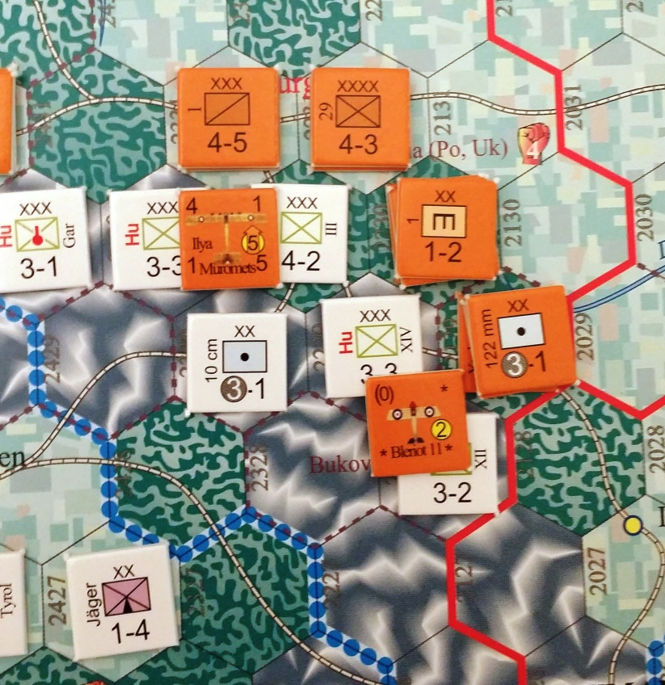
Russian attack preparations (with recon "ground support" assigned)
The Russian forces advance into Austrian territory during the land movement step. Yudenich lines up a strong force vs. the Austrian southern flank, just north of the Rumanian border. After all land movement is complete, the Russians announce two attacks: one against the Hungarian 4-2 INF in the forest hex, and one against the Hungarian 3-3 INF in the top mountain hex (which is doubled to 6 defense for being in a mountain).

The Russians allocate an aircraft in range to fly as a recon mission for each attack (which are actually allocated and then landed face-down one at a time, before each attack is resolved but after all attacks are declared). The Austrians are unable to allocate any aircraft or fire the gun in defensive ground support because of the surprise impulse. The Russians choose to fire the 3-1 artillery in offensive ground support (it could attack instead, but it its factors are doubled to 6 on the surprise impulse for bombardment - the disadvantage being that it automatically flips after combat if it bombards).
On the Northern attack on the 4-2 INF, the Russians have 4+4+4+4 = 16 factors, against the Austrian 4 factors on defense (16/4 = 4:1). However, Yudenich can choose to double the factors of up to 6 units because of the declared land offensive, so the Russian player decides to double two of the 4-factor units for a total of 24 attacking factors. This gives the Russians 24:4 in the Northern attack, which on the combat table results in a +12 from odds (24/4 = 6 x 2 = +12 modifier).

Since the Russians don't have any MECH or armor (stosstruppen count as mech), the Austrians get to choose the table (almost always the case). Hoping to inflict casualties on the Russians, the Austrians select an assault. Since the Russians have an observer aircraft, they don't suffer a -1 penalty. There are no other modifiers, so the Russians roll two dice (2d10). The die roll is a '8', so the final combat result is 20 (8+12=20). Looking at the assault table for a 20, the result is 1/1.5S (with half the attackers not turned face-down; applied after advancing after combat). The Russians must lose 1 corps-sized unit, so they choose to lose one of the 4-3 INF. The Austrians would have to lose a corps and a division (1.5), but since they just have a corps, they lose it. The players set the destroyed units aside in a pile - these will count towards morale losses at the end of turn (0.3 morale points for the unit costs), but the Austrian player will get 1 bonus build point for losing a corps-sized unit in its major power home country.

Then Russians advance after combat. Since cavalry can advance after combat without flipping, the Russians move the 4-4 CAV into the combat hex. Now the Russians apply the half face-up result by flipping one of the remaining face-up units (half of 3 units remain face-up = 2 units face-up, so 1 unit must flip).

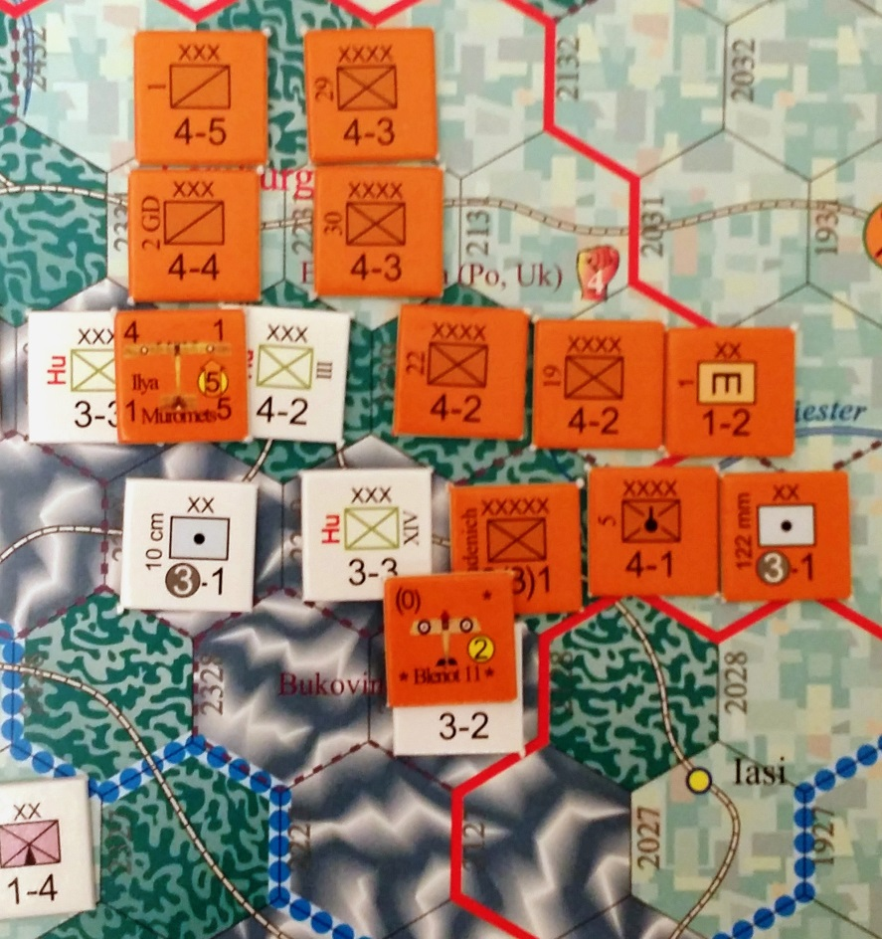Now the Russians resolve the Southern attack on the 3-3 INF. They have 4+4+1+3+4+6 = 22 attacking factors, but since they can still double the factors of 4 units from the Yudenich offensive, they double the 3 artillery to 6 before doubling for surprise (=12 total bombardment factors), and the three 4-factor units, giving a total of 40 attacking factors. The combat odds are 40/6 (mountain) = 6.67:1 x2 = +13.3. Additionally, the Russians have 1 Engineer (+1), and an aircraft to avoid the lack of observer penalty. Not wanting to take any chances, the Russians also decide to use HQ support (+3/2 = +1.5), for a total of a +13.3+1+1.5 = +15.8 attack. Hoping to save their unit, this time the Austrians select a Blitz attack.
Russian Force lineup

Since the attack has a fractional value, if you're playing with fractional odds, you'd roll a third die and if it was an 8 or less, the attack would become a +16 (on a 9-10 it would be a +15). Otherwise, you could choose to round or truncate combat results to the nearest whole number. The Russian player rolls a '6' on the fractional die and '7' on the d10 attack roll. Not a great roll, but still good enough to get a +16+7 = 23 result. The result is */1R.

The Russians lose nothing and remain face-up, while the Austrians lose their corps (any remaining Austrian units would have been retreated by the Russians). The Russians advance two INF into the hex, which have to flip during advance after combat. Since Yudenich used HQ support, it also flips after combat (along with the ART which bombarded). If the Russians hadn't used HQ support, they wouldn't have destroyed the Austrian unit, but they would have been able to reorganize units with Yudenich (at half cost using the selected HQ for land units during the land offensive). Note that reorganizing air or naval units on a land impulse would cost double the normal value (2 reorg points).

Advance the impulse marker again. The Central powers roll for weather (the first impulse of a turn, and then again every time that same side moves), and then start their second impulse (impulse #3 on the track). Now the Germans must declare war on Russia (again no political effects for this forced DOW [and no politics in this scenario], but in the campaign you would roll for US and CW entry markers). Since the Germans are now active, they may place their reserves (reinforcements arrive in cities, and for some units in specific cities as marked on them). Also place Russian ‘Ge’ reserves. Now the Central Powers may declare war on other countries if they wish (e.g., Rumania; unlikely at this point), and then select an impulse type, and start moving.

With each impulse, keep moving and advancing the impulse marker. When you get high enough on the impulse track, you'll start checking for end of turn. When you roll that value or less, the turn ends and you start the end of turn step where you'll produce new units, reorganize everything, etc.

Naval Example:

Meanwhile, later in the turn, Russia decides to perform a naval action to get unlimited naval moves to put some ships out to sea in the Baltic. It costs one naval move per task force (ships moving together) that you move out to a sea zone (i.e., each group of ships in a different box costs an extra naval move). The Russians move the battleships Gangut and Poltava from St. Petersburg to the 3 box (the highest they could get with 4 speed since it would cost 1 to get to the ‘0’ box, 2 to get to the ‘1’ box, 3 to get to the ‘2’ box, etc.). This costs 1 naval move. Since the ships are only moving 1 sea zone (Baltic), it only costs them 1 range. To move to an adjacent sea zone, it would cost the ship 1 range and also 1 movement point (so the ships could only get to the ‘2’ box in the next sea zone).

The Russian player also moves the older battleship Retvizan to the ‘2’ box (at 3 speed, the highest it can get). Since the Russians are moving two different sets of ships (to two different boxes), it costs them two naval moves (which they couldn’t do on a combined action where they just get one naval move). The Russians initiate a search for the German convoys in the ‘0’ box (which started the scenario at sea). They turn over one of their ship counters to initiate the search.

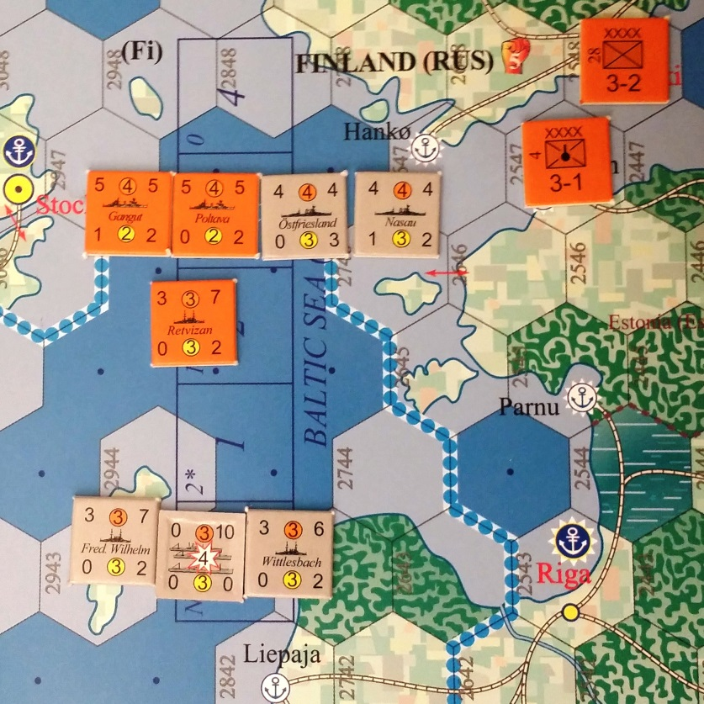The Russians in the ‘3’ box need to roll a ‘4’ to find (3 for box + 1 for searching for convoys), and the Retvizan needs to roll a ‘3’ to find (only one die is rolled by the Russian player). The Russians and Germans both roll a die (although the German player can’t find from the ‘0’ box, so their roll only counts if the Russians find). In this case, however, the Russians roll an ‘8’ and fail to find the German convoys.
Naval Combat in the Baltic (Note that in the described example, at least one Russian ship and one German ship should be turned face-down for the two initiated combats)

Later in the turn, the Germans select a combined action on their impulse, and use one of their naval moves to send the Nassau and Ostfriesland to the ‘3’ box in the Baltic and their other naval move to put two ships into the 0-box to escort the convoys. They then turn over one unit to initiate a search (note that it could even be a unit in the ‘0’ box, but not a convoy). The Germans need a ‘3’ to find, while the Russian 3-box and 2-box find on a ‘4’ or ‘3’, respectively (with the +1 convoy bonus). In this case, the German player rolls a ‘5’, while the Russian player rolls a ‘4’. Based on the rolls, the Russian ships in the 3-box find the Germans, while the Germans fail to find the Russians. The Russian ship in the ‘2’ box cannot be included, but the Russian ships in the ‘3’ box can choose which German boxes they want to include in combat. Since they’re aiming for the convoys, the Russians elect to include the German ‘0’ box only.

The Russians earn surprise points equal to their highest included box (3) plus the German roll (5) = 8. The Germans earn surprise points equal to their highest included box (0) plus the Russian roll (4) = 4. The Russians can spend the difference (8-4 = 4 surprise points). Since no one has any subs, it is a surface combat. The Russians have 10 surface combat factors against the 4 German ships in the 0-box (each 2 convoys or part thereof counts as a ship), which inflicts 2D and 1A result. The Germans opt to screen their convoys, meaning they may only be attacked if the screening units are sunk or aborted or if surprise points are spent to select them. Since the Russians are trying to attack German convoys, they decide to use 3 points to apply one of the D results to a German convoy, sinking 1 convoy point (this will also reduce German production by stopping a resource from Sweden unless replaced before the end of the turn). The last surprise point is wasted (the Russians could instead have chosen to shift either their result column or the German result column or both for two surprise points per shift).

Since the Russians apply every second result against the Germans (and selected the first result which normally would have been a German pick) but can't select screened convoys, they apply a D to the Fred. Wilhelm (defense = 7), and it rolls a '5' for its defense roll (resulting in it being damaged). The German then apply the last result they take, an 'A'. They apply it to the damaged Fred. Wilhelm and roll a '9', which is over the new defense value of 8 (+1 for damaged). So the ship remains in the sea zone until the end of all combats there (if it aborted, it would immediately return to base).

Now the Russians take damage. The Germans have 6 surface factors against 2 Russian ships = 1 D, 1A. The Russians apply the D to Poltava and roll a '6', meaning Poltava immediately aborts (saved D becomes 1/2D = A if there are no more D results) and chooses to return to St. Petersburg. Next the Germans apply the A to the only remaining Russian ship in combat, Gangut. Gangut rolls a '9' so stays at sea. The combat round is over.

Since there was a combat, both sides decide if they want to remain at sea and search again or return to base (all ships would have to return, not just those involved in combat). Since it's the German impulse they decide first, and decide to stay because they have convoys in the sea zone. The Russians decide discretion is the better part of valor, and return their two remaining ship in the sea zone to home port.

