KABO TOOL COMPANY
TW1 - Calibration SOP
maintain |  | Calibration SOP |  |  | Date： |  | version no：
 |  |  |  |  | 2015/01/30 |  | A1
 |  |  |  |  | Establish date : |  | PAGE/OF：
 |  |  |  |  | 2015/01/30 |  | 1/2
Process |  |  | Photo |  |  | Operation/Testing points
`  Preparation |  |  | 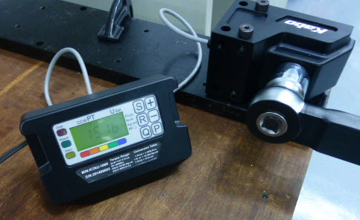  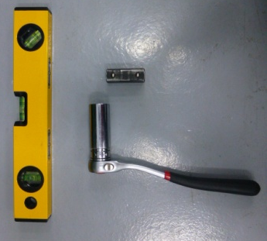  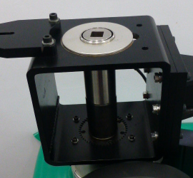  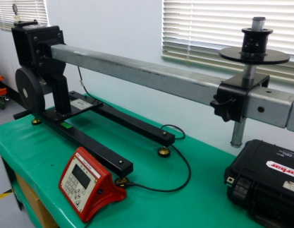 |  |  | - Torque Tester:  - Torque tester-  KABO_KTT1500  - Torque loader-  Norbar_I.S.O.2000  - Transducer (500 NM)-  Norbar torque  - Product  - TW1 Torque Wrench  - Tools  - 6-Point 22mm Socket  - 3/8”Dr. Ratchet handle  - 3/4" 四角條  - Level
20% of the max torque Calibration |  |  | 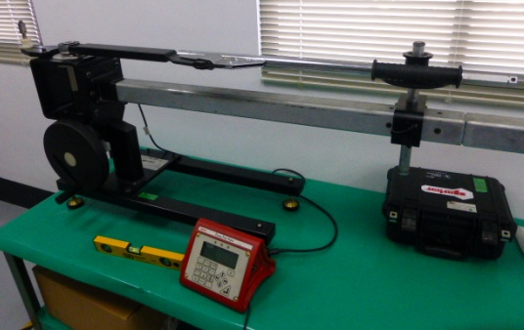  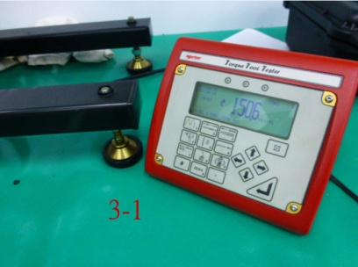  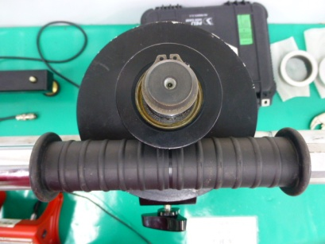  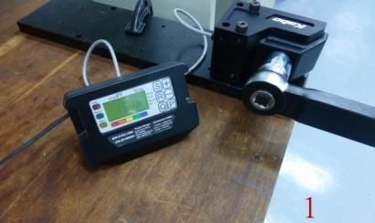  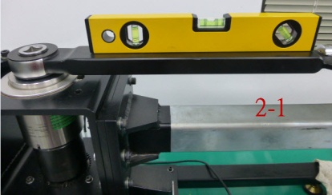  3-2  2-2 |  |  | To confirm the initial scale-  - Use the torque equipment to check the accuracy, 150 Ft-lb.  - Place the torque wrench on the torque loader and use “level” to check the wrench in horizontal line.  - Adjust the forcing point in place.  - Make sure the value 150 Ft-lb within +/-4% tolerance.  3-2 The scale must be “face-up”.
Authorize | Plant Manager: Edward Chang |  |  | QC Manager：Jack Tsai |  | Issue by Ben Chang
KABO TOOL COMPANY
TW1 – Calibration SOP
maintain |  | Calibration SOP |  |  | Date： |  | Version no:
 |  |  |  |  | 2015/01/30 |  | A1
 |  |  |  |  | Establish date : |  | PAGE/OF：
 |  |  |  |  | 2015/01/30 |  | 2/2
Process |  |  | Photo |  |  | Operation/Testing points
60% of the max torque Calibration |  |  | 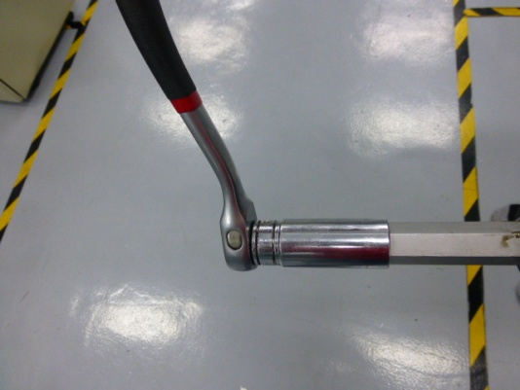  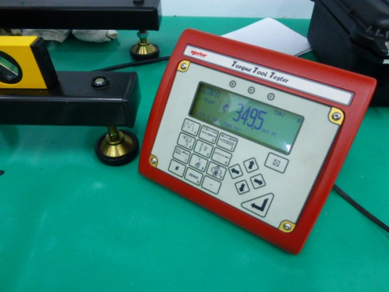 |  |  | Check the torque value of 350 Ft-lb-  - When 150 Ft-lb values confirmed, then turn 18.5 laps clock-wisely to 350 Ft-lb.  - Then, check the value 350 Ft-lb is within +/-4% tolerance.
100% of the max torque Calibration |  |  | 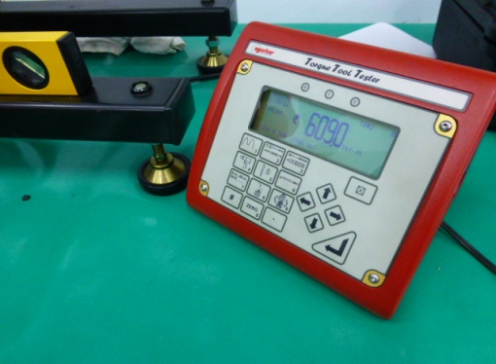  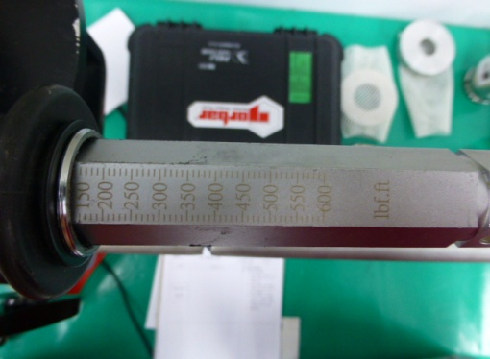 |  |  | Check the torque value of 600 Ft-lb-  - To turn the handle 22.5 laps clock-wisely to 600 Ft-lb.  - Then, check the value 600 Ft-lb is within +/-4% tolerance.  - Once the toque value is within +/-4% tolerance, then turn 41 laps counter-clockwisely to 150 Ft-lb.
Authorize | Plant Manager: Edward Chang |  |  | QC Manager：Jack Tsai |  | Issue by Ben Chang

