PT245G - Green Buffer/In-Line Drill, 2600 RPM

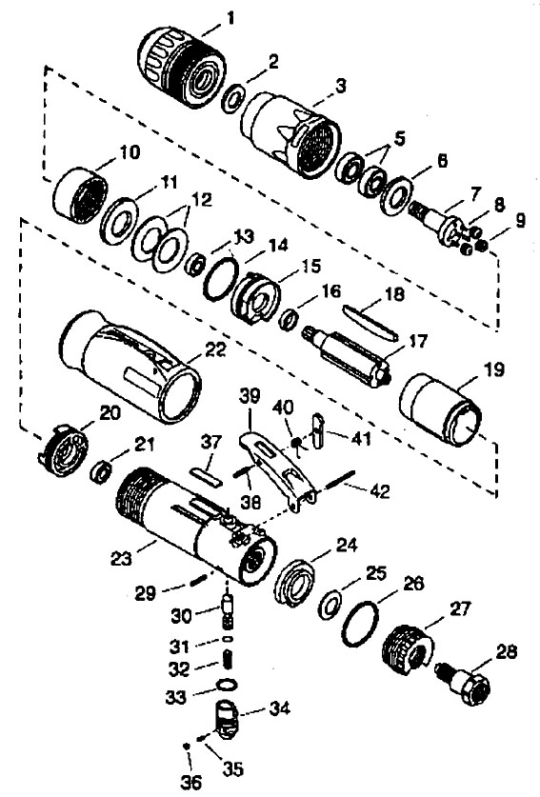

 |  | KEY |  | PART NO. | QTY |  | DESCRIPTION
 | 2 |  | ME5A72 |  |  | 1 |  | Washer, Spring (between 4 and 5)
 | 3 |  | PT240-3R |  |  | 1 |  | Nut, Clamp (incl. RPM label)
 | 5 |  | ME11A17 |  |  | 2 |  | Bearing
 | 6 |  | ME5A142 |  |  | 1 |  | Washer
 | 7 |  | PT245-39 |  |  | 1 |  | Spindle
 | 8 |  | ME2A136 |  |  | 3 |  | Pin, Gear
 | 9 |  | PDR3A400 |  |  | 3 |  | Planet Gear
 | 10 |  | PT245-8 |  |  | 1 |  | Gear, Internal
 | 11 |  | PT260-34 |  |  | 1 |  | Pilot
 | 12 |  | ME1G10 |  |  | 2 |  | Spring, Disc
 | 13 |  | ME11A12 |  |  | 1 |  | Ball Bearing
 | 16 |  | PT200-10B |  |  | 1 |  | Front End Plate Spacer
 | 18 |  | PT200-30-4V |  |  | 1 |  | Vane
 | 19 |  | PT200-7A |  |  | 1 |  | Cylinder Liner
 | 20 |  | PT200-5A |  |  | 1 |  | Rear End Plate
 | 21 |  | ME11A35 |  |  | 1 |  | Ball Bearing
 | 22 |  | PT210-204 |  |  | 1 |  | Br. Green Jacket
 | 23 |  | PT200-1 |  |  | 1 |  | Housing
 | 25 |  | ME1G13 |  |  | 1 |  | Disc Spring
 | 14 |  | ME7B93 |  |  | 1 |  | O-Ring
 | 27 |  | PT200-23 |  |  | 1 |  | Exhaust Deflector
 | 28 |  | ME6F5 |  |  | 1 |  | Inlet Bushing
 | 30 |  | PT200-11A |  |  | 1 |  | Valve Stem
 | 31 |  | ME7B11 |  |  | 1 |  | Retaining Ring
 | 32 |  | ME1A227 |  |  | 1 |  | Compression Stem Spring
 | 33 |  | ME7B61 |  |  | 1 |  | O-Ring
 | 34 |  | PT200-12 |  |  | 1 |  | Regulator
 | 35 |  | ME1A189 |  |  | 1 |  | Compression Spring
 | 36 |  | ME9A14 |  |  | 1 |  | 1/8" diameter Ball
 | 37 |  | PT200-2A |  |  | 1 |  | Slick Pad
 | 38 |  | ME2C77 |  |  | 1 |  | Spiral Pin
 | 39 |  | PT250-9A |  |  | 1 |  | Paddle
 | 40 |  | ME1C11 |  |  | 1 |  | Paddle Torsion Spring
 | 41 |  | PT250-20A |  |  | 1 |  | Paddle Lever
 | 29 |  | ME2C78 |  |  | 1 |  | Roll Pin
 | 42 |  | ME2C78 |  |  | 1 |  | Roll Pin
 | – |  | ME7B73 |  |  | 1 |  | O-Ring (Motor)
 | 1 |  | PT265-42 |  |  | 1 |  | Chuck

