|  |
| --- |
| **PT200LG - Green Extended Die Grinder** |

|  |
| --- |
| D:\Install\catalog\html\objects\30900\30800.JPG |

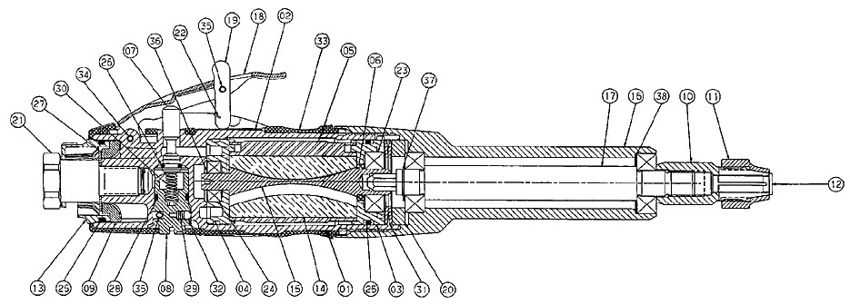

|  |
| --- |
|  |

|  |  |  |  |  |  |  |  |  |  |
| --- | --- | --- | --- | --- | --- | --- | --- | --- | --- |
|  | | **KEY** | | **PART NO.** | **QTY** | | **DESCRIPTION** | |  |
| **C:\Program Files\partscd\Snap-on Parts\html\images\add_sm.gif** | 1 | | PT200-1 | | | 1 | | Housing | |
| **C:\Program Files\partscd\Snap-on Parts\html\images\add_sm.gif** | 2 | | PT200-2A | | | 1 | | Slick Pad | |
| **C:\Program Files\partscd\Snap-on Parts\html\images\add_sm.gif** | 4 | | PT200-5A | | | 1 | | Rear End Plate | |
| **C:\Program Files\partscd\Snap-on Parts\html\images\add_sm.gif** | 5 | | PT200-7A | | | 1 | | Cylinder Liner | |
| **C:\Program Files\partscd\Snap-on Parts\html\images\add_sm.gif** | 6 | | PT200-10B | | | 1 | | Front End Plate Spacer | |
| **C:\Program Files\partscd\Snap-on Parts\html\images\add_sm.gif** | 7 | | PT200-11A | | | 1 | | Valve Stem | |
| **C:\Program Files\partscd\Snap-on Parts\html\images\add_sm.gif** | 8 | | PT200-12 | | | 1 | | Regulator | |
| **C:\Program Files\partscd\Snap-on Parts\html\images\add_sm.gif** | 10 | | PT200-15 | | | 1 | | Collet, .25 | |
| **C:\Program Files\partscd\Snap-on Parts\html\images\add_sm.gif** | 11 | | PT200-17A | | | 1 | | Collet Cap | |
| **C:\Program Files\partscd\Snap-on Parts\html\images\add_sm.gif** | 13 | | PT200-23 | | | 1 | | Exhaust Deflector | |
| **C:\Program Files\partscd\Snap-on Parts\html\images\add_sm.gif** | 14 | | PT200-30-4V | | | 1 | | Vane | |
| **C:\Program Files\partscd\Snap-on Parts\html\images\add_sm.gif** | 16 | | PT200L-40 | | | 1 | | Housing Extension Tube | |
| **C:\Program Files\partscd\Snap-on Parts\html\images\add_sm.gif** | 17 | | PT200L-41 | | | 1 | | Spindle Extension Shaft | |
| **C:\Program Files\partscd\Snap-on Parts\html\images\add_sm.gif** | 18 | | PT250-9A | | | 1 | | Paddle | |
| **C:\Program Files\partscd\Snap-on Parts\html\images\add_sm.gif** | 19 | | PT250-20A | | | 1 | | Paddle Lever | |
| **C:\Program Files\partscd\Snap-on Parts\html\images\add_sm.gif** | 20 | | PT260-34 | | | 1 | | Pilot | |
| **C:\Program Files\partscd\Snap-on Parts\html\images\add_sm.gif** | 21 | | ME6F5 | | | 1 | | Inlet Bushing | |
| **C:\Program Files\partscd\Snap-on Parts\html\images\add_sm.gif** | 22 | | ME2C11 | | | 1 | | Torsion Spring | |
| **C:\Program Files\partscd\Snap-on Parts\html\images\add_sm.gif** | 23 | | ME11A12 | | | 3 | | Ball Bearing | |
| **C:\Program Files\partscd\Snap-on Parts\html\images\add_sm.gif** | 24 | | ME11A35 | | | 1 | | Ball Bearing | |
| **C:\Program Files\partscd\Snap-on Parts\html\images\add_sm.gif** | 25 | | ME7B93 | | | 2 | | O-Ring | |
| **C:\Program Files\partscd\Snap-on Parts\html\images\add_sm.gif** | 26 | | ME7B11 | | | 1 | | Retaining Ring | |
| **C:\Program Files\partscd\Snap-on Parts\html\images\add_sm.gif** | 27 | | ME1G13 | | | 1 | | Disc Spring | |
| **C:\Program Files\partscd\Snap-on Parts\html\images\add_sm.gif** | 28 | | ME7B61 | | | 1 | | O-Ring | |
| **C:\Program Files\partscd\Snap-on Parts\html\images\add_sm.gif** | 29 | | ME1A189 | | | 1 | | Compression Spring | |
| **C:\Program Files\partscd\Snap-on Parts\html\images\add_sm.gif** | 30 | | ME1A227 | | | 1 | | Compression Stem Spring | |
| **C:\Program Files\partscd\Snap-on Parts\html\images\add_sm.gif** | 31 | | ME1G10 | | | 2 | | Spring, Disc | |
| **C:\Program Files\partscd\Snap-on Parts\html\images\add_sm.gif** | 32 | | ME9A14 | | | 1 | | 1/8" diameter Ball | |
| **C:\Program Files\partscd\Snap-on Parts\html\images\add_sm.gif** | 33 | | PT210-204 | | | 1 | | Br. Green Jacket | |
| **C:\Program Files\partscd\Snap-on Parts\html\images\add_sm.gif** | 34 | | ME2C78 | | | 1 | | Roll Pin | |
| **C:\Program Files\partscd\Snap-on Parts\html\images\add_sm.gif** | 35 | | ME2C77 | | | 2 | | Spiral Pin | |
| **C:\Program Files\partscd\Snap-on Parts\html\images\add_sm.gif** | 36 | | ME7A165 | | | 1 | | Rotor Retaining Ring | |
| **C:\Program Files\partscd\Snap-on Parts\html\images\add_sm.gif** | 37 | | ME7A166 | | | 1 | | Shift Retaining Ring | |
| **C:\Program Files\partscd\Snap-on Parts\html\images\add_sm.gif** | 38 | | ME5C15 | | | 1 | | Bearing Preload Spring | |