FAR7200 - 3/8" Sq. Dr. Air Ratchet

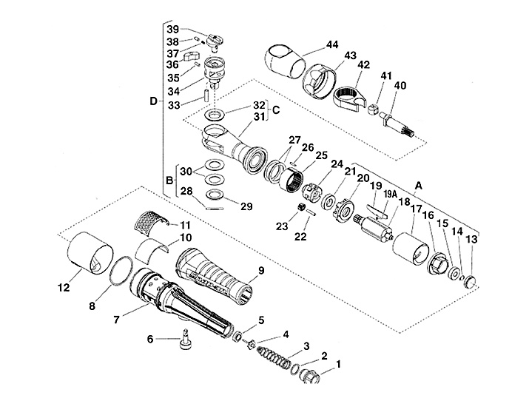

 |  | KEY |  | PART NO. | QTY |  | DESCRIPTION
 | A |  | FAR7200-500 |  |  | 1 |  | Air Motor Assembly
 | 15 |  | – ME11A27 |  |  | (1) |  | – Ball Bearing
 | 19A |  | – ME1A203 |  |  | (4) |  | – Rotor Blade Spring
 | 13 |  | – PD3C203 |  |  | (1) |  | – Plug
 | 21 |  | – ME11A46 |  |  | (1) |  | – Bearing, Ball
 | 14 |  | – ME7A184 |  |  | (1) |  | – Ring, Retaining
 | 16 |  | – FAR7200-55 |  |  | (1) |  | – Plate, Rear End
 | 17 |  | – FAR7200-52 |  |  | (1) |  | – Liner, Cylinder
 | 18 |  | – FAR7200-51 |  |  | (1) |  | – Rotor
 | 19 |  | – FAR7200-56V4 |  |  | (4) |  | – Vane
 | 20 |  | – FAR7200-54 |  |  | (1) |  | – Plate, Front End
 | B |  | FAR7200-600R |  |  | 1 |  | Kit, Brake, Disc
 | 28 |  | – ME2D173 |  |  | (1) |  | – Pin, Grooved
 | 30 |  | – ME1G17 |  |  | (2) |  | – Spring, Disc
 | C |  | FAR7200-400R |  |  | 1 |  | Ratchet Housing Assembly
 | 32 |  | – FAR7200-9R |  |  | (1) |  | – Bushing, Wear
 | D |  | FAR7200-300R |  |  | 1 |  | Kit, Drivebody
 | 38 |  | – FAR72A306A |  |  | (2) |  | – Plunger
 | 37 |  | – ME1A168C |  |  | (2) |  | – Pawl Spring
 | 33 |  | – ME2A108B |  |  | (1) |  | – Pawl Pin
 | 35 |  | – ME2A133 |  |  | (2) |  | – Pawl Stop Pins
 | 39 |  | – FAR72A310AR |  |  | (1) |  | – Knob, Selector
 | 28 |  | – ME2D173 |  |  | (1) |  | – Pin, Grooved
 | 30 |  | – ME1G17 |  |  | (2) |  | – Spring, Disc
 | 34 |  | – FAR7200-301R |  |  | (1) |  | – Drivebody
 | 1 |  | ME6F4A |  |  | 1 |  | Inlet Bushing
 | 2 |  | – ME7B68 |  |  | (1) |  | – O-Ring
 | 2 |  | ME7B68 |  |  | 1 |  | O-Ring
 | 3 |  | ME1A226 |  |  | 1 |  | Spring
 | 4 |  | IM5100-20A |  |  | 1 |  | Trigger Valve
 | 2 |  | – ME7B68 |  |  | (1) |  | – O-Ring
 | 5 |  | IM5100-22A |  |  | 1 |  | Valve Seat
 | 6 |  | FAR7200-200 |  |  | 1 |  | Trigger
 | 7 |  | FAR7200-1R |  |  | 1 |  | Handle
 | 8 |  | ME7B23J |  |  | 1 |  | Spacer Plate O-Ring
 | 9 |  | FAR7200-28 |  |  | 1 |  | Grip, Cushion
 | 10 |  | FAR7200-33 |  |  | 1 |  | Material, Muffler
 | 11 |  | FAR7200-12 |  |  | 1 |  | Retainer, Muffler
 | 12 |  | FAR7200-10 |  |  | 1 |  | Sleeve, Muffler
 | 13 |  | PD3C203 |  |  | 1 |  | Plug
 | 14 |  | ME7A184 |  |  | 1 |  | Ring, Retaining
 | 42 |  | – FAR72B-8B |  |  | (1) |  | – Ratchet Head
 | 41 |  | – FAR7200-7 |  |  | (1) |  | – Bar Element
 | 40 |  | – FAR7200-5 |  |  | (1) |  | – Shaft, Drive
 | 15 |  | ME11A27 |  |  | 1 |  | Ball Bearing
 | 16 |  | FAR7200-55 |  |  | 1 |  | Plate, Rear End
 | 17 |  | FAR7200-52 |  |  | 1 |  | Liner, Cylinder
 | 18 |  | FAR7200-51 |  |  | 1 |  | Rotor
 | 19 |  | FAR7200-56V4 |  |  | 4 |  | Vane
 | 19A |  | ME1A203 |  |  | 4 |  | Rotor Blade Spring
 | 20 |  | FAR7200-54 |  |  | 1 |  | Plate, Front End
 | 21 |  | ME11A46 |  |  | 1 |  | Bearing, Ball
 | 22 |  | ME2A107 |  |  | 3 |  | Planetary Gear Pin
 | 23 |  | FAR72-6 |  |  | 3 |  | Planetary Gear
 | 24 |  | – FAR72-4A |  |  | (1) |  | – Planetary Gear Carrier
 | 23 |  | – FAR72-6 |  |  | (3) |  | – Planetary Gear
 | 22 |  | – ME2A107 |  |  | (3) |  | – Planetary Gear Pin
 | 21 |  | – ME11A46 |  |  | (1) |  | – Bearing, Ball
 | 24 |  | FAR72-4A |  |  | 1 |  | Planetary Gear Carrier
 | 25 |  | FAR7200-3 |  |  | 1 |  | Gear, Internal
 | 26 |  | ME2A148 |  |  | 2 |  | Pin
 | 27 |  | ME1G18 |  |  | 2 |  | Spring, Disc
 | 28 |  | ME2D173 |  |  | 1 |  | Pin, Grooved
 | 29 |  | FAR7200-41 |  |  | 1 |  | Washer, Grooved
 | 30 |  | ME1G17 |  |  | 2 |  | Spring, Disc
 | 31 |  | FAR7200-2 |  |  | 1 |  | Housing, Ratchet
 | 32 |  | FAR7200-9R |  |  | 1 |  | Bushing, Wear
 | 33 |  | ME2A108B |  |  | 1 |  | Pawl Pin
 | 34 |  | FAR7200-301R |  |  | 1 |  | Drivebody
 | 35 |  | ME2A133 |  |  | 2 |  | Pawl Stop Pins
 | 37 |  | ME1A168C |  |  | 2 |  | Pawl Spring
 | 38 |  | FAR72A306A |  |  | 2 |  | Plunger
 | 39 |  | FAR72A310AR |  |  | 1 |  | Knob, Selector
 | 40 |  | FAR7200-5 |  |  | 1 |  | Shaft, Drive
 | 41 |  | FAR7200-7 |  |  | 1 |  | Bar Element
 | 42 |  | FAR72B-8B |  |  | 1 |  | Ratchet Head
 | 43 |  | FAR7200-11 |  |  | 1 |  | Nut, Clamp
 | 44 |  | YA889A |  |  | 1 |  | Boot, Air Tool, Vinyl (for FAR72 Series)
 | – |  | FAR7200-60 |  |  | 1 |  | Label

