AT811 - 3/8" (10mm) Reversible Right Angle Drill

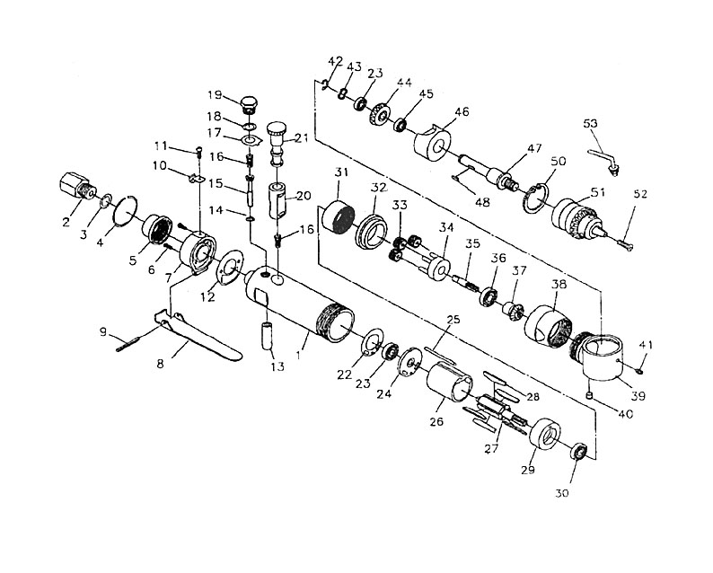

 |  | KEY |  | PART NO. | QTY |  | DESCRIPTION
 | 1 |  | AT811-1 |  |  | 1 |  | Housing, Motor
 | 2 |  | AT811-2 |  |  | 1 |  | Inlet, Air
 | 4 |  | AT811-3 |  |  | 1 |  | Ring, Stop
 | 5 |  | AT811-4 |  |  | 1 |  | Muffler
 | 6 |  | AT811-5MP2 |  |  | 2 |  | Screw, 2/pkg
 | 7 |  | AT811-6 |  |  | 1 |  | Intake, Air
 | 8 |  | AT811-7 |  |  | 1 |  | Lever, Throttle
 | 9 |  | AT109-13 |  |  | 1 |  | Pin
 | 10 |  | AT811-8 |  |  | 1 |  | Holder, Key, Chuck
 | 11 |  | AT803-28 |  |  | 1 |  | Screw
 | 12 |  | AT811-9 |  |  | 1 |  | Gasket, Housing
 | 13 |  | AT811-10 |  |  | 1 |  | Bushing, Valve
 | 14 |  | AT105-4 |  |  | 1 |  | O-Ring
 | 15 |  | AT811-11 |  |  | 1 |  | Pin, Throttle
 | 16 |  | AT105-7 |  |  | 2 |  | Spring
 | 17 |  | AT811-12 |  |  | 1 |  | Retainer, Reverse
 | 19 |  | AT811-13 |  |  | 1 |  | Screw, Valve
 | 20 |  | AT811-14 |  |  | 1 |  | Bushing, Reverse
 | 21 |  | AT811-15 |  |  | 1 |  | Valve Reverse
 | 22 |  | AT803-16 |  |  | 1 |  | Gasket, Motor
 | 23 |  | AT156-17 |  |  | 2 |  | Steel Ball
 | 24 |  | AT803-15 |  |  | 1 |  | Plate, Rear End
 | 25 |  | AT811-16 |  |  | 1 |  | Pin, Cylinder
 | 26 |  | AT803-13 |  |  | 1 |  | Cylinder
 | 27 |  | AT811-17 |  |  | 1 |  | Rotor
 | 28 |  | AT805-14MP4 |  |  | 5 |  | Blade, Rotor, 4/Pkg
 | 29 |  | AT811-18 |  |  | 1 |  | Case, Bearing
 | 31 |  | AT811-19 |  |  | 1 |  | Gear, Internal
 | 32 |  | AT811-20 |  |  | 1 |  | Spacer
 | 33 |  | AT811-21MP3 |  |  | 3 |  | Gear, Planet, 3/Pkg
 | 34 |  | AT811-22 |  |  | 1 |  | Cage, Gear
 | 35 |  | AT811-23 |  |  | 1 |  | Spindle, Gear
 | 36 |  | AT107-4 |  |  | 1 |  | Ball Bearing
 | 37 |  | AT811-24 |  |  | 1 |  | Shaft, Gear, Bevel
 | 38 |  | AT811-25 |  |  | 1 |  | Ring, Lock
 | 39 |  | AT811-26 |  |  | 1 |  | Housing, Angle
 | 40 |  | AT109-31 |  |  | 1 |  | Flush Type Grease Fitting
 | 41 |  | AT107-9 |  |  | 1 |  | Nut, Thumb
 | 42 |  | AT811-27 |  |  | 1 |  | Ring, Retainer
 | 43 |  | AT811-28 |  |  | 1 |  | Washer, Wave
 | 44 |  | AT811-29 |  |  | 1 |  | Gear, Bevel
 | 45 |  | AT811-30 |  |  | 1 |  | Bearing, Ball
 | 46 |  | AT811-31 |  |  | 1 |  | Case, Bearing
 | 47 |  | AT811-32 |  |  | 1 |  | Spindle
 | 48 |  | AT107-13 |  |  | 1 |  | Key, Woodruff
 | 50 |  | AT811-33 |  |  | 1 |  | Ring, Retainer
 | 51 |  | AT803-2 |  |  | 1 |  | Chuck, Keyed, 3/8"
 | 52 |  | AT803-1 |  |  | 1 |  | Screw
 | 53 |  | AT811-36 |  |  | 1 |  | Key, Chuck
 | – |  | AT811-34 |  |  | 1 |  | Nameplate
 | – |  | AT811-35 |  |  | 1 |  | Label, Warning
 | – |  | SS1373 |  |  | 1 |  | Icon Label
 | 30 |  | AT109-24MP2 |  |  | 1 |  | Bearing, Ball, 3/pkg
 | 3 |  | AT105-3MP3 |  |  | 1 |  | O-Ring, 3/pk

