AT801MCK - Micro Drill

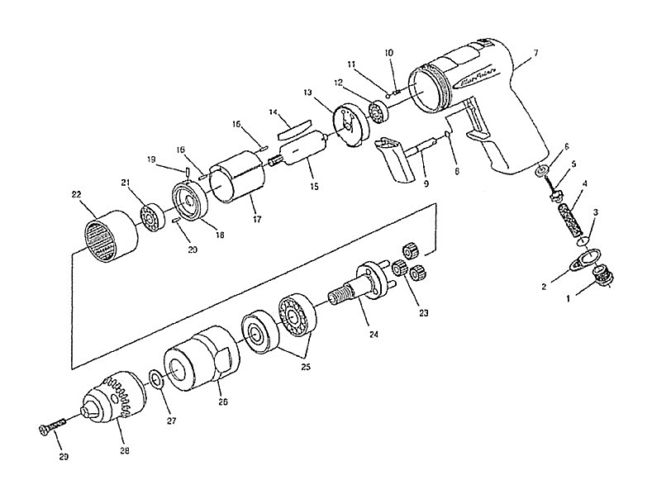

 |  | KEY |  | PART NO. | QTY |  | DESCRIPTION
 | 1 |  | AT801MC-1 |  |  | 1 |  | Bushing, Inlet, w/Screen
 | 2 |  | AT801MC-2 |  |  | 1 |  | Deflector
 | 3 |  | AT801MC-3 |  |  | 1 |  | O-Ring
 | 4 |  | AT801MC-4 |  |  | 1 |  | Spring, Valve
 | 5 |  | AT801MC-5 |  |  | 1 |  | Valve, w/Pin
 | 6 |  | AT801MC-6 |  |  | 1 |  | Seat, Valve
 | 7 |  | AT801MC-7 |  |  | 1 |  | Housing, Motor
 | 8 |  | AT805-13 |  |  | 1 |  | O-Ring
 | 9 |  | AT801MC-8 |  |  | 1 |  | Assembly, Trigger
 | 10 |  | AT805-11 |  |  | 1 |  | Regulator Spring
 | 11 |  | AT350-11 |  |  | 1 |  | Steel Ball
 | 12 |  | AT801-7 |  |  | 1 |  | Bearing, Ball
 | 13 |  | AT801MC-9 |  |  | 1 |  | Plate, Rear
 | 14 |  | AT700-16MP4 |  |  | 4 |  | Blade, Rotor, 4/pk
 | 15 |  | AT801MC-10 |  |  | 1 |  | Rotor
 | 17 |  | AT801-5 |  |  | 1 |  | Cylinder
 | 18 |  | AT801MC-11 |  |  | 1 |  | Plate, Front
 | 19 |  | AT110-14 |  |  | 1 |  | Roll Pin
 | 20 |  | AT700-28MP2 |  |  | 1 |  | Pin, 2/pk
 | 21 |  | AT800-13MP2 |  |  | 1 |  | Bearing, Ball, 2/Pkg
 | 22 |  | AT801MC-12 |  |  | 1 |  | Gear, Internal
 | 23 |  | AT801MC-13 |  |  | 3 |  | Gear, Idler
 | 24 |  | AT805-5 |  |  | 1 |  | Spindle (incl 9)
 | 26 |  | AT801MC-14 |  |  | 1 |  | Ring, Lock
 | 27 |  | AT800-4 |  |  | 1 |  | Spacer (up to Serial #13301)
 | 28 |  | AT825-6 |  |  | 1 |  | Chuck, Drill, 1/4" (For AT825A)
 | 29 |  | AT801A-1 |  |  | 1 |  | Screw, Chuck
 | – |  | AT801MC-15 |  |  | 1 |  | Nameplate
 | – |  | AT801MC-16 |  |  | 1 |  | Label, Warning
 | 16 |  | AT700-17MP2 |  |  | 2 |  | Pin, Roll, 2/Pkg

