AT321 - 3/8" Sq. Dr. Pistol Grip Impact Wrench

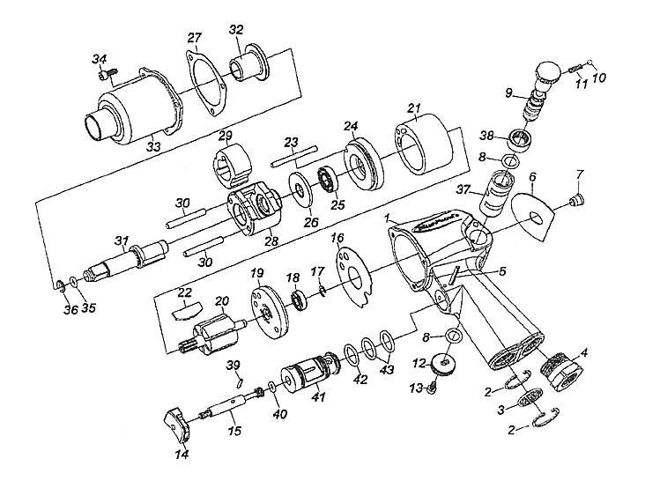

 |  | KEY |  | PART NO. | QTY |  | DESCRIPTION
 | 1 |  | AT321-1 |  |  | 1 |  | Motor Housing Assembly
 | 3 |  | AT321-3 |  |  | 1 |  | Deflector, Exhaust
 | 4 |  | AT123-6 |  |  | 1 |  | Strainer, Air
 | 5 |  | AT321-4 |  |  | 1 |  | Pin
 | 6 |  | AT321-5 |  |  | 1 |  | Nameplate
 | 7 |  | AT123-17 |  |  | 1 |  | Fitting, Grease, Flush Type
 | 8 |  | AT321-6 |  |  | 2 |  | Bushing Seal, Reverse Valve
 | 9 |  | AT321-7 |  |  | 1 |  | Valve, Reverse
 | 10 |  | AT321-8 |  |  | 1 |  | Ball, Steel
 | 11 |  | AT321-9 |  |  | 1 |  | Spring
 | 12 |  | AT321-10 |  |  | 1 |  | Knob, Reverse Valve
 | 13 |  | AT321-11 |  |  | 1 |  | Screw, Knob, Reverse Valve
 | 14 |  | AT321-12 |  |  | 1 |  | Trigger
 | 15 |  | AT321-13 |  |  | 1 |  | Pin
 | 16 |  | AT321-14 |  |  | 1 |  | Gasket, End Plate
 | 17 |  | AT321-15 |  |  | 1 |  | Retainer, Bearing, Rear Rotor
 | 18 |  | AT321-16 |  |  | 1 |  | Bearing, Rear Rotor
 | 19 |  | AT321-17 |  |  | 1 |  | Plate, End, Rear
 | 20 |  | AT321-18 |  |  | 1 |  | Rotor
 | 21 |  | AT321-19 |  |  | 1 |  | Cylinder
 | 23 |  | AT321-21 |  |  | 1 |  | Dowell, Cylinder
 | 24 |  | AT321-22 |  |  | 1 |  | Plate, End, Front
 | 25 |  | AT321-23 |  |  | 1 |  | Bearing, Front Rotor
 | 26 |  | AT321-24 |  |  | 1 |  | Washer, Rear, Hammer Frame
 | 27 |  | AT321-25 |  |  | 1 |  | Gasket, Hammer Case
 | 28 |  | AT321-26 |  |  | 1 |  | Cage, Hammer
 | 29 |  | AT321-27 |  |  | 1 |  | Hammer
 | 30 |  | AT321-28 |  |  | 2 |  | Pin, Hammer
 | 31 |  | AT321-29 |  |  | 1 |  | Anvil, Standard
 | 32 |  | AT321-30 |  |  | 1 |  | Bushing, Hammer Case
 | 33 |  | AT321-31 |  |  | 1 |  | Case, Hammer
 | 35 |  | AT321-33 |  |  | 1 |  | O-Ring, Retainer
 | 36 |  | AT321-34 |  |  | 1 |  | Retainer, Socket
 | 37 |  | AT321-35 |  |  | 1 |  | Bushing, Reverse Valve
 | 38 |  | AT321-35 |  |  | 1 |  | Bushing, Reverse Valve
 | 38 |  | AT321-36 |  |  | 1 |  | Bushing
 | 39 |  | AT321-37 |  |  | 1 |  | Pin
 | 40 |  | AT321-38 |  |  | 1 |  | Face, Throttle Valve
 | 41 |  | AT321-39 |  |  | 1 |  | Bushing, Throttle Valve
 | 42 |  | AT321-40 |  |  | 1 |  | O-Ring, Bushing
 | 43 |  | AT321-41MP2 |  |  | 2 |  | O-Ring, Bushing, 2/Pk
 | – |  | AT321-42 |  |  | 1 |  | Label, Warning
 | – |  | AT321-44 |  |  | 1 |  | Boot, Air Tool, Vinyl (for AT321)
 | – |  | SS1373 |  |  | 1 |  | Icon Label

