AT187 - Air Engraving Pen

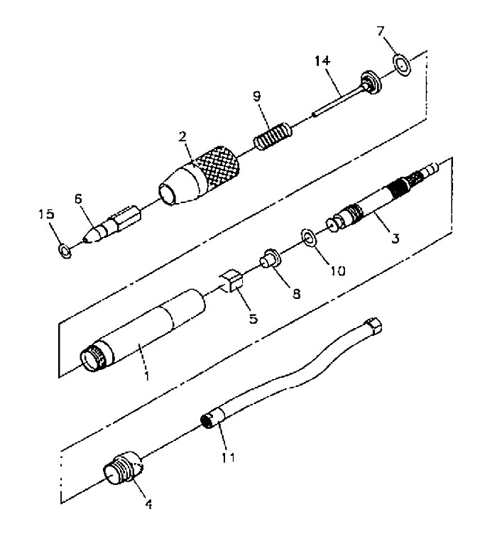

 |  | KEY |  | PART NO. | QTY |  | DESCRIPTION
 | 1 |  | AT187-1 |  |  | 1 |  | Body
 | 2 |  | AT187-2 |  |  | 1 |  | Nose
 | 3 |  | AT187-3 |  |  | 1 |  | Valve, Throttle
 | 4 |  | AT187-4 |  |  | 1 |  | Ring Nut
 | 5 |  | AT187-5 |  |  | 1 |  | Valve Seat
 | 6 |  | AT186-6 |  |  | 6 |  | Needle Guide
 | 7 |  | AT185-26 |  |  | 1 |  | Ring, Back-Up
 | 8 |  | AT187-7 |  |  | 1 |  | Seal
 | 9 |  | AT187-8 |  |  | 1 |  | Spring
 | 10 |  | AT187-9 |  |  | 1 |  | O-Ring, 5.2 x 2.6mm
 | 11 |  | AT187-10 |  |  | 1 |  | Hose, w/Air Inlet, Blue
 | 14 |  | AT187-11 |  |  | 1 |  | Tip, Engraving, Coarse, 45°
 | 15 |  | AT187-12 |  |  | 1 |  | O-Ring, 5 x 1.8mm
 | – |  | AT187-13 |  |  | 1 |  | Tip, Engraving, Fine, 15°
 | – |  | AT187-14 |  |  | 1 |  | Tip, Engraving, Medium, 30°
 | – |  | AV1000 |  |  | 1 |  | Vacuum, Air
 | – |  | SS1924 |  |  | 1 |  | Warning Label Icon

