

Operating Instructions Manual

1/4” Mini Die Grinder
87-1626

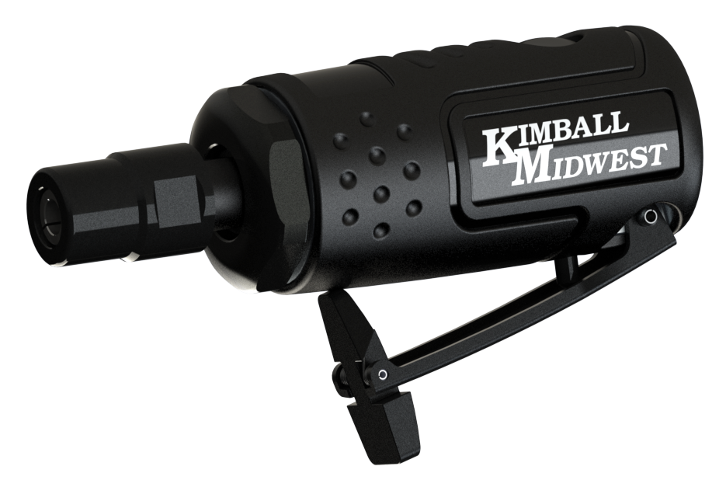

Read through this operating instructions manual carefully before using the product. Protect yourself and others by observing all safety information, warnings, and cautions. Failure to comply with instructions could result in personal injury and/or damage to the product or property. Please retain these instructions for future reference.

SPECIFICATIONS:

Free Speed (RPM) ………………..……  Dynamic Air Pressure (P.S.I.) …………………  Air Inlet (NPT) ………………….……..…  Avg. Air Consumption (CFM).……....……  Length (Inches) …….…....................  Weight (Lbs.) ….………………..……..…. |  | 25,000  90  1/4  3.0  4.53  0.64
AIR SUPPLY:
Tools of this class operate on a wide range of air pressure. It is recommended that the dynamic air pressure be maintained at 90 P.S.I. at the tool. Higher pressure and unclean air will shorten the tool’s life due to accelerated wear and may create a hazardous condition.

Water in the airline will cause damage to the tool. Drain the air tank daily. Clean the air inlet filter screen at least weekly.

The air inlet, used for connecting the tool to the air supply, has a standard 1/4” NPT Thread.
Line pressure should be increased to compensate for pressure drops in air hoses over 25’ in length.

OPERATING INSTRUCTIONS:
- Always turn off the air supply, drain hose of air pressure and detach tool from air supply before installing, removing, or adjusting any part or accessory on this tool, or before performing any maintenance on the tool.
- Use the two wrenches provided to loosen the collet nut.
- Insert the ¼” diameter shank of an abrasive or cutting tool (not included) such as a bur, flap wheel, bore brush, etc. fully into the collet. Then firmly re-tighten the collet nut to lock the collet in place.
- Connect the air supply to the tool. Turn on the air compressor, and set the regulator to the recommended 90 P.S.I.
- Secure the work with clamps or a vise so both hands are free to operate the tool. Don’t overreach. Always keep proper footing and balance and grip tool with both hands.
- Trip the safety and slowly apply hand pressure to the trigger until the desired speed is obtained.
- With a firm grip on the die grinder, lightly apply the abrasive or cutting tool to the workpiece, slowly and steadily moving to the right and left until the desired finish is achieved.
- Once the work is completed, release hand pressure on the trigger.
- Turn off the air compressor. Then disconnect the air hose from the tool.
- Remove the cutting tool or abrasive from the die grinder. Store the tool in a clean, dry location.

WARNING:
Oil will discharge through the exhaust during the first few seconds of operation after lubricating. The exhaust port must be covered with a towel before applying air pressure to prevent serious injury.

STORAGE:
Avoid storing the tool in a high humidity environment. Before storing and after operation, oil the tool at the air inlet with air tool oil and run it for a few seconds.

MODIFICATIONS:
Do not modify this tool. Modifications may reduce the effectiveness of safety measures and increase the risks to operator.

DISPOSAL:
Dispose of damaged tools in accordance with state and local regulations.

NOTE: Ensure that cutting or grinding attachments are not damaged before use to prevent injuries.


WARNINGS:
- This power tool is not intended for use in potentially explosive atmospheres and is not insulated from coming into contact with electric power.
- Always wear face protection, hand protection and impact-resistant eye protection when operating this tool.
- Note the direction of rotation BEFORE operating the tool.
- High sound levels can cause permanent hearing loss. Always use hearing protection. Operate and maintain the power tool to prevent unnecessary increase in noise level.
- Never carry the tool by the hose and beware of a whipping compressed air hose. Protect the hose from sharp objects and heat.
- Do not modify this tool. Modifications may reduce the effectiveness of safety measures and increase the risks to operator.
- Keep away from rotating end of tool. Do not wear jewelry or loose clothing. Choking, scalping and/or lacerations can occur if jewelry, hair, or gloves are not kept away from tool and accessories.
- Secure the work with clamps or a vise so both hands are free to operate the tool. Don’t overreach. Always keep proper footing and balance.
- Air tools can vibrate in use. Vibration or uncomfortable positions over extended periods of
time may be harmful to your hands and arms or other parts of your body. Discontinue use if you experience discomfort. Instantly tell your employer and consult a qualified health professional.
- Air under pressure can cause severe injury. Never direct air at yourself or others. Hose whip can cause serious injury. Always check for damaged, frayed or loose hoses and fittings, and replace immediately.
- Use only the suggested shaft diameter of the insert tool. Never mount a grinding wheel, cut-off wheel, router bit or drill bit.
- Do not lock, tape or wire the “on/off” safety lever in the “on” position. The lever must be free to return to the “off” position when released.
- Anticipate and be alert for sudden changes in motion during start up and operation of any power tool.
- Some dust created through the use of abrasive products can expose you to chemicals know to the State of California to cause cancer, birth defects, or other reproductive harm. For more information go to www.P65Warnings.ca.gov.
LUBRICATION:
Lubricate the tool daily with a high-quality air tool oil [K-M No. 80-1426]. If no inline oiler is used, run a teaspoon of oil through the tool. The oil can be added into the tool air inlet or into the hose at the nearest connection to the air supply, then run the tool.

MAINTENANCE:
Other factors outside the tool may cause loss of power. Reduced compressor output, excessive draw on the air line, moisture or restriction in air lines or the use of hose connections of improper size or poor condition may reduce the air supply. Grit or gum deposits in the tool may reduce power and may be corrected by cleaning the air strainer and flushing out the tool with Ultra Guard Extreme Air Tool Conditioner [K-M No. 80-293 or 80-291].

REPAIR & SERVICING:
For tools out of warranty, Kimball Midwest carries a rebuild kit [K-M No. 87-1626-1]. To rebuild, disconnect the tool from the air supply, disassemble the tool, replace any worn or damaged parts, clean, reassemble, and re-lubricate. Tools can also be serviced by Power Tool Repair (371 West Ave. Tallmadge, OH 44278, 330-630-0022).

LIMITED WARRANTY:
Kimball Midwest warrants to the original buyer ("Buyer") all parts and accessories purchased by it from Kimball Midwest against defects in material or workmanship.

Kimball Midwest will repair or replace, at no charge to the buyer, this tool which, after examination by Kimball Midwest, is determined to be defective within a period of 1 year from receipt.

Coverage under this warranty will be provided only if the defective tool has been submitted to Kimball Midwest for inspection.

This warranty does not cover any damage to this tool due to alteration, modification, improper installation, accident, post-installation misuse, abuse, negligence, inadequate maintenance, or malfunction of associated parts or equipment not supplied by Kimball Midwest.

This warranty is in lieu of any other warranty, expressed or implied, including any warranty of merchantability or fitness for a particular purpose. Replacement or repair as provided under this warranty is the exclusive remedy of the buyer. Kimball Midwest shall not be liable for any incidental or consequential damages resulting from breach of this warranty. Kimball Midwest neither assumes, nor authorizes any person to assume for it, any other liability in connection with the sale of its products.
If this Kimball Midwest Product proves defective in material or workmanship within one year after purchase, contact the Kimball Midwest Quality Assurance Department at:
All-QualityAssurance@kimballmidwest.com

- WARNING: Cancer and Reproductive Harm –www.p65warnings.ca.gov.

Exploded View & Parts List
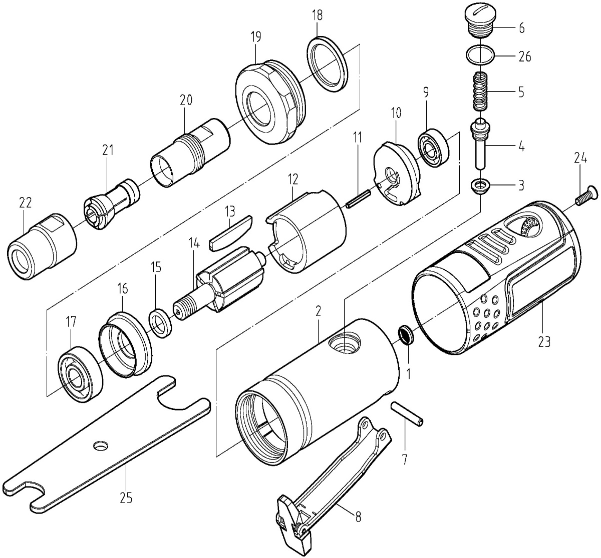
NO. | Description | Q'TY | NO. | Description | Q'TY
1 | Air Strainer | 1 | 16 | Front Plate | 1
2 | Housing | 1 | 17 | Ball Bearing | 1
3 | Anvil Collar | 1 | 18 | Washer | 1
4 | Pin Valve Rod | 1 | 19 | Cylinder Set Screw | 1
5 | Spring | 1 | 20 | Bushing | 1
6 | Screw | 1 | 21 | Chuck-1/4" | 1
7 | Spring Pin | 1 | 22 | Lock Nut | 1
8 | Trigger | 1 | 23 | Cover | 1
9 | Ball Bearing | 1 | 24 | Screw | 1
10 | Rear Plate | 1 | 25 | Wrench | 2
11 | Spring Pin | 1 | 26 | O-Ring | 1
12 | Cylinder | 1
13 | Blade | 5
14 | Rotor | 1

NOTES:

____________________________________________________________________

____________________________________________________________________

____________________________________________________________________

____________________________________________________________________

____________________________________________________________________

____________________________________________________________________

____________________________________________________________________

____________________________________________________________________

____________________________________________________________________

____________________________________________________________________

____________________________________________________________________

____________________________________________________________________

____________________________________________________________________

____________________________________________________________________

____________________________________________________________________

____________________________________________________________________

____________________________________________________________________

____________________________________________________________________

Manufactured For:
Kimball Midwest
4800 Roberts Road
Columbus, OH 43228
1-800-233-1294
www.kimballmidwest.com

