

Operating Instructions Manual

1” Impact Gun with 6” Anvil

84-046
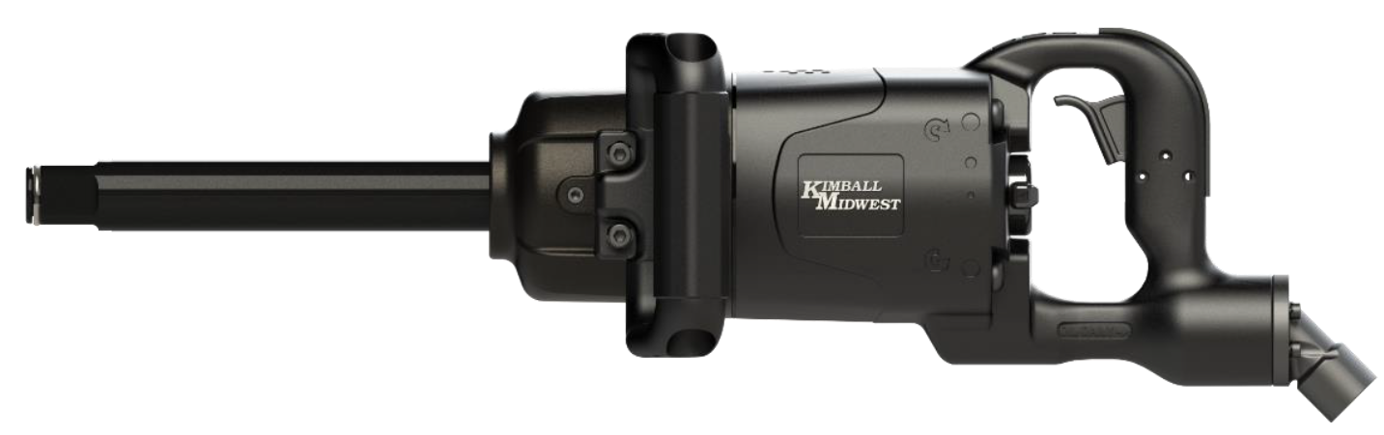

Read through these operating instructions manual carefully before using the product. Protect yourself and others by observing all safety information, warnings, and cautions. Failure to comply with instructions could result in personal injury and/or damage to product or property. Please retain instructions for future
reference.

WARNING: Cancer and Reproductive Harm – www.p65warnings.ca.gov.

SPECIFICATIONS:

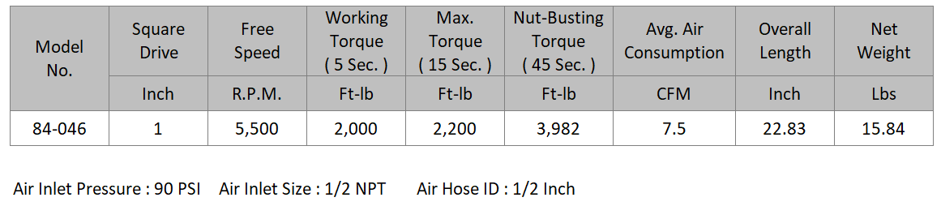

AIR SUPPLY:
Tools of this class operate at a wide range of air pressure. It is recommended that the dynamic air pressure be maintained at 90 PSI at the tool. Higher pressure and/or unclean air will shorten the tool’s life due to accelerated wear and may create a hazardous condition.

Water in the airline will cause damage to the tool. Drain the air tank daily. Clean the air inlet filter screen at least weekly.

The air inlet, used for connecting the air supply, has a standard 1/2” NPT thread.

Line pressure should be increased to compensate for pressure drops in air hoses over 25’ in length.

OPERATING INSTRUCTIONS:
Keep hands off the trigger while connecting the tool to the air supply. Disconnect the tool from the air supply before lubrication, maintenance, changing sockets and when not in use. When changing sockets, make sure the anvil c-clip holds the socket firmly in place. Replace the c-clip if the socket is not held firmly in place, or when it shows obvious wear. Always use the tool while at a safe distance from other people in the work area.

BOLT/NUT INSTALLATION AND REMOVAL:
Place the socket securely on the bolt or nut to be removed or installed. Hold the side handle with one hand and the trigger handle with the other hand. Control the speed of the gun by depressing the trigger to remove or install the fastener.
NOTE:
Use only approved impact sockets on the impact gun. Non-impact sockets can break or shatter when used on an impact gun; injury or death may also occur.

Airline Setup (components not included):

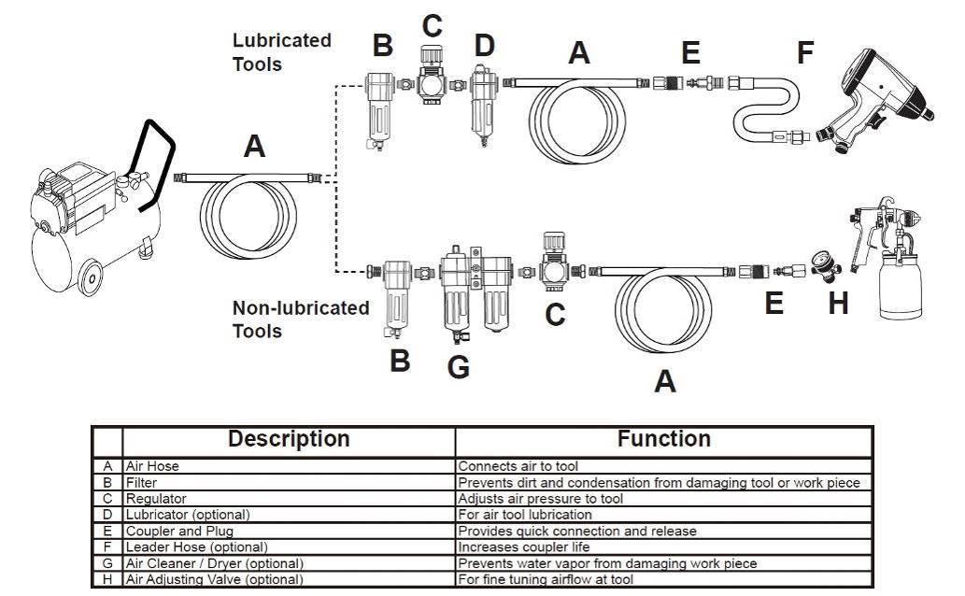

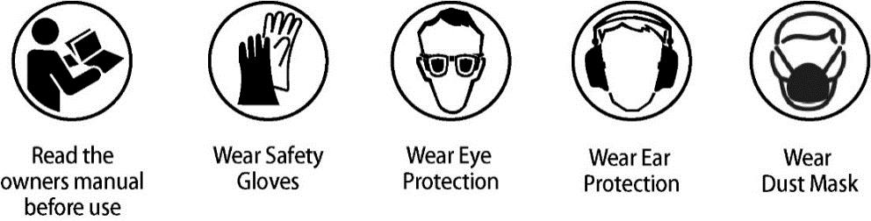

SAFETY PRECAUTIONS:
- Make sure the socket is properly installed to help prevent accidental release while in use.
- Disconnect the tool from the air supply before performing maintenance, changing sockets, or when not in use.
- Always use the tool a safe distance from other people in the work area.
- Keep the tool away from your body when it is running. Do not overtighten fasteners.
- Do not wear loose or ill-fitting clothing; remove watches and rings. Keep proper footing and balance at all times.
- Maintain tools with care. Keep tools clean and oiled for the best performance. Follow the instructions for lubricating and changing accessories. Wiping or cleaning rags and other flammable waste materials must be disposed of as per local, state and federal regulations.

LUBRICATION:

Lubricate the tool daily with a high-quality air tool oil. If no airline oiler is used, run a teaspoon of oil through the tool. The oil can be added into the tool air inlet or into the hose at the nearest connection to the air supply, then run the tool. To properly maintain this tool, grease needs to be applied to the impact mechanism as needed [Between part numbers #32, #33, #34 & #35 in the parts diagram]. To grease the air impact mechanism, remove the impact housing socket screws and apply a lithium-based grease with an NGLI of 2 [Motive-Power White Lithium Grease K-M No. 80-808] on the impact mechanism.

MAINTENANCE:
Other factors outside the tool may cause loss of power. Reduced compressor output, excessive draw on the air line, moisture or restriction in air lines or the use of hose connections of improper size or poor condition may reduce the air supply. Grit or gum deposits in the tool may reduce power and may be corrected by cleaning the air strainer and flushing out the tool with Ultra Guard Extreme Air Tool Conditioner [K-M No. 80-293 or 80-291] or Power+ Air Tool Conditioner [K-M No. 80-769].

REPAIR & SERVICING:
For tools out of warranty Kimball Midwest carries a General Maintenance Kit [K-M No. 84-044-1]. Tools can also be serviced by Power Tool Repair (371 West Ave. Tallmadge, OH 44278, 330-630-0022).

LIMITED WARRANTY:
Kimball Midwest warrants to the original buyer ("Buyer") all parts and accessories purchased by it from Kimball Midwest against defects in material or workmanship.

Kimball Midwest will repair or replace, at no charge to the buyer, this tool which, after examination by Kimball Midwest, is determined to be defective within a period of 1 year from receipt.

Coverage under this warranty will be provided only if the defective tool has been submitted to Kimball Midwest for inspection.

This warranty does not cover any damage to this tool due to alteration, modification, improper installation, accident, post-installation misuse, abuse, negligence, inadequate maintenance, or malfunction of associated parts or equipment not supplied by Kimball Midwest.

This warranty is in lieu of any other warranty, expressed or implied, including any warranty of merchantability or fitness for a particular purpose. Replacement or repair as provided under this warranty is the exclusive remedy of the buyer. Kimball Midwest shall not be liable for any incidental or consequential damages resulting from breach of this warranty. Kimball Midwest neither assumes, nor authorizes any person to assume for it, any other liability in connection with the sale of its products.

If this Kimball Midwest Product proves defective in material or workmanship within one year after purchase, contact the Kimball Midwest Quality Assurance Department at All-QualityAssurance@kimballmidwest.com

Exploded View & Parts List

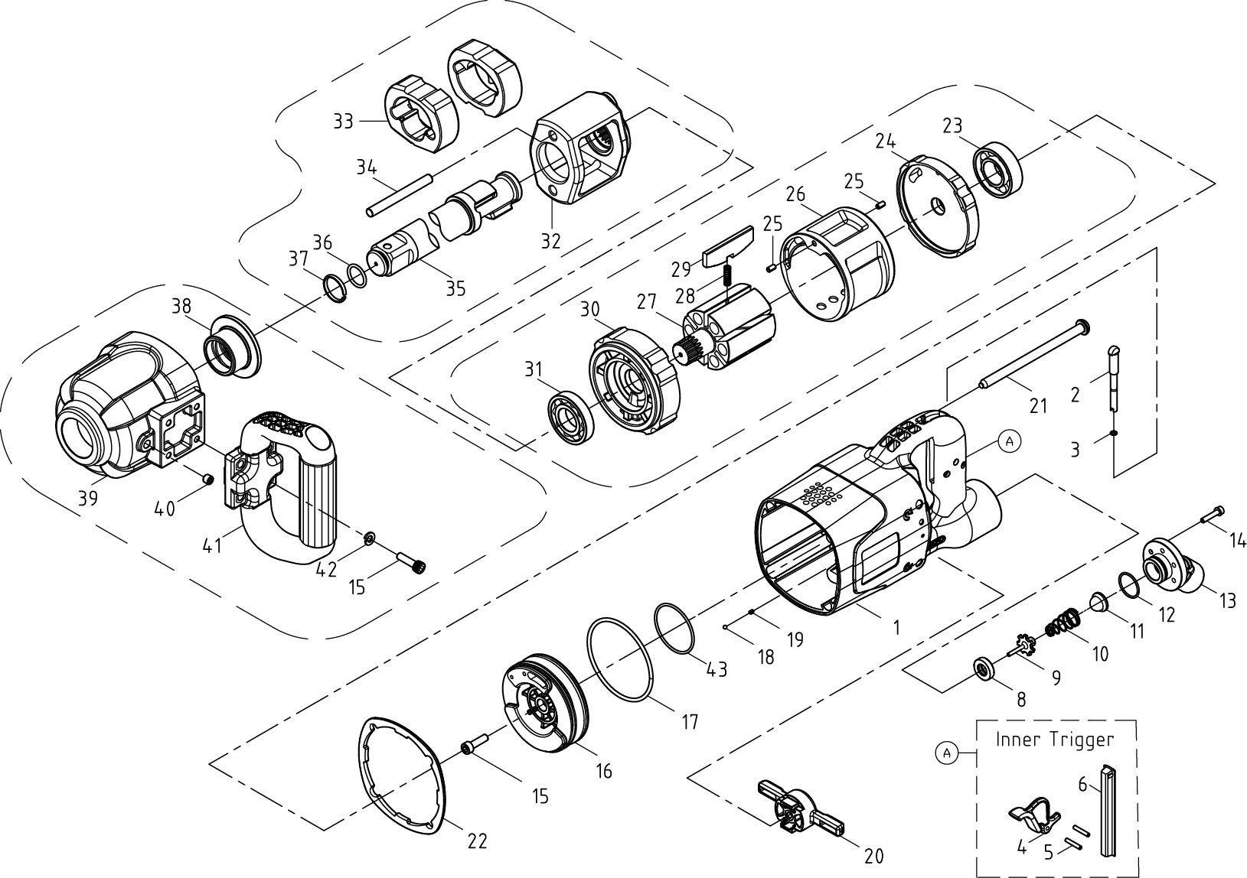

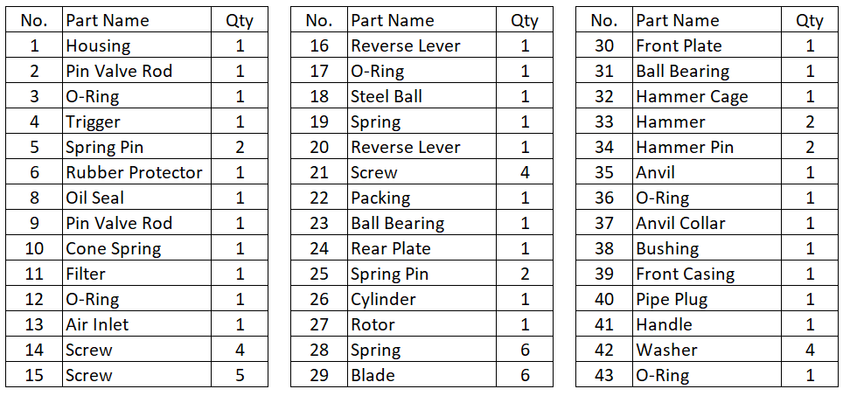

NOTES:

NOTES:

Manufactured For: Kimball Midwest 4800 Roberts Road
Columbus, OH 43228
1-800-233-1294
www.kimballmidwest.com

