FORT WAYNE-ALLEN COUNTY AIRPORT AUTHORITY
Fort Wayne-Allen County Airport Authority Board Meeting
Regular Session
August 17, 2026
3:00 p.m.

A meeting of the Fort Wayne-Allen County Airport Authority Board of Directors was held on August 17, 2026, at the Fort Wayne International Airport, 3801 W. Ferguson Rd., Fort Wayne, Indiana 46809, pursuant to proper legal notice. A quorum being present, Mr. Barry Sturges, Board President, called the meeting to order at 3:05 p.m.

ATTENDANCE:

AIRPORT AUTHORITY AIRPORT AUTHORITY STAFF
BOARD MEMBERS: & LEGAL COUNSEL PRESENT:

Richard B. (Barry) Sturges, Jr., President, present | Scott Hinderman, Chief Executive Officer
Kimberly Grannan, Vice President, present | Joseph Marana, Chief Operating Officer
Timothy J. Haffner, Secretary, present | Tyler Davis, Chief Financial Officer
Jerome F. (Jerry) Henry, Jr., present | Ryan Bauer, Airport Development Manager
Réna Bradley, present* | Mike Deam, Airport Attorney
Ramadan Abdul-Azeez, present | Jordan Huttenlocker, Airport Attorney
*electronic meeting participation | Doug Robertson, Controller
 | Annie Hoffmeier, Administrative Assistant I

CALL TO ORDER:

A quorum being present, Mr. Sturges called the meeting to order at 3:05 p.m. Mr. Sturges noted that board member Ms. Réna Bradley would be attending the meeting electronically and so all votes taken would be by roll call.

1. CONSIDERATION AND APPROVAL OF TODAY’S AGENDA AND CONSENT
AGENDAS

Mr. Barry Sturges welcomed everyone to the board meeting and started the meeting by saying that the first item for consideration is the agenda and consent agendas. Mr. Tim Haffner made a motion to approve the August 17, 2026, Board Agenda as posted and the bid and consent agendas as presented below. Ms. Kimberly Grannan seconded the motion. Mr. Sturges called for a roll call vote. Below is a tally of the votes:

Ms. Kimberly Grannan – Aye
Mr. Tim Haffner – Aye
Mr. Jerry Henry – Aye
Ms. Réna Bradley – Aye
Ms. Ramadan Abdul-Azeez – Aye
Mr. Barry Sturges -Aye
The motion carried.

- ADMINISTRATIVE CONSENT AGENDA:

- Approval of Board Minutes – 07.20.2026
- Review & Approval of Claims #26-08
- Accounts Receivable Reports

- BID CONSENT AGENGA:

- Bid Results: Repair Air Trade Center Apron Pavement, AF26-06

Airport staff solicited bids for the Air Trade Center Apron Pavement Repair Project, which will provide minor concrete pavement repairs on the Air Trade Center apron at the Fort Wayne International Airport, including joint and corner spall repairs, joint resealing, and related pavement restoration work.

Two bids were received in response to the solicitation, as shown on the bid tabulation below. After review by Airport staff and CHA, the Airport’s engineering consultant, staff recommend award of the contract to The Harper Company in the amount of $243,679.70 for the base bid.
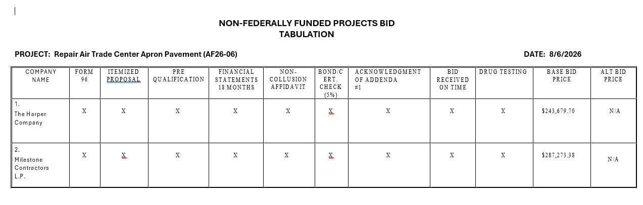
Staff requests that the Board approve the following motion:

An award to The Harper Company as the lowest responsive and responsible bid received
for the base bid in the amount of $243,679.70.

Authorization for the Chief Executive Officer to sign the contract documents.

b) Bid Results: FWA-Public Safety Department Roof Replacement – Phase 2 TB26-
05

Airport staff solicited bids for FWA – Public Safety Department Roof Replacement – Phase 2. The purpose of this project is to remove and replace the remaining deteriorated sections of roofing at the Public Safety Department building.
In response to our bid solicitation, two bids were received as indicated below. Airport staff along with MartinRiley, our architectural firm, have reviewed the bids and we are recommending that the Board make an award to SPG Roofing and Exteriors, LLC for the base bid in the amount of $390,000.00.
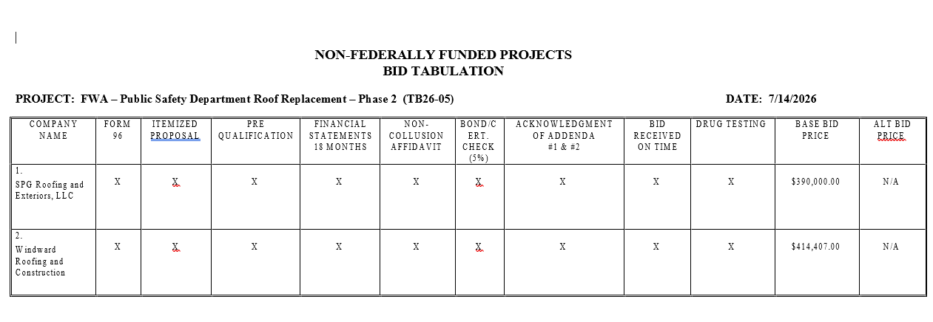
2. CONTRACT CONSENT AGENDA

- Addendum Number 21 – Guaranteed Maximum Price Amendment, Exhibit A, Construction Manager as Constructor, Fort Wayne International Airport East Terminal Expansion with Clayco.

This is an addendum to the Guaranteed Maximum Price amendment with Clayco, Inc. for the East Terminal Expansion. This addendum incorporates the items listed below and results in a credit to FWACAA in the amount of $18,269.03. The credit consists of $100 for the correction of a previous accounting error and the remaining amount reflects a decision to contract directly with the irrigation subcontractor for the repair of sprinkler systems damaged during the East Expansion project.

Description of Change:

No. | Description
COR. #407 | Install and Repair Existing Damaged Irrigation Lines
COR. #374 | Accounting Correction – RFI-641–Level 1 Area E Vertical Circulation Drywall F – Reveal – R1

Staff recommend approval of this Addendum Number 21 which provides credit of
$18,269.03 and authorizes the Chief Executive Officer to execute the addendum on
behalf of the Authority.

- Addendum Number 5 (CO6) – Guaranteed Maximum Price Amendment to the Construction Manager as Constructor Agreement with Hagerman Inc. for the Hangar 2003 Renovation Project

This is an addendum to the Guaranteed Maximum Price amendment with Hagerman Inc. for the Hangar 2003 Renovation Project. This addendum will incorporate the items listed below for an overall increase of $84,429.00.

No. | Description
025 | Power and access controls portion of PR004
043 | Gas pressure regulators addition
044 | Credit for bollards and finishes product substitutions
045 | Overhead door replacement in hangar and workshop areas
046 | Parking lot curb/asphalt grading correction
047 | Addition of exterior lights above employee entrance canopy
048 | Replacement of explosion proof receptacles and power runs to hangar pits

c) Consideration and Approval of Amendment #3 to the Professional Services
Agreement with Mead and Hunt for the FWA Terminal Building – East Expansion
CA/Phase 2

Mead & Hunt provided design and construction administration services for the East
Terminal Expansion Project. Due to the general contractor’s schedule extending approximately 14 months beyond the anticipated completion date, Mead & Hunt incurred additional construction administration costs that were not previously billed. Mead & Hunt and its subconsultants also incurred additional costs related to the contractor’s phasing, sequencing, and construction methods, including extended soil and concrete testing services, additional signage and passenger boarding bridge design support, and additional concession area design services. Additional effort was also required to evaluate the contractor’s claims and prepare Initial Decision Maker responses. Therefore, airport staff are requesting approval of Amendment #3 for an increase in the amount of $300,000.00 to accommodate these additional services.

Staff are recommending that the Board make a motion to approve this Amendment #3 and is also requesting authorization for the Chief Executive Officer to sign the contract documents.

2. ACTIVITY REPORT – July 2026

Mr. Scott Hinderman reported to board members on our recent Airport Authority air service and marketing activities. His report to the board included the following:
- Our traffic continues to grow and for the month of July we increased for the month to 2.96% and our year-to-date is up 1.85%.
- American Airlines seats were slightly lower while United Airlines significantly increased capacity by adding more flights to O’Hare. Mr. Hinderman noted that O’Hara serves as an important connecting hub, providing passengers with greater access to destinations throughout the air transportation system.
- Mr. Hinderman also explained that Allegiant Air’s traffic typically slows down during late August and September because the schools have started back up for the year. As a result, enplanement totals may decrease from the 48, 538 passengers recorded in July.
- The Board asked how many flights a day United Airlines provides to O’Hara now and Mr. Hinderman stated that United has seven flights a day to Chicago compared to last year at this time they had four daily flights. American Airlines has three daily flights. Combined, FWA now offers ten daily flights to Chicago, providing passengers with convenient access to a major connecting hub.

3. CONSIDERATION AND APPROVAL OF FORT WAYNE-ALLEN COUNTY
AIRPORT AUTHORITY 2026 BUDGET

Mr. Hinderman and Airport Authority CFO, Mr. Tyler Davis, made a presentation to the Board regarding the 2027 FWACAA operating and capital budgets related to the Operating Fund, Debt Service Fund and the Cumulative Building Fund. Mr. Hinderman reported to the Board that preparation for the 2027 budget began in March 2026 and the 2027 proposed budget was presented to the airlines on August 5th of this year. Mr. Hinderman noted that the airlines appreciated the Airport Authority’s overall transparency and were in agreement with the proposed airline rates and charges.

Staff recommendations for the 2027 Budget were presented as follows:

Operating Fund Budget
Revenues | $59,111,097
Expenditures | $58,716,233
Personal Services | $10,374,574
Supplies | $5,498,320
Contractual Services | $20,826,574
Capital Outlays | $22,016,765
Operating Fund Budget Surplus | $394,864
Debt Service Fund Budget
Revenues | $1,965,628
Expenditures | $1,926,030
Debt Service Fund Surplus | $39,598
Cumulative Building Fund
Revenues | $793,965
Expenditures | $0
Cumulative Building Fund Surplus | $793,965

Airline Rates and Charges were outlined as follows:
- Landing Fees $2.94 per 1,000 lbs.
- Apron Fees 0.28 per 1,000 lbs.
- Terminal Rent $27.98 per square foot

Landing and Apron Fees will both increase in 2027 compared to 2026 due to an increase in the cost center requirement for each. Also, for the landing fee, the Authority is decreasing the stabilization factor pursuant to the newly negotiated Airline Use and Lease Agreement. Terminal Rent will increase by 6.3% in 2027 due to a cost center requirement increase of approximately $400,000, which includes 2 new full-time custodial positions as well as a new full-time position for a Air Service and Marketing Manager.

Mr. Hinderman also noted that staff anticipate presenting the budget to the Allen County Council on September 17, 2026, with the Council adopting the budgets on October 7, 2026.

Ms. Kimberly Grannan made a motion to approve the 2027 Budget as presented above. Mr. Jerry Henry seconded the motion. Mr. Barry Sturges called for a roll call vote. Below is a tally of the votes:

Ms. Kimbery Grannan – Aye
Mr. Timothy Haffner – Aye
Mr. Jerry Henry - Aye
Ms. Réna Bradley – Aye
Mr. Ramadan Abdul-Azeez – Aye
Mr. Barry Sturges - Aye
The motion carried.

4. CONSIDERATION AND APPROVAL OF SITA INFORMATION NETWORK
COMPUTING USA INC. LEASE

Ryan Bauer, Airport Development and Properties Manager, addressed the board with the lease
agreement with SITA Information Network Computing USA, Inc. He stated that they have
been a long-standing tenant for the past five years and they do communication and radio
equipment service that serves the aeronautical customers, primarily the airlines. SITA would
like to conduct a new lease of eight square feet of the network room at the Air Trade Center
in building 2060. Below are the lease details:

Summary Information:
Fort Wayne-Allen County Airport Authority with SITA Information Network Computing
USA Inc.

FACILITY: | LAN Room of Building 2060 located at 12602 Global Drive, Yoder IN 46798
TENANT: | Societe Internationale de Telecommunications Aeronautiques d.b.a. SITA Information Network Computing USA Inc
USE OF  PREMISES: | Installation, maintenance and use of communication equipment (including VHF radios, associated cables, antenna, and cabinet), serving the aviation industry.
LEASE TERM: | 5-year
RENTAL RATE:
  YEAR | EFFECTIVE DATE | MONTHLY RENT
  1 | Upon Execution | $318.80
  2 | May 1, 2027 | $328.36
  3 | May 1, 2028 | $338.21
  4 | May 1, 2029 | $348.36
  5 | May 1, 2030 | $358.81
DEPOSIT: | One month’s rent on file from previous lease agreement
OPTION TO  RENEW: | None
UTILITIES: | Landlord responsible for sewer, gas, electricity, water, building life safety. Tenant responsible for any others required.
IMPROVEMENTS/  RENT CREDITS | None
OTHER  INFORMATION  REGARDING  THE LEASE | - Landlord has early termination rights for aeronautical needs expansion  - Both Landlord and Tenant have 60-day early termination rights  - FWACAA Tenant since 2021
Mr. Timothy Haffner made a motion to approve the SITA Information Network Computing USA Inc. Lease as presented above. Mr. Jerry Henry seconded the motion. Mr. Barry Sturges called for a roll call vote. Below is a tally of the votes:

Ms. Kimbery Grannan – Aye
Mr. Timothy Haffner – Aye
Mr. Jerry Henry - Aye
Ms. Réna Bradley – Aye
Mr. Ramadan Abdul-Azeez – Aye
Mr. Barry Sturges - Aye
The motion carried.

5. OTHER BUSINESS

Mr. Barry Sturges asked Mr. Scott Hinderman if there were any other business to discuss and Mr. Hinderman indicated that he wanted to introduce two current employees who have been promoted recently. Katie Scherer, who has been with the airport 15 years, recently was promoted to Director of Operations and Facilities and Angie Dillon, who has been with the airport 2 years, starts her new position as Air Service and Marketing Manager today.
Mr. Sturges then said he wanted to thank all those involved for the great job of the recent ribbon cutting event held last week for the East Terminal Expansion Completion. Mr. Sturges said he received a lot of positive feedback on the event and on the terminal expansion itself. Mr. Hinderman was quick to praise Joe Marana and Angie Dillon who was worked hard on getting everything organized.

5. Adjournment

Mr. Barry Sturges adjourned the August 17, 2026, Regular Session Board Meeting at 3:21 pm.

EXECUTIVE SESSION:

An Executive Session was held on Monday, August 17, 2026 at 2:00 p.m. - prior to the regular session in the Board Room (Ste. 210), to discuss Personnel (pursuant to IC 5-14-1.5-6.1(b)(5) or (b)(6) or (b)(9) or Lease Negotiations (pursuant to IC 5-14-1.5-6.1(b)(2)(D), pending or threatened litigation which is pursuant to IC 5-14-1.5-1(b)(2)(B), to have communications with an attorney that are subject to the attorney client privilege (pursuant to IC 5-14-1.5-6.19(b)(19) pursuant to or confidential records which is pursuant to IC 5-14-1.5-6.1-(b)(7).

Attendance:
Richard B. (Barry) Sturges, Jr., President; present
Ms. Kimberly Grannan, Vice President; present
Timothy T. Haffner, Secretary; present
Jerome F. (Jerry) Henry, Jr.; present
Ms. Réna Bradley; present*
Mr. Ramadan Abdul-Azeez; present
Mr. Scott Hinderman; present
Mr. Mike Deam, Airport Attorney; present
Ms. Jordan Huttenlocker, Airport Attorney; present
Mr. Joe Marana; present
Mr. Tyler Davis; present
Mr. Ryan Bauer, present
Mr. Doug Robertson; present
Ms. Annie Hoffmeier; present
*electronic participation

By signing the minutes of the August 17, 2026, board meeting, it is hereby certified that nothing other than the topics, as noted above, were discussed during the Executive Session.

Signatures on file

__________________________ ___________________________
Mr. Richard (Barry) Sturges Ms. Kimberly Grannan
Board President Board Vice-President

