# Speeding Extra Enforcement Social Media for Partners

Below are several sample social media posts. These are for traffic safety partners during their speed enforcement campaigns to serve as a jumping off point for raising awareness on social media. To use the photos in this document simply right click and select “save as photo.” Remember, individualized posts and images specific to your community are always preferred over premade graphics. If your law enforcement officers are making stops have them write a brief description and take a photo of the road where the speeding happened.

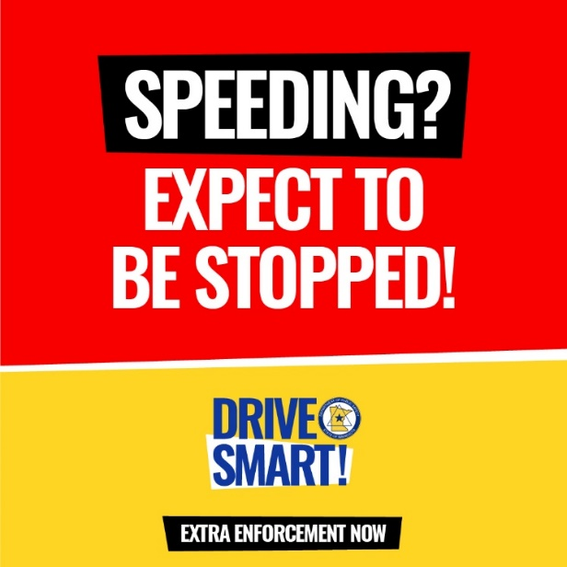

**Suggested text:**

Speeding? Extra enforcement is out on Minnesota roads. Slow down or you will be pulled over.

You know what really slows you down? A speeding ticket or a crash. [Agency Name] officers are on the lookout for dangerous drivers. Slow down and get there on time.

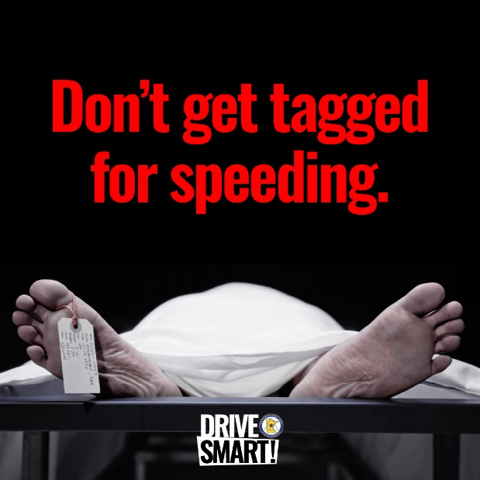

**Suggested text:**

Speeding won’t get you there any faster, but it might end your life sooner than you think. Slow down and make it to your destination -- extra enforcement will be out to catch you if you don’t.

Last year, 137 Minnesotans lost their lives in speeding-related crashes. Don’t add to the count, slow down and make it there safely.

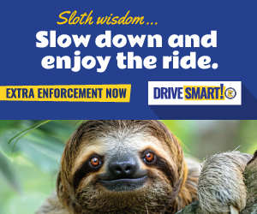**Suggested text:**

Even the sloth knows extra enforcement is out now on Minnesota roads. Our officers will be on the lookout for speeders, so slow down or you will be pulled over.

Last year, from Memorial Day to Labor Day our officers stopped [Local stops data] people for speeding. Make this summer a safe one -- slow down or you will be pulled over.