DWI Extra Enforcement Social Media for Partners
Below are several sample social media posts. These are for traffic safety partners during the DWI enforcement campaign to serve as a jumping off point for raising awareness on social media. To use the photos in this document, simply right click and select “save as photo.”
Remember, individualized posts and images specific to your community are always preferred over premade graphics. Or you can download the corresponding graphic on Dropbox.

If your law enforcement officers are making stops, have them write a brief description and take a photo. Photo ideas include a PBT reading, the squad car on the side of the road, flashing lights, a view through the squad windshield showing the vehicle that is pulled over, a breathalyzer or a jail cell where a drunk driver might spend the night.
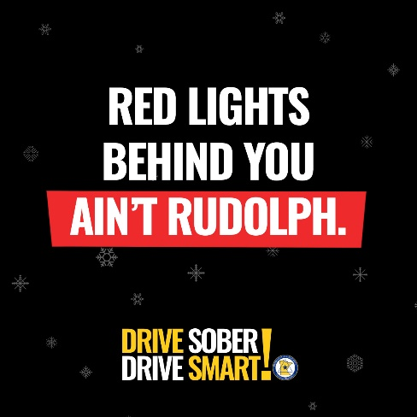
Suggested text: You spend the holiday with family, maybe have a few beers and decide to drive home. Then you see it, red lights. That’s not Rudolph behind you — it’s consequences. Don’t spend the holiday season in a jail cell, drive sober, drive smart!

Suggested text: Had a few drinks? If you think you’re ok to drive, you’re probably not. Don’t risk it! Plan ahead to have a sober driver every time you drink. Extra enforcement is on our roads.

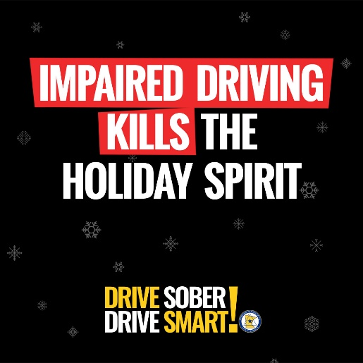
Suggested text: What happens when you drive impaired? If you’re fortunate, you will get pulled over and arrested before you hurt yourself or someone else. Last year, 150 people died on Minnesota roads in alcohol-related crashes. Don’t add to the count. Drive sober, drive smart!

