**MN BCA FSS Internship Interest Form**

|  |  |  |  |
| --- | --- | --- | --- |
| **Name:** |  | **Date:** |  |

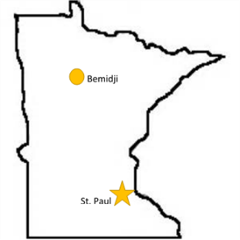***Check all locations and sections of interest:***

Testing – **Bemidji**

Biology

Drug Chemistry

Firearms & Toolmarks

Latent Prints

Calibration – **St. Paul**

Testing – **St. Paul**

Biology

Drug Chemistry

Evidence Intake & Processing

Firearm and Toolmarks

Latent Prints

Toxicology

Trace Evidence

|  |  |
| --- | --- |
| **University/College Currently Attending:** |  |
| **Major/Program:** |  |
| **Anticipated Graduation Date:** |  |
| **Current GPA:** |  |
| **Date able to start internship:** |  |
| **Hours per week:** |  |

|  |  |
| --- | --- |
| **Relevant courses taken/in progress:**  ***Choose all that apply*** | Molecular Biology  Genetics  Biochemistry  Organic Chemistry  Statistics  Instrumental Analysis |
| **Other relevant courses/skills:** |  |
| **Laboratory experience:** |  |
| **Laboratory instrumentation experience:** |  |

| **Why are you interested in forensic science?** |
| --- |
|  |

| **Please write a brief statement about your ideal internship experience, how it fits into your future goals, how it will enhance your academic and professional career, and what qualifies you for that internship.** |
| --- |
|  |