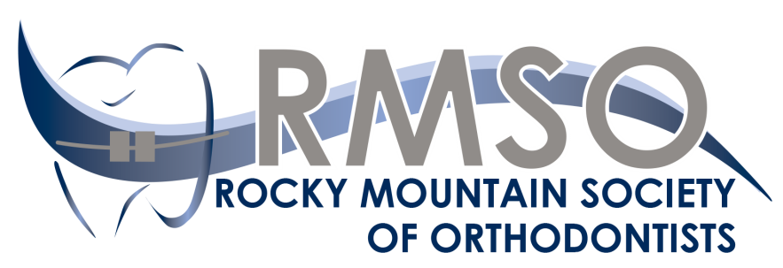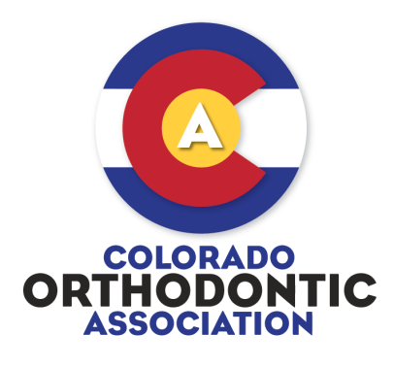
2018 ANNUAL MEETING
October 25-27, 2018
Brown Palace Hotel, Denver, Colorado

REGISTRATION FORM
Please Print  Doctor’s Name: _________________________________________  Address: _______________________________________________  City, State, ZIP: _________________________________________  Phone: ______________________________________  Email: _______________________________________ | Register online at rmso.org or register by mail, fax, or email  NO PHONE REGISTRATIONS ACCEPTED  RMSO  401 N Lindbergh Blvd  Saint Louis, MO 63141-7816  Fax: (314) 997-1745  snappier@aaortho.org
All registrants are invited to attend a free Welcome Reception on Thursday, free continental breakfast and a morning break on Friday and Saturday, and free lunch and an afternoon break on Friday.
REGISTRATION CATEGORIES |  | FEE | AMOUNT DUE
___AAO Member |  | $350
___AAO Student Member |  | $0
___AAO Retired or Service Member |  | $175
___Non-AAO member |  | $450
___Spouse/Guest | Name ____________________________________ | $175
 |  | TOTAL | $
PAYMENT INFORMATION

___Check payable to RMSO ___Visa ___MasterCard ___American Express ___Discover

Credit Card #_______________________________________________________Exp. Date ______________

Security Code _________ Name on card ______________________________________________________

Address on card (if different from above) ________________________________________________________

CANCELLATION AND REFUND POLICY
Cancellations requests must be received in writing by the RMSO office seven (7) full business days or less in advance of the meeting. No cancellations will be accepted and no refunds will be issued on-site. Exceptions to the cancellation and refund policy may be made only by the RMSO Board of Directors, in case of documented medical or personal emergency and then only upon written request. The RMSO office will process all approved refunds within thirty (30) full business days after the completion of the meeting.

