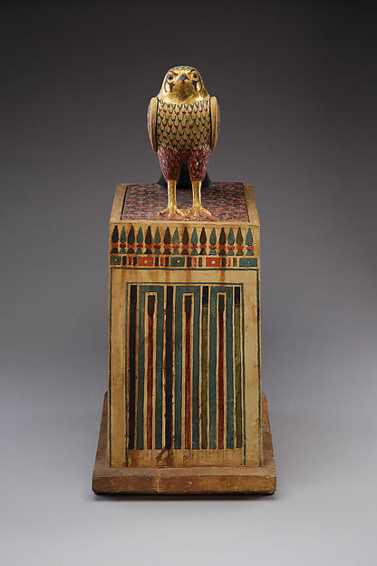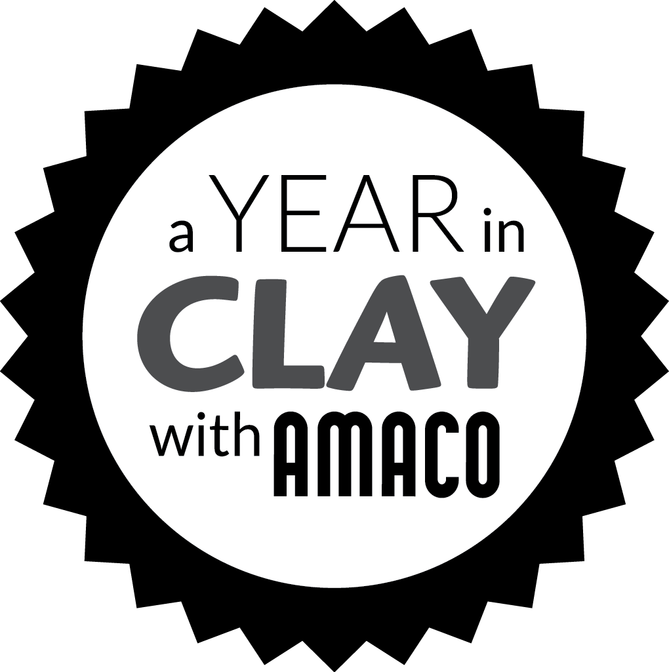 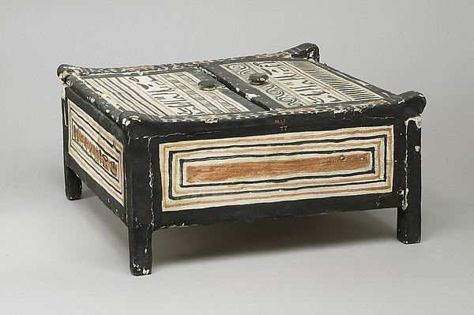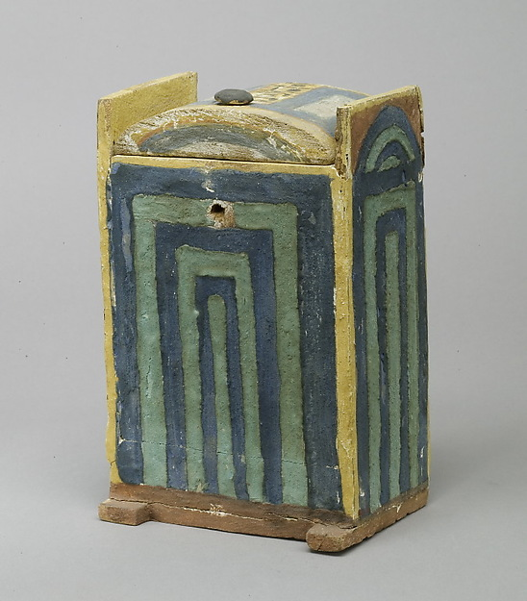

Tiles made from flat clay slabs have been around for thousands of years. Joining the **flat slabs** to create pottery has not been around as long, but still has a rich and “thousands of years” history. The Middle East, Europe, and even the Mayan culture have used this method for building their vessels. This is the most involved method of hand-building techniques and is better for more experienced students.

Start by rolling out an even slab of clay. This can be achieved by a slab roller or place two yardsticks either side of the clay, then roll with a rolling pin until the clay is even with the yardstick. Cut your base, sides, and top, then let sit until leather-hard before joining by slip and scoring.

[*https://www.artsy.net/article/artsy-editorial-5-ceramic-techniques-you-need-to-know*](https://www.artsy.net/article/artsy-editorial-5-ceramic-techniques-you-need-to-know)

**Egyptian Boxes:** The elaborately decorated box features a falcon statuette on top of its lid. Inside is a tightly wrapped linen bundle. X-rays have shown that it does not contain a complete bird mummy but only feathers.

Period: Ptolemaic Period

Date: 332–30 B.C.

Geography: From Egypt;   
 Said to be from Middle Egypt, Asyut (Lykopolis)

Medium: Painted and gilded wood, linen, resin, feathers

**Egyptian Boxes**

[*http://www.metmuseum.org/art/collection/search/551150?rpp=60&pg=50&ft=gold&pos=2990*](http://www.metmuseum.org/art/collection/search/551150?rpp=60&pg=50&ft=gold&pos=2990)

**History of the**

Name:

Date:

Period:

**Cosmetic Box**

# **Shabti Box of Khabekhnet**

Period: New Kingdom, Ramesside

Dynasty: Dynasty 19

Reign: reign of Ramesses II

Date: ca. 1279–1213 B.C.

This shabti box belonged to a man named Khabekhnet, son of Sennedjem in whose tomb the box was found. Other objects in the collection that were discovered in the same tomb are numbered 86.1.1–86.1.29

[*http://www.metmuseum.org/art/collection/search/551118*](http://www.metmuseum.org/art/collection/search/551118)

**Shabti Box**

**Cosmetic Box from the Tomb of Sennedjem**

Period: New Kingdom, Ramesside

Dynasty: Dynasty 19

Reign: reign of Ramesses II

Date: ca. 1279–1213 B.C.

The interior of this box is divided into four compartments. It was probably used to store the cosmetic utensils of the deceased. The cover has two flaps attached with pivots at the edge of the box.  
The inscription bears the names of Iyti and Ramose, both of whom were related to Sennedjem in whose tomb the box was found. Other objects in the collection that were discovered in the same tomb are numbered 86.1.1–86.1.29

[*http://www.metmuseum.org/art/collection/search/551116*](http://www.metmuseum.org/art/collection/search/551116)

**History of the** *– page 2*

Name:

Date:

Period: