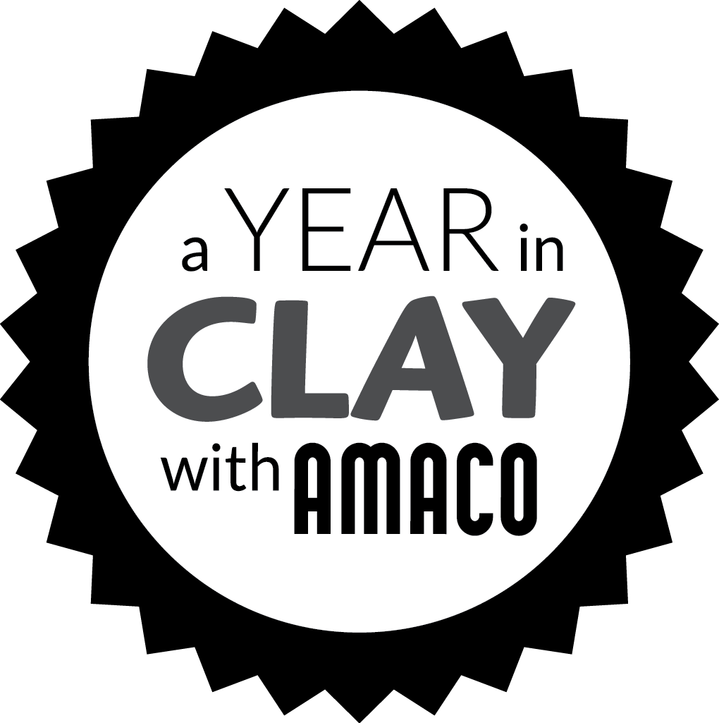

**Pacing Guide**

|  |  |  |
| --- | --- | --- |
| **PART 1 – FORMING** | Day 1 | DEMO: Form Pinch Pot. Wrap loosely in a plastic bag so the air inside the bag  will allow the pinch pot to dry slightly but not completely. |
| Day 2 | Smooth the inside. Smooth the outside as much as possible but this is more difficult than the inside. Press the rim so the walls look even in thickness and smooth out any cracks.  DEMO: Starting with a coil or sphere show students how to make parts to attach to the bottom. Encourage them to play with parts before they attach to come up with an interesting design. Parts can also be added to the sides and rim. |
| **PART 2 – ADDITIONS** | Day 3 | STUDIO DAY: Continue adding attachments to pinch pot. |
| Day 4 | STUDIO DAY: Complete adding attachments to pinch pot.  DEMO: How to cut and clean the rim. They can leave the rim uneven but if students would like a straight rim they can cut it before it dries. |
| **PART 3 – DECORATING** | Day 5 | DEMO: How to use underglazes. Underglazes can be applied to leather-hard to bone dry clay. Underglaze colors can be overlapped to create patterns such as stripes and dots.  Suggestion: Use underglazes on additons only so that a glaze can be used on the actual Pinch Pot. |
| Day 6 | OPTIONAL STUDIO DAY: Students complete painting Pinch Pots.  Pinch Pots are left out to dry before firing. |
| Day 7 | Complete Technical Record Sheet Drawing and Written description of the process. |

Part 1 – Forming the Pinch Pot

Part 2 – Pinch Pot Additions

Part 3 – Decorating with Underglazes

*This pacing guide is based on a 90 minute class every other day*

School Name:

Teachers Name:

Ceramics and Pottery I

Grades 6 - 12

[Dates]